Republic of the Philippines

**BULACAN STATE UNIVERSITY**

**Hagonoy Campus**

Iba-Carillo Hagonoy, Bulacan

**Smart Plastic Bottle Bin: A Reverse Vending Machine**

In Partial Fulfillment of the Requirements

for Information Technology Capstone Research Project

Submitted by:

Balmeo, Kyle ​​Erol S.

Clemente, Aemee Nicole L.

Dela Peña, Noah Mark S.

Roxas, Carl James M.

Santos, Rhiza Mae M.

Yap, Gio Edrian L.

Submitted to:

Dr. Jaime P. Pulumbarit

November 2023

**APPROVAL SHEET**

In partial fulfillment of the requirements for the degree of Bachelor of Science in Information Technology, this capstone project entitled **“Smart Plastic Bottle Bin : A Reverse Vending Machine”** has been prepared and submitted by **Kyle Erol S. Balmeo, Aemee Nicole L. Clemente, Noah Mark S. Dela Peña, Carl James M. Roxas, Rhiza Mae M. Santos, and Gio Edrian L. Yap,** who are hereby recommended for oral examination.

**Mark David P. Otayde, BSIT**

Capstone Adviser

Approved in partial fulfillment of the requirements for the degree of Bachelor of Science in Information Technology by the Committee on Oral Examination.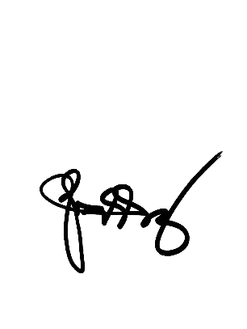

**ORLANDO BERLANDEZ, MIT** **MARVIN C. SANTOS, BSIT**

Panel Member Panel Member

**JESSE EDWIN V. GUECO, MSIT**

Panel Chair

Approved in partial fulfillment of the requirements for the degree of Bachelor of Science in Information Technology.

**MIRIAM P. PARIÑAS, DIT**  **FELICIDAD A. ELEOGO, Ed. D**

Department Head Campus Dean

**ACKNOWLEDGEMENT**

The research cannot accomplish this study without the help of the Almighty God for giving the researcher the wisdom, strength, patience, and provision from the start to finish of this study. Also, the researcher recognizes the help of the following individuals in pursuing this study. To our Capstone Coordinator, Dr. Jaime P. Pulumbarit, for his valuable inputs on each presentation made of the study. To our Capstone Adviser, Mr.. Mark David Otayde, for his valuable statements, comments, and suggestions for this study to be a more successful work. To the critics of the project, Mr. Marvin C. Santos, Mr. Orlando Berlandez, and Mr. Jesse Edwin V. Gueco, for their comments that strengthened the project to a quality project.

To the researcher’s family, friends, and colleagues, a big thanks to all of you for supporting and believing in the researcher for the success of this study.

**DEDICATION**

Wholeheartedly, I dedicate this work to my parents, Mr. Nelson and Mrs. Marcela Dela Dela Peña, for being supportive throughout the development of this thesis. They were, are, and always will be my inspiration to make all my works be successful.

I also dedicate this work to the one who inspires and motivates me the most, Our Dear God, who’s always there supporting me to do my thesis, for being the person who calms me every time I feel nervous, and for always being there to always cheer me up.

N.M.S. Dela Peña

**TABLE OF CONTENTS**

1. **Introduction**
   1. **Project Context …………………………………………………………. 1**
   2. **Purpose and Description ………………………………………………. 3**
   3. **General and Specific Objectives …………………………………..…... 5**
   4. **Scope and Limitations of the Study …………………………………… 7**
2. **Review of Related Literature / Systems**
3. **Review of Related Literature ………………………………………….. 9**
4. **Review of Related Systems …………………………………………… 16**
5. **Technical Background**
6. **Research Methodology ……………………………………………….. 24**
7. **Software Development Methodology ………………………………... 25**
8. **Conceptual Framework ………………………………………………. 30**
9. **Requirements Analysis and Documentation ………………….…….. 33**
10. **System Requirements ………………………………………………… 33**
11. **Functional Requirements ………………………………….…………. 36**
12. **Performance Requirements ………………………………………….. 38**
13. **Design of Software, Systems, Product, and / or Processes …….…… 39**
14. **Testing …………………………………………………………….….... 60**
15. **Implementation Plan …………………………………………………. 89**
16. **Results and Discussions** 
    1. **Results and Discussions ………………………………………………. 91**
17. **Summary and Recommendations**
18. **Summary of the Findings …………………………………………… 109**
19. **Conclusions …………………………………………………………... 110**
20. **Recommendations …………………………………………………… 111**

**References ……………………………………………………………………………. 113**

**CHAPTER I**

**INTRODUCTION**

**Project Context**

Plastics have altered our lives since they were developed in the 20th century, bringing tremendous advantages and enormous environmental harm. The main issue with plastics is that many have a very long lifespan and can take a very long time to decompose. It is causing significant problems, such as the accumulation of plastic waste on the land and oceans. Every year, 1.15 to 2.41 million tonnes of plastic are thought to enter the ocean and accumulate in sizable offshore zones. By 2050, 3.40 billion tonnes of waste will be produced worldwide, yet only 13.5% will be recycled (Kaza et al., 2018).

Plastic pollution is currently one of the most serious threats to our planet. Every minute, millions of plastic bottles are consumed worldwide. According to the UN Environment Programme, plastic pollution has a significant impact on the livelihoods of millions of people by altering the habitats and natural processes of the environment, reducing its ability to adapt to climate change, and also has an impact on food production and people's well-being.

Recycling helps to reduce waste while also assisting in the production of reusable items for the country. In the Philippines, recycling is heavily based on the monetary value of recyclable materials, making it an appealing source of income for waste collectors (Pepino, 2019).

In the present scenario, the Hagonoy Campus of Bulacan State University (BulSU)  is one of the five (5) external campuses of the university which is located in Iba Carillo Hagonoy, Bulacan. The Municipality of Hagonoy granted 8.5 hectares of land to Bulacan State University in 1994 to meet its demands and cater to a substantial number of students.

As the pandemic subsided, the start of face-to-face classes in BulSU Hagonoy Campus unlocked new challenges, mainly plastic waste problems. As a counter to the problem in plastic waste management, the administration formulated a waste management system by scattering a great number of trash bins around the campus. The current method of disposing of used plastic bottles is to simply open the trash can and place them inside without knowing whether the trash can is really for plastic bottles. It leads to incorrect waste segregation at the Bulacan State University Hagonoy Campus and further gives a hard time for the utilities to segregate those waste. Monitoring the status of the trash bin is also a problem, on which the current process to know if the trash bins are full is by manually looking or checking at each of those bins. Also, many students are not motivated to contribute to helping the environment by the means of recycling activities.

Recently, efforts for greening the campus led to the designation of green advocates by colleges and satellite campuses. Each has assigned one faculty and one student to lead in the advocacy campaign and solicit active participation of students and faculty through volunteerism in environmental and other related events. Its institutionalization, relationships with above partners operates with a heart in advocating for sustainable action geared towards protection and conservation.

Upon observing this, the researchers aim to develop a system that will assist the school in reducing used plastic pet bottles. Smart Plastic Bottle Bin: A Reverse Vending Machine which is low cost and endogenously developed that will aim to encourage recycling habits by giving a grade-based reward to the students for every item, a creative idea that has been used to aid in the collection of recyclable items and, as a result, to increase recycling activities. Automated monitoring will ease the problem of checking the status of the trash bins. The researchers understand the development of a system to improve the lives of students and teachers as well as to help preserve the environment.

**Purpose and Description**

A large number of plastic bottles might take decades or even centuries to decompose. In essence, they are always present in their surroundings. In line with the Dark Green University mandated by Bulacan State University, The goal of the study is to create and construct an IoT-based smart bin for collecting plastic bottles throughout the BulSU Hagonoy Campus and integrates web-based monitoring and application for convenient tracking of trash bin level, points allocation for student, reports, and analytics. The study will also have a rewarding system for students to promote recycling activities and to be an income-generating project for the campus that can be used for environmental projects and programs. The device is said to provide the following benefits.

**Bulacan State University - Hagonoy Campus.** The project will help the university in several ways such as it will promote sustainability within its community and become a model for other educational institutions, inspiring them to adopt similar initiatives. This will also help with the goal of the university, which is to have a safe environment and to have a Dark Green University. This project can also be used to educate students and faculty about the importance of recycling and managing waste. The system will reduce, if not eliminate, the existing problems of plastic bottles inside the campus.

**End Users.** The system will enhance the plastic bottle waste management culture among end users, including students, and administrators. For students and administrators, the project will serve as a practical example of how technology can be utilized to address real-world challenges. It will raise students' awareness of the importance of recycling. The token system of the machine will provide a grade-based reward, where each bottle is equivalent to 0.05 points. This means that students need to insert at least 20 bottles to earn a single point, which will be added as incentives. This project will encourage them to actively engage in plastic bottle waste management.

**Community**. This will help the community in reducing plastic waste in the organization and promoting recycling activities to its citizens. The community will benefits from cleaner surroundings, reduced plastic waste in landfills, and a positive impact on the environment and public health.

**Future Researchers.** This research will benefit future researchers of the same nature by providing them with more relevant references.

**General and Specific Objectives**

The project objectives lead the researcher to the overall goal and the specific objectives discuss the detailed steps on how the project objective is met.

**General Objective**

The general objective of the study is to develop and design a Smart Plastic Bottle Bin: A Reverse Vending Machine, which is a waste management system that can reduce the number of plastic bottles at Bulacan State University Hagonoy Campus.

**Specific Objectives**

Specifically, the study seeks to achieve the following specific objectives:

1. To be able to create a Smart Plastic Bottle Bin as a plastic bottle waste management system that integrates the following functions:
   1. Collects Plastic Pet Bottles.
   2. Notify if the trash bin is full
      1. Web notification in the admin/super admin dashboard.
      2. Warning modal on the GUI that stops the user from using the machine.
   3. Reward the users based on the number of their inserted plastic bottles in a form of Grade-based token where every bottle is equal to 0.05 which will be given as incentives. Twenty bottles are needed to complete a whole point. Over the course of a month, participants can earn up to three points, equivalent to sixty bottles. Only one whole point per participant per subject can be utilized. The total number of token per student will be shown in the student dashboard;
2. Develop a web application that is integrated to the hardware for effective plastic bottle waste management with the following modules:
   1. User authentication for different access controls.
   2. Student Modules
   3. Admin Modules
3. To evaluate the application using the following criteria under the Software and Hardware quality evaluation content or ISO/IEC 25010:
   1. Functionality;
   2. Reliability;
   3. Usability;
   4. Maintainability;
   5. Portability;
   6. Workability;
   7. Safety; and
   8. Training and Documentation;

**Scope and Limitations of the Study**

The project will focus on how to collect used plastic bottles for recycling, how to keep the school clean, and how to motivate the students to participate in the proper segregation of plastic bottles. This study will help to reduce improper disposal and improve the recycling of plastic bottles. To implement this project, the project requires the prerequisites that will be used for its development, which must include at least an NodeMCU ESP 8266 microcontroller, ultrasonic sensors, and break beam sensor for the hardware and as for the software, it should have a GUI and a website for the students to use to gain points, as well as use those points. The students should also have a verified account before they can use the machine since to login on the machine, it needs to accept the student number of the user. The accumulated points can only be allocated as grades for subjects that are participating in the project.

The Smart Plastic Bottle Bin will be placed beside the guard house so that the plastic bottles doesnt be need to be brought inside the university. The Hagonoy campus school's head, professors, and the students will utilize the Smart Plastic Bottle Bin: A Reverse Vending Machine. The machine can only operate online and will need to have a stable internet connection.

The study's primary limitation is that it will be carried out at the Bulacan State University Hagonoy Campus—which precludes generalizing its results. Using a different sampling approach, conducting a comparison study with a larger sample size, and generalizing the findings to a larger geographic area are possible. Another limitation of the study is that the sensors that are attached to the machine don't have the capability to reject glass bottles since the machine uses infrared sensors which means it will accept any transparent object, this also means that it rejects any objects that are not transparent like tin cans, paper, plastic bottle with plastic wrapper, paper cups, etc. Also, the machine will only be able to accept pet plastic bottles and anything that is larger than pet bottles will not be detected by the machine. Furthermore, the sensors used in the machine don't have the capabilities to discern if the bottle has contents inside like water.

**CHAPTER II**

**REVIEW OF RELATED LITERATURE/STUDIES**

This chapter provides the relevant literature and studies that the researchers considered to strengthen the significance of the current study. It also provides a synthesis of the art to fully comprehend the research for a better understanding of the study.

**Related Literature**

A literature review is a critical appraisal of existing research on a specific issue that significantly improves knowledge in the study. This review aims to provide a complete overview of the present state of knowledge on a particular topic, identify gaps in the literature, and suggest future directions for research. This review will examine the existing literature on Smart Plastic Bottle Bin: A Reverse Vending Machine, focusing on Smart Bins for Waste Management, Reverse Vending Machine for Improving Recycling Habits, and Integrating Monitoring Systems for Smart Bins. By synthesizing and analyzing the available research, We aim to improve knowledge of the topic and identify areas for further investigation.

**Smart Bins for Waste Management**

Smart bin is a modern high-tech garbage container that incorporates smart sensors to allow tracking of waste management operations. Dalli (2022) mentioned that the ability to track the occupancy ratio of smart garbage bins brings numerous advantages to the business and enables effective time management in the waste management process.

Traditionally, the cleaning staff collects litter bin garbage at scheduled times, and waste segregation cannot be done correctly; it has various limitations, such as bins filling up much faster in a densely populated area. A fixed garbage collection schedule causes an overflow of waste, posing hygienic issues and polluting the environment. It shows how the Smart-bin technology enables cleaning personnel to detect real-time cleanliness issues. Smart Bins are used to collect waste and detect the level of waste in the bin (Rai, Goyal, 2020).

Smart Solid Waste Management Systems (SSWMS) through smart waste bins are equipped with various sensors. These sensors subsequently collect real-time waste data from smart bins and transmit it to an internet site where individuals may access and monitor the availability of compartments located around a city (Pardini et al., 2020; Majid, Aiman et al., 2019). It may send an alert message to the corporation so that the relevant authorities can coordinate waste collection from the dustbin (Rai, Goyal, 2020).

Moreover, Pardini et al. (2020) stated that this SSWMS is significant since its efficiency is superior to traditional waste management processes. The goal of this system is to help the waste management staff do their job more efficiently, including (but not limited to) monitoring, scheduling, and lowering operational expenses (Majid, Aiman, et al., 2019). As a result, smart waste management systems have become crucial for cities aiming to decrease costs while managing resources and time. The primary goal of this study is to address the challenges associated with improper disposal of solid waste in urban areas by developing and validating an IoT-based bin level monitoring system for solid waste management. The study emphasizes the need for successful waste collection to mitigate the impact on human health and environmental pollution caused by overflowing trash bins resulting from traditional or inefficient waste management practices (Jino, Jackuline, & Vishnu et al., 2020).

Therefore, Smart bins also have the potential to improve recycling rates by providing real-time feedback on the types of materials being disposed of and how much of each material is being generated (Rai, Goyal, 2020). This information can help waste management companies develop more effective recycling programs and educate the public on proper waste disposal practices. One of the key benefits of smart bins is that they help to optimize waste collection routes, reducing the amount of time and fuel required for garbage trucks to collect waste from multiple locations (Majid, Aiman, et al., 2019). This not only saves money for waste management companies but also reduces carbon emissions and traffic congestion. By alerting waste management companies when bins are full, they can ensure that bins are emptied promptly, preventing overflowing waste from accumulating on streets and sidewalks (Rai, Goyal, 2020). However, it is worth noting that smart bins require an initial investment in technology and infrastructure. In addition, privacy concerns may be associated with collecting and transmitting data from these bins. As a result, it is important to carefully consider the potential benefits and disadvantages of smart bins before implementing them in a waste management system.

**Reverse Vending Machine for Improving Recycling Habits**

The Reverse Vending Machine (RVM) is a vending machine just like any other one, except it offers rewards like cash or shopping vouchers in exchange for particular materials recognized when entered into the machine. Mariya, Usman, Mathew, & Aa (2020) stated that RVM is a cutting-edge idea that has been presented to assist in collecting recyclable materials and, as a result, promote recycling activities.

It is a device typically used to promote proper trash disposal in the community, particularly for recycled materials like plastic, paper, and aluminum. Both the users and the waste management authority will gain from this. In a recent study on waste recycling in China, Bin Lu & Jie Wang (2021) found that monetary incentives were the most effective in influencing residents' recycling behavior, followed by environmental framing, institutional, and moral incentives.

There are several advantages to using reverse vending machines, according to the article by Taylor (2021). One benefit is that they help the environment by recycling materials and reducing the need for raw materials to make new beverage containers. Thus, RVM helps to collect recycling materials effectively, boosting recycling activities and improving waste management. Its procedure is effective. and a motivated manner of collecting waste items. (Aditya Gaur et.al., 2018).

RVMs also are conveniently placed in public locations such as grocery stores, gas stations, schools, parks, etc., which make them easily accessible for users (Taylor, 2021). Indirectly, it can encourage people to recycle a small number of PET bottles at the closest and most accessible location while reaping the benefits (Rahim & Khatib, 2023).

Many nations have adopted RVM because they recognize its benefits; however, it is still not widely employed due to its expensive installation and maintenance costs. Taylor (2021) mentioned in his article that one machine can cost between $10,000 and $25,000, making it difficult for businesses to purchase many RVMs. This is an issue with these machines because they have relatively high initial costs for purchase or leasing arrangements.

It was clear that with the aforementioned related literature, the reverse vending machine concept is an approach to green engineering technology (Shilpa Sambhi et al. 2020). The study underscored the influential moderating role of social norms, particularly descriptive norms, in shaping the impact of incentives on recycling behavior (Bin Lu & Jie Wang 2021). Amantayeva et al. (2021) studied that the monetary incentive offered by RVMs is a powerful incentive to engage the general public in recycling efforts. RVMs are perceived to contribute to the circular economy by facilitating public participation in recycling programs. If the incentives are appealing enough, more individuals will be attracted to the system and eager to engage in efficient recycling. As a result, the willingness to recycle is one characteristic that cannot always be explained. Still, it is certain that convenience, willingness, involvement, awareness, and incentives are the basis for influencing recycling behavior and are interrelated (Cherry, K., 2023).

**Integrating Monitoring System for Smart Bins**

As Jim (2019) stated, an effective garbage monitoring system is critical to keeping the environment nice and clean with the increase in all types of garbage. Every year, much money and space is squandered on city trash collection. Rather than visiting all routes to clean the waste bin, it is more efficient if the waste management system can tell the collector that only the waste bin needs to be emptied. A system that can gather and analyze data is required as a decision support tool to assist the local authority or waste management contractor in improving their service (Yusof et al.,2018).

Minhaz & Amit (2020) addresses the pressing issue of urban waste management through the development of a smart IoT-based system. Recognizing the challenges posed by improper waste disposal in densely populated urban areas, the proposed system integrates an identification system, automated lid system, display system, and communication system using Arduino Uno as a central microcontroller. Sensors facilitate garbage level identification, enabling continuous monitoring with real-time updates displayed on a liquid crystal display (LCD). The communication system, employing a global system for mobile communications (GSM) module, automatically notifies relevant authorities when the bin reaches full capacity, promoting timely waste collection. This automated solution proves to be more efficient than conventional waste management methods, minimizing manpower, preventing waste overflow, saving time, and proving cost-effective for sustainable urban living.

An IoT-based trash management system is equipped with different sensors and microcontrollers, and these technologies are employed to keep track of the trash cans. When a garbage can reaches a certain level, the sensor calculates it and sends it to the system. This method helps reduce the number of people required to collect waste from various sites implementing traditional methods (Hadria et al., 2018).

Moreover, Nisarga et al. (2018) stated that the system assures the cleaning of trash cans once the garbage level reaches its maximum limit. It helps in route optimization for the collection of garbage and overall management and it helps to find the garbage thrown outside the dustbin. Sends real-time information about the dustbin status. The smart bin monitoring system makes garbage collection more efficient and easier. It ultimately helps to keep cleanliness in society and ensures the security of the city. According to Jim (2019), The waste management system would be easier if the solution was more up-to-date; for example, if there was a system that could identify when a trash can was filled rather than collecting every trash can once a week.

**Plastic Waste Management through the Development of a Low Cost and Light Weight Deep Learning Based Reverse Vending Machine**

According to (Huma Zia et al., 2022).The management of the abundant amount of used plastic bottle waste is a major concern nowadays, because it is a major contributor to landfills and overburdens waste processing facilities. Once disposed of, plastic can take centuries to break down, hence, recycling not only manages the waste efficiently, but it reduces the environmental impact and creates economic opportunities, as well. An incentive-based Reverse Vending machine (RVM) is an effective way to involve the general public in the management of plastic waste. The existing solutions are either very expensive, from a computation and cost perspective, or they lack the robustness and durability necessary for deployment.

Currently, plastic pollution is one of the biggest hazards faced by our planet. According to the United Nations, marine pollution includes 8 million tons of plastic waste annually, causing 1 million seabirds and 0.1 million sea mammals to die every year. Furthermore, the expanse of terrestrial plastic pollution is so huge that it has yet to be quantified. If the current rates of goods production and waste generation persist, the total annual mismanaged waste worldwide will be more than double by 2050. Plastic bottles have become one of the major causes of plastic pollution, due to the rapid increase of the consumption of soft and cold drinks in the last decade or so, resulting in environmental pollution as well as resource depletion.

**Related Systems**

This section involves the researcher's contemplation of examining studies and research relevant to the progress of office transactions and web-based management information systems.

**Bote-Fi RVM: Plastic Bottle Collector for Free Wi-Fi Connection**

This study was developed by Custodio, Dotollo, Hernandez, Mateo, Toribio, and Vibar (2018), entitled Bote-Fi RVM: Plastic Bottle Collector for Free Wi-Fi Connection, a reverse vending machine that accepts recyclable bottle in exchange of internet connection for a limited time. The study mainly aims to reduce plastic bottles scattered in the campus environment. The machine accepts a plastic bottle and rejects the fragile, metal, and canned waste through the sensors set up. The research also believes that the recycling method will be improved efficiently through motivation from something they will receive and need. A study developed by Custodio et.al. (2018) was the researchers' basis for generating a sensor that detects waste like plastic bottles. Both studies believe how individuals are motivated to behave in certain ways based on the incentives they receive.

**Smart Plastic Bottle Bin With Vending And Shredding Machine**

This study is aimed by Abacan, Beunaorbra, Manapat, and Pangilinan (2019) to design and develop a smart bin that includes vending and shredding. The design consists of an ultrasonic sensor that detects the number of input bottles and the bin level; these two parameters will trigger the vending and shredding machine. Although Abacan, et al. (2019) have shredding in the machine, the researcher determined that their study will still greatly contribute to this study. Since the study focuses on how the incentives motivate students to generate less waste and reduce plastic pollution. This vending machine is an innovative and effective solution for recycling plastic bottles and an environmentally friendly approach to waste management.

**VENDOBIN: An IOT-based Plastic Bottle Waste Disposal Vending Machine**

A previous research study by Dacay, Sapida, Jumawan, Dela Cruz, and Paran (2020) states that in the Philippines, about 35,580 tons of garbage are generated every day. VendoBin is a combination of the garbage bin and vending machines, which aims to develop a habit of properly disposing of plastic bottles through a rewards system. Classification between the plastic bottle and non-plastic items was done using Infrared Sensors. Ultrasonic Sensors were used to determine the status of the VendoBin, whether it is full or not. Point systems will be given to every user on every transaction and saved on the text file database. The new or old users are given a unique code needed to redeem usable items. When the VendoBin reaches the threshold limit, it will send a text message to the concerned authorities for disposal.

The researchers believe recycling and waste management are among the key areas that have received significant attention, with the aim of reducing waste generation, conserving resources, and promoting a circular economy. That is why incentives are a significant part of motivation theory, and they play an important role in molding behavior and decision-making.

**Trash Converter Machine**

In this project, the researchers intended to help reduce the garbage that clogs our irrigation system that causes floods and help reduce the use of our natural resources and minimize pollution. The researchers intended to do this by building a machine that gives you an amount that corresponds to the number of plastic bottles that you have (Angeles et al., 2018). The project aimed to address several environmental issues regarding waste management and pollution. Researchers identified plastic bottles as the primary sources of trash that clog irrigation systems and result in floods.

**SPAMAST Garbage Bin Monitoring System Using Wireless Sensor Network**

According to the study conducted by Padal, Salado, and Sobejana (2019) about developing a monitoring system that displays the real-time level of the garbage inside the garbage bins using the ultrasonic sensor. Padal et al. (2019) and team created a Desktop Application that displays the level of garbage inside the garbage bins that could be graphed. The module notifies the admin when it reaches the maximum level of garbage inside the garbage bin and automatically opens using a servo motor and laser sensor after detecting the objects nearer and automatically notifies the users of the garbage level when the garbage bin is already full.

In relation to this study, the researchers' study, "Smart Plastic Bin: A Reverse Vending Machine", aims to improve waste management at Bulacan State University (Hagonoy Campus). It notifies the administration department when the garbage has reached its maximum capacity. This prevents trash from overflowing, leading to improper waste disposal, littering, and pest infestation.

**IoT-based Waste Collection Management System for Smart Cities: An Overview**

In the study of Chaudhari, Patil, & Raut (2019), monitoring bins' fullness while using sensors is possible to obtain a more efficient system than the one now in use. The design for a smart waste administration system focuses primarily on monitoring waste administration, given the smart technology used for waste systems, preventing human involvement, decreasing human time and effort, and resulting in healthy and waste-ridden surroundings.

The researcher probed into the study of Chaudhari et al. (2019) about IoT; hence IoT has played a key role in enabling smart waste management systems by providing a network of interconnected devices that can communicate and share data. These devices can be installed in waste bins, trucks, and other waste management equipment to monitor and manage waste collection and disposal activities in real time. The data collected from these devices can be used to optimize waste collection routes, improve operational efficiency, and reduce costs.

**Development of PET bottle shredder reverse vending machine**

The purpose of the study of Rahim and Khatib (2021) is to return polyethylene terephthalate (PET) bottles that are shredded into smaller pieces for the use of the next recycling process. A reverse vending machine is a machine that accepts empty beverage containers and returns money which helps to encourage users to recycle. The hardware is equipped with capacitive sensors that will detect bottles and status displays by using Liquid Crystal Display (LCD), and all major processes will be controlled by Arduino UNO. The microcontroller will send the signal to activate both motors, which are (direct current) DC motors that will actuate the shredding process and coin dispensing, respectively. This PET shredder RVM can shred the standard size of empty PET bottles, and consumers will be rewarded with an amount according to the number of bottles inserted.

The researcher promotes the rewards system rather than shredding, nevertheless, both bring significant benefits to the waste management system. Furthermore, the researcher believes that this machine will reduce plastic pollution because people will not have to throw plastic bottles on the streets but on the thing that will benefit them.

**Smart Systems and the Internet of Things (IoT) for waste management**

The study of Tamakloe and Akorli (2019) focuses on the use of smart systems and the Internet of Things (IoT) to provide an efficient approach to waste management. This project designed and manufactured a solar-powered, self-compacting smart bin prototype with a server-side monitoring application. The bin also monitors total weight and is capable of sending all this information to a secure server-side application. The accompanying web application monitors the state of each smart bin and proposes optimal routes for pick-up.

The researcher draws from Tamakloe and Akorli (2019) the concept of Smart Systems and the Internet of Things (IoT) has revolutionized waste management by providing more efficient and effective solutions to the challenges faced in this sector. By leveraging advanced technologies and data analytics, smart waste management systems can improve operational efficiency, reduce costs, and minimize environmental impact.

**IOT Based Smart Garbage alert system using Wireless Sensor Network for Environmental Hygiene**

According to Malini and Hemalatha (2019) , garbage management is one of the biggest problems in the world. The proposed solution focuses on monitoring the street bins and automatically sending a message to the respective authorities. Monitoring the Street bins can be possible using level and temperature sensors. WSN (Wireless Sensor Network) technology reads these sensors and sends a message to respective authorities to take action. While drizzling, the level sensor will automatically sense the rain and close the garbage bin.

The researcher draws from the ideas of Malini and Hemalatha (2019) that the concept of a waste management monitoring system involves using advanced technologies to collect and analyze data related to waste collection, transportation, processing, and disposal. Hence, the study discovered that monitoring systems are one of the most critical aspects that researchers have.

**Plastic Bottle Reverse Vending Machine**

The aim of the work by Divya Patil, Ganavi HP, Krishnasagar, Marasanna, and Arpitha Raju (2021) is to present the concept of a reverse vending machine which is proposed to serve as a solution to the problem of pollution caused due to plastic items. This article describes the operation of a reverse vending machine that starts working after inserting a plastic material. There are some very interesting bonuses for users of reverse vending machines, and they will receive coins as a reward. The reverse vending machine handles the acceptance of plastic products and offers coins as a reward based on the weight of the plastic products.

This paper focuses on the concept of cash-from-trash, where recycled plastic can produce useful products and help reduce greenhouse gas emissions and pollution. The researcher also focuses on this kind of concept to promote and encourage the student to recycle by providing a convenient and accessible way to dispose of empty bottles.

**Synthesis**

The researchers have reached the conclusion that all the accumulated related literature and foreign studies are comparable to the most recent study. The linked study will aid in complete comprehension. It will support relating and differentiating the research based on how the system's network analysis will flow about the proposed study.

The researchers selected the aforementioned related studies and literature to support and facilitate the creation of a solution for their proposed study. The selected studies and literature assist them in identifying the potential strengths, weaknesses, opportunities, and threats that may influence the outcome of their proposed study.

Therefore, the collections of other systems that related to the study have justified the credibility of the project. This study is possible to materialize because of the success of the other studies in similar situations. Furthermore, these studies suggest that there is a need for more efficient and sustainable solutions in recycling and waste management. Hence, reverse vending machines and incentive systems can be effective tools in promoting recycling and waste reduction, and can contribute to a more sustainable future.

**CHAPTER III**

**TECHNICAL BACKGROUND**

This chapter discusses how the researchers will plan and develop the product. The quantitative type developmental research method has been chosen to facilitate the development approach due to its relevance to the study's development process.

It also shows the development method, which is Agile Methodology, and the requirements analysis; these chapters also discuss the product design, system requirements, evaluation process, and the proposed prototype description.

**Research Methodology**

The researchers will implement a quantitative and developmental method and a survey as an instrument. According to Beb (n.d.), the developmental method refers to putting different aspects of a development process such as design, development, evaluation, programs, and the actual product that meets the specified requirements.

The researchers will implement this research method since the entire study is focused on developing a product, which means that this approach is a step-by-step guide for the researchers. Also, the researchers will use quantitative research to analyze the results of our testing tool, the survey. The survey will involve a set of questionnaires given to the respondents to obtain data on the respondents' experiences with the Smart Bin aligned with the ISO Standards. The most crucial part is that the questions' purpose was to analyze the data and identify.

**Software Development Methodology**

Software Development Life Cycle (SDLC) is a systematic process of creating high-quality software and the lowest cost in the shortest time possible. SDLC provides a well-structured sequence of stages that aids an organization in rapidly producing high-quality software that has been thoroughly tested and is suitable for production use. SDLC defines a method for planning, developing, testing, and deploying information systems. Since this study is about developing an IoT-based system for the client to battle plastic bottle waste, a continuous development and integration process is needed. Therefore the researchers will use Agile Development Cycle to create a Smart Plastic Bottle Bin: A Reverse Vending Machine.

The agile method is powerful in developing IoT-based projects as it is built to adapt to change. Using agile methodology in creating this type of project prioritizes usable software over lengthy documentation, personal communication over procedural tools, collaboration with clients over formal agreements, and adjusting to changes over sticking to a plan. Its primary goal is to provide incremental, usable software components for continual feedback and improvements.

This strategy will aid the team in developing the system's necessary features based on the client's needs. After gathering the requirements, the researchers will use the Agile process with Scrum to construct a prototype system for the organization. Because it allowed the client to participate in the system's development, this methodology was a necessary and logical approach to solving the customer's problems. So, creating a system prototype is crucial to demonstrate that the design works for the client given the relevant software requirements specifications.

Following each sprint, a meeting with the customer will be held to present the system's upgrades and improvements. The client's feedback and comments on the provided prototype will then be used for system improvements. Furthermore, the client will assess our work on the system after each sprint. The system was evaluated using a survey based on good software features such as functionality, reliability, performance efficiency, maintainability, portability, security, compatibility, and usability.

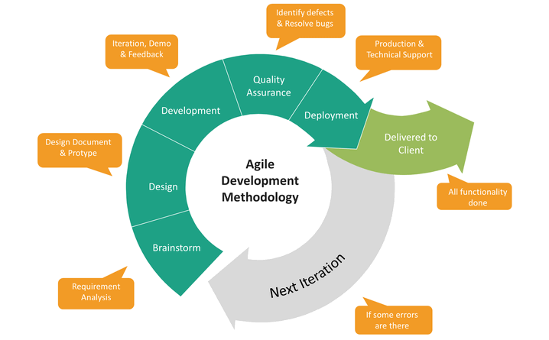

**Figure 1 System Development Life Cycle(Agile Model)**

The agile method includes Brainstorm, Design, Development, Quality Assurance, and Deployment.

**Brainstorm Phase**

During this phase, the researchers will identify the problem and gather relevant information. The team will create a strategy, objectives and scope, and consider several ways and ideas for the project's outcome. It will include critical thinking and brainstorming. Furthermore, the planning shall entail how the researchers would work on the many procedures essential to complete the project. And how the developers manage their time and effort to finish within the time frame set.

Also in this phase, all gathered requirements will be analyzed to ensure that all sides of the problem will be covered. A set of numerous meetings, brainstorming, and editing with the developers and the client shall produce a list of achievable objectives and needs for the said project.

**Design Phase**

This phase will focus on designing the system based on the requirements. This is the phase where all of the analyzed requirements will be used to create the technical details of the product such as user interface, entity relationship diagram, schematic diagrams, flowcharts, etc. Developers will follow the client's needs and use tools like schematic and data flow diagrams to develop the system's design.

In the design phase, the developers will design the system architecture, use case diagram, context diagram and data flow diagram, system flow chart, schematic diagram, and design entity relationship diagram of the monitoring system. The developers will also design its prototype for the machine and design the UI/UX of the software.

**Development Phase**

This phase involves building the project based on the design specifications and requirements that have been done during the previous stage. After approving the design of the proposed system, the developers will start making the prototype of the reverse vending machine and writing the code for the monitoring software.

The developer will interpret the schematic design to integrate multiple hardware components of the said project, along with developing the source code using Arduino IDE with C++ Language and web technologies such as HTML, CSS, and JavaScript for the front end and PHP for server-side scripting. MySQL will be utilized as the database of this project. The developers shall ensure that all parts of the project will finish following the design specifications that have been approved.

**Quality Assurance Phase**

At this phase, businesses must conduct various tests to ensure that the system is fully functional, reliable, usable, maintainable, portable, workable, and safe. The vending machine shall undergo exhaustive testing from different scenarios, while the monitoring system will contain faulty codes that will be redone and checked until the appropriate output is obtained. During this phase, the developers will do system testing and black-box testing methods to confirm that all of the system's features are working as expected of the commissioned system from the client's perspective and that the system is reliable.

**Deployment Phase**

The deployment phase involves installing the approved application into the company. Primary tasks include announcing the implementation schedule, training end-users who will use the system, and installing the product.

At this phase, the finalization of the proposed system will be completed, and developers will conduct training with the end users to be tested out for the usability of the project. After which, researchers will deploy the system.

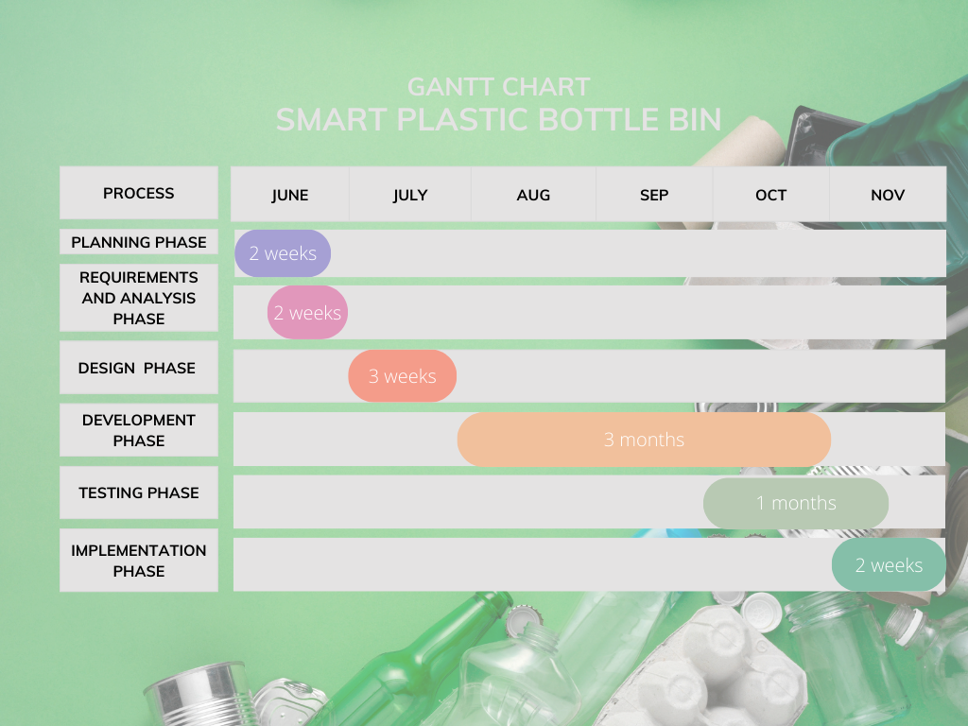

**Figure 2 Gantt Chart of Capstone Main Activities**

**Conceptual Framework**

The researchers will utilize the Input Process Output (IPO Model) of evaluation As explained by MacCuspie, R. I., Hyman, H., Yakymyshyn, C., Srinivasan, S. S., Dhau, J. S., & Drake, C. (2014), the IPO model represents a system in three stages: input, process, and output. Inputs will be modeled as consumables and efforts that are introduced to a system at the beginning stage of the life cycle. Outputs will be modeled as a result produced by the system. The process will be modeled as the conversion of the inputs to the outputs. The IPO model will be relevant to this study because it will provide the general structure of this research.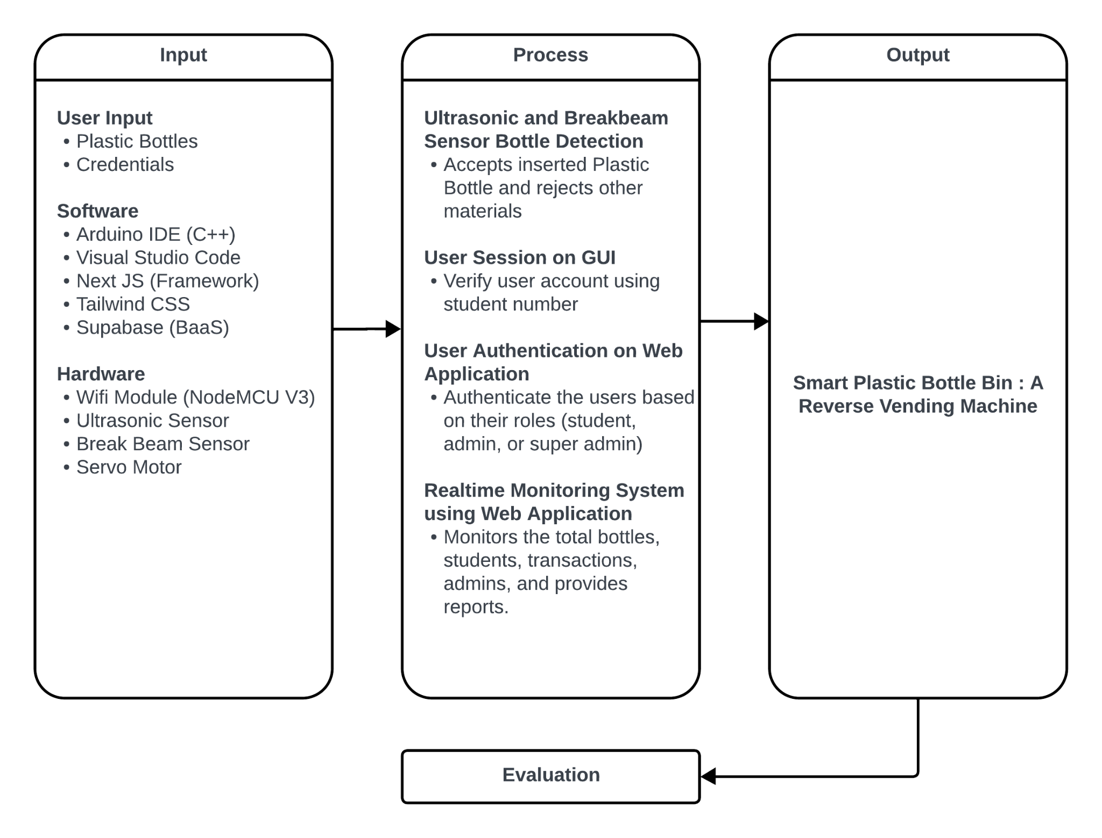

**Figure 3 IPO Model of Smart Plastic Bottle: A Reverse Vending Machine**

As shown in Figure 3, the input within the system will be the plastic bottles and the user credentials inserted by the users. For the software technologies which will be used in the development, the researchers used Arduino IDE to configure the NodeMCU board, ultrasonic sensor, break beam sensor, and servo motor to perform its functions. Visual Studio Code is the IDE used by the researchers to code role-based websites for monitoring the points and transactions of users. Lastly, the researchers used supabase for the crud functions, as well as, database. Meanwhile, the hardware technologies that the researchers will use are, NodeMCU ESP8266 v3 board as the microcontroller as well as wifi module, breadboard for the circuits, Ultrasonic sensor and break beam sensor for detection of the inserted bottles and measuring the capacity of the bin, and, servo motor that serves as a gateway for all the items.

All of the main components are executed using the inputs and technologies utilizing the Agile Methodology with its different phases such as planning, requirements and analysis, design, development, testing, and implementation. The first process is the ultrasonic sensors and break beam sensor will detect the plastic bottle inserts by the users. If the inserted object is a plastic bottle, it will be accepted by the system; otherwise, it will be rejected. The second process is the user session in the GUI where after the user inserts their student number, their session will be created and will stay as long as the user is not finished inserting plastic bottles. The third process is the user authentication on the web application which is role-based and is separated as users, admin, and super admin. Lastly, using the data from the database, the real-time monitoring system detects the capacity of the bin and sends a notification once the capacity of the bin is full, also it shows the number of bottles per day, per week, and per month which is also presented in a form of line graph, and monitors all of the transactions of the users.

When the integration of input and the different processes are finished, the Smart Plastic Bottle Bin will be produced. The Smart Bin will contain the grade based rewarding system, real-time plastic bottle detection, and real-time monitoring system.

**Requirements Analysis and Documentation**

The requirement analysis and documentation will show the system, software, and hardware requirements needed for the completion of the study. It will also show the operational requirements which will be the basis after the implementation.

**System Requirements**

The system requirements show the different software and hardware specification requirements. The components shown in the tables below will be used in the completion of the software and hardware side of the study.

| **Components** | **Description** |
| --- | --- |
| Operating System | Windows 7 - 10 |
| IDE | Arduino IDE (C++) and Visual Studio Code |
| Browser Support | Google Chrome, Mozilla Firefox, Microsoft Edge, Internet Explorer, Brave |
| Frontend | Tailwind CSS, Next JS framework |
| Backend | Supabase |
| Database | Supabase |
| Embedded Software | C++ (ArduinoIDE) |

**Table 1 Software Specification Requirements of Smart Plastic Bottle Bin:**

**A Reverse Vending Machine**

Table 1 presents the software specification requirements for the Smart Plastic Bottle Bin: A Reverse Vending Machine. The system is designed to operate seamlessly on Windows 7 through 10 as its preferred operating system. For software development, the chosen Integrated Development Environments (IDEs) include Arduino IDE (C++) and Visual Studio Code. Users can access the system using various web browsers such as Google Chrome, Mozilla Firefox, Microsoft Edge, Internet Explorer, and Brave.

On the frontend, the system employs Tailwind CSS and the Next JS framework to ensure an intuitive and responsive user interface. The backend is powered by Supabase, providing robust and scalable backend services. The database management is also handled by Supabase, ensuring a seamless integration between the backend and database components. Embedded software development is facilitated through C++ using the Arduino IDE.

| **Components** | **Description** |
| --- | --- |
| Microcontroller | NodeMCU ESP8266 v3 Wifi Module |
| Sensors | Ultrasonic Sensor and Break Beam Sensor |
| Servo Motor | MG90 / SG90 (3.3v) |

**Table 2 Hardware Specification Requirements of Smart Plastic Bottle Bin:   
A Reverse Vending Machine**

Table 2 shows the hardware specification requirements of Smart Plastic Bottle Bin: A Reverse Vending Machine. The hardware side of the study required the microcontroller to be NodeMCU ESP8266 v3 since it helped the researchers to connect the hardware to the internet and send data to the database. Also, it requires the sensors to be an Ultrasonic sensor and break beam sensor for the detection of the plastic bottle inputs and reject other products such as metals, papers, etc. It also requires another ultrasonic sensor to measure the capacity of the bin and send the data to the database for monitoring.

**Functional Requirements**

The Smart Plastic Bottle Bin System introduces an approach to sustainable plastic bottle waste management. This system integrates hardware for efficient plastic bottle collection with a sophisticated web application. The functional requirements outlined below delineate essential features, including user interactions, notification mechanisms, a comprehensive reward system, and a robust web application with distinct modules for students, administrators, and super administrators.

1. **Smart Plastic Bottle Bin Functions:**
   1. **Plastic Bottle Collection:**
      1. The system should be able to collect Plastic Pet Bottles effectively.
   2. **Bin Status Notification:**
      1. Notify the admin/super admin when the trash bin is full through:
         1. Web notifications on the admin/super admin dashboard.
         2. A warning modal on the GUI that stops users from using the machine.
   3. **User Reward System:**
      1. Reward users based on the number of inserted plastic bottles:
      2. Grade-based token system: 1 bottle = 0.05 points.
      3. Twenty bottles complete one point.
      4. Users can earn up to three points per month.
      5. Points should be displayed on the student dashboard.
2. **Web Application Modules:**
   * 1. **Authentication and Access Control:**
        1. Implement user authentication for different access controls.
   1. **Student Dashboard:**
      1. Display Points Allocation History.
      2. Provide Transaction Management:
      3. Allow students to create transactions.
      4. Display transaction history.
      5. Points Management:
      6. Allow students to allocate points through a modal form.
      7. Display point allocation history.
      8. Student Profile:
         1. Allow students to update their information.
   2. **Admin and Super Admin Dashboard:**
      1. Display Monitoring System:
      2. Show the number of bottles accumulated per day, week, and month.
      3. Display the capacity level of the Bin.
      4. Transaction Management:
      5. View transaction history.
      6. Points Management:
      7. View point allocation history.
      8. Student Management:
      9. Insert, view, and update student users.
      10. Subject Management:
      11. Insert, update, and delete subjects.
      12. Reports.
      13. Admin Management:
      14. Add, view, update, and delete admin users.

**Performance Requirements**

In the pursuit of an optimized and responsive user experience, the performance requirements outlined below define the benchmarks for the Smart Plastic Bottle Bin System. These requirements ensure swift response times, scalable user capacity, efficient database throughput, and high availability. By setting these performance expectations, the system aims to deliver seamless operations, timely data processing, and a reliable foundation for sustainable waste management.

1. **Response Time**
   1. The data should be fetched from the database and displayed in the website in under three seconds.
   2. It should only take a maximum of five seconds while the users add, update, or delete data within the system.
2. **Database Limitations**
   1. The system database should be able to handle a maximum of 1,800 token refreshes per hour.
   2. Number of emails that can be sent per hour is 25 emails.
3. **Availability**
   1. The monitoring system should be available all the time, except for scheduled maintenance.
   2. The machine should be available for at least 12 hours per day, except for scheduled maintenance.
   3. Downtime for maintenance should occur during non-peak hours. Except for emergency maintenance.

**Design of Software, Systems, Product, and/or Processes**

Figures 4 - 14 present the diagrams used within the study. These diagrams were developed during the design phase of the software development methodology. The diagrams included and used in this study are context diagram (level 0 data flow diagram), level 1 data flow diagram, enhanced entity-relationship diagram, flowcharts, and schematic diagram of the hardware.

**Figure 4 Context Diagram of Smart Plastic Bottle Bin:** 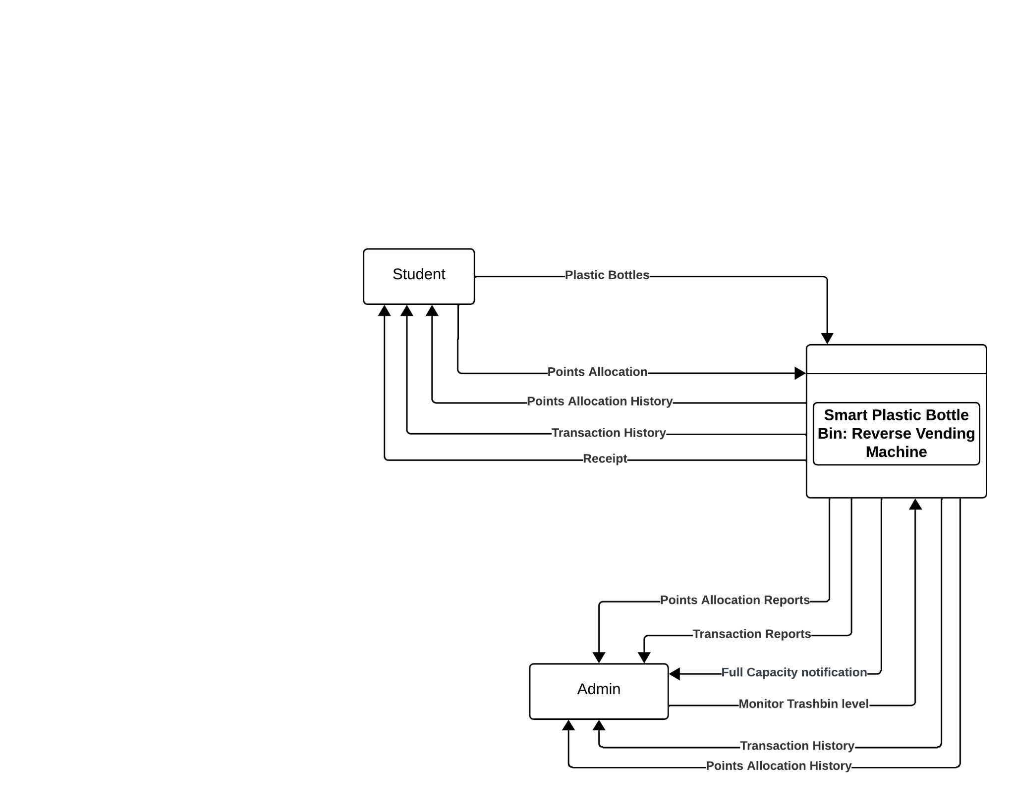

**A Reverse Vending Machine (Level 0)**

Based on Figure 4 the students will start by logging in their account and insert a bottle using the machine. After inserting bottles, the transaction is stored at the transaction history which is available for students to view and download, then the students are able to allocate points using the web application where the data will be inserted and stored to the points allocation history where the students are able to print their receipt. Meanwhile the Admins can monitor trash bin level and receive notification from the web application of the smart bin if it is full . Also, the admins can add, view, update, and delete transactions and points allocation in the Transaction and Points Allocation History. Lastly, the admins are able to download the reports of all the transactions and points allocation using the web application.

**Figure 5 Level 1 Data Flow Diagram of Smart Plastic Bottle Bin:   
A Reverse Vending Machine**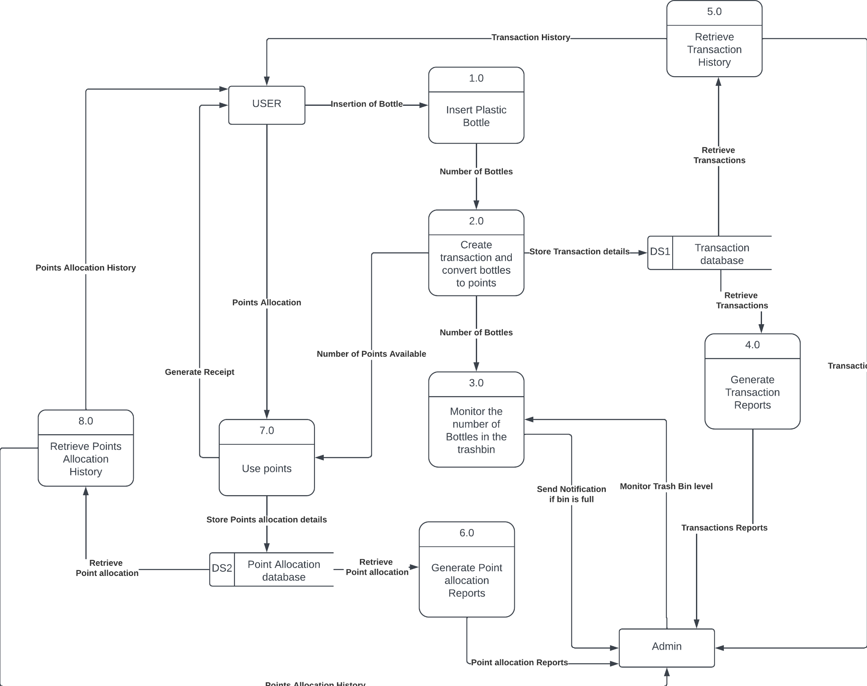

Figure 5 shows a detailed version of the context diagram or the Level 1 Data Flow Diagram. The diagram presents each process that will happen inside the machine and in the monitoring system as well as all the actions that all entities shall do. For the student, the first process is inserting the bottle in which after the action, it will create a transaction and convert the number of bottles into points. The transactions are stored to the transaction database which is reflected in the web application which are retrieved by the users in their accounts and can also be downloaded as reports by the administrator. Once the students have points, the number of points will be reflected in the dashboard and the students are able to use the Use points function. Once the use points have been used, the data will be stored in the points allocation table which is retrieved by the dashboard of the students and can also be downloaded as reports by the administrator.

**Figure 6 Entity Relationship Diagram of Smart Plastic Bottle Bin:   
A Reverse Vending Machine**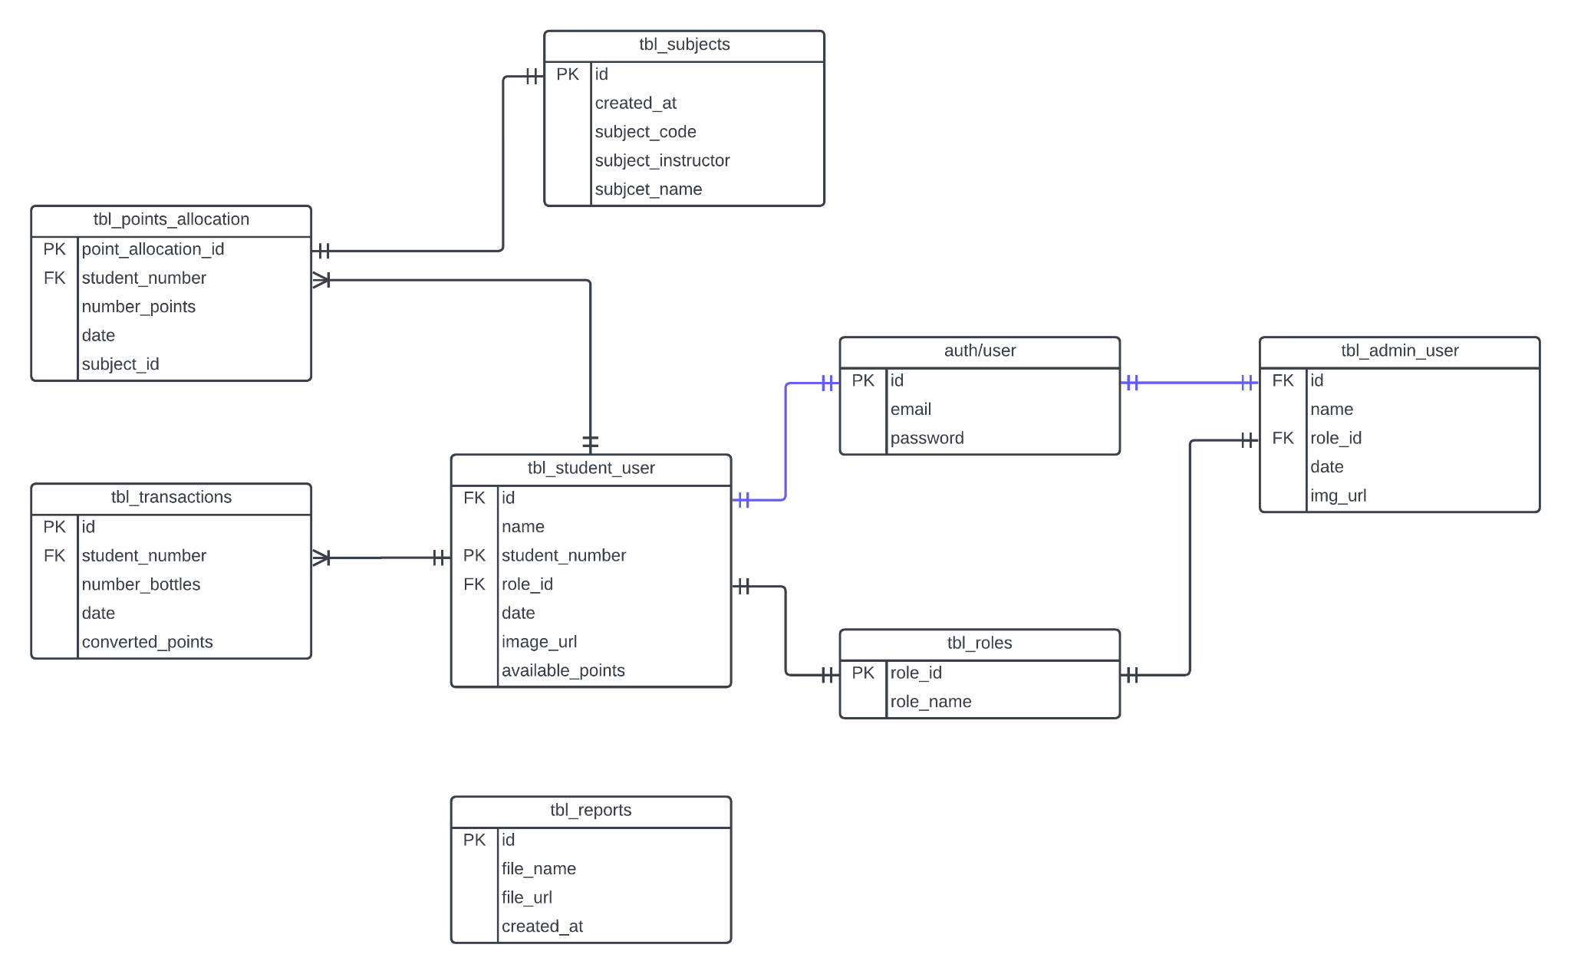

The researchers created an entity relationship diagram (see Figure 6) illustrating the entities and their relationships. The researchers will ensure the data is straightforward, non-redundant, and adaptable to future needs or changes. The Smart Plastic Bottle Bin: A Reverse Vending Machine collects admin information and user information and its authentication, roles, reports, transactions, and points allocation. The auth/user table contains the primary key id and email and password. It is connected to tbl_admin_users which contains id as it foreign key, name, role_id as the other foreign key, date, and img_url. It is also connected to the tbl_student_users which contains id which is the foreign key connected to the primary key of auth/user, primary key named student_number, role_id which is a foreign key, date, image_url, and available_points. The role_id foreign key of tbl_student_users and tbl_admin_users is connected to the primary key role_id of tbl_roles which also contains the role_name. The two tables connected to the foreign key student_number from tbl_student_users are tbl_points_allocation and tbl_transactions. The tbl_points_allocation contains point_allocation_id as its primary key which is the primary key of tbl_subjects, foreign key student_number, number_points, date, and subject_id. The tbl_subjects contains id, created_at, subject_code, subject_instructor, and subject_name. The tbl_transactions on the other hand contains primary key id, foreign key student_number, number_bottles, date, converted_points. Lastly, the tbl_reports which is a standalone table contains id as its primary key, file_name, file_url, and created_at. These tables are the storage of all the data inserted and fetched on the web application and the machine.

**Figure 7 Software System Architecture of Smart Plastic Bottle Bin:   
A Reverse Vending Machine**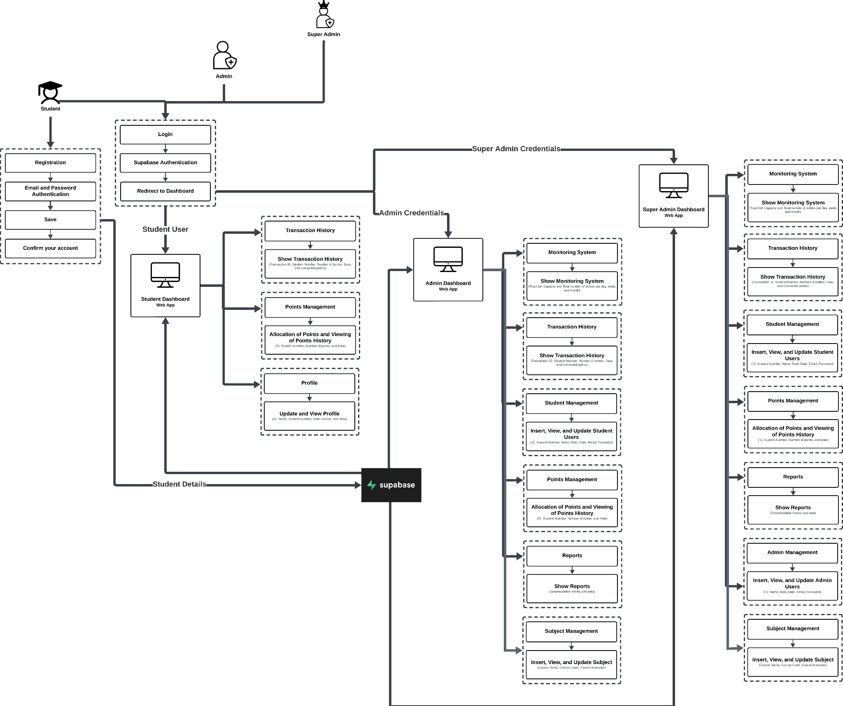

In figure 7, the Software System of Smart Plastic Bottle Bin: A Reverse Vending Machine is presented which shows the conceptual model that defines the structure, behavior, and more views of a system. For the student authentication, there is registration and login before entering the dashboard. The student dashboard contains the Dashboard where the students can check their total points, allocate points and check recent history, then the transaction history where the students can view all of their transactions, points allocation history where the students can view all of the points that they have allocated, and the profile where the students can update their information. For the admin dashboard, it contains the Dashboard which shows the number of bottles per day, week, and month, the recent history, and a graphical representation of the number of bottles. It also has transaction and points allocation history where the admin can view, add, update and delete the transactions. Furthermore, it has student management and subject management where the administrator can view, add, update and delete the current student accounts and subjects participating in the project. It also has reports where the administrator can download reports of all the transactions, and a profile page where the administrator can update their profile. Lastly, for the super admin, it contains every page the administrator has except it has an admin management page where the super admin can view, add, update and delete the current administrator accounts. All of the data fetched and inserted goes to supabase database.

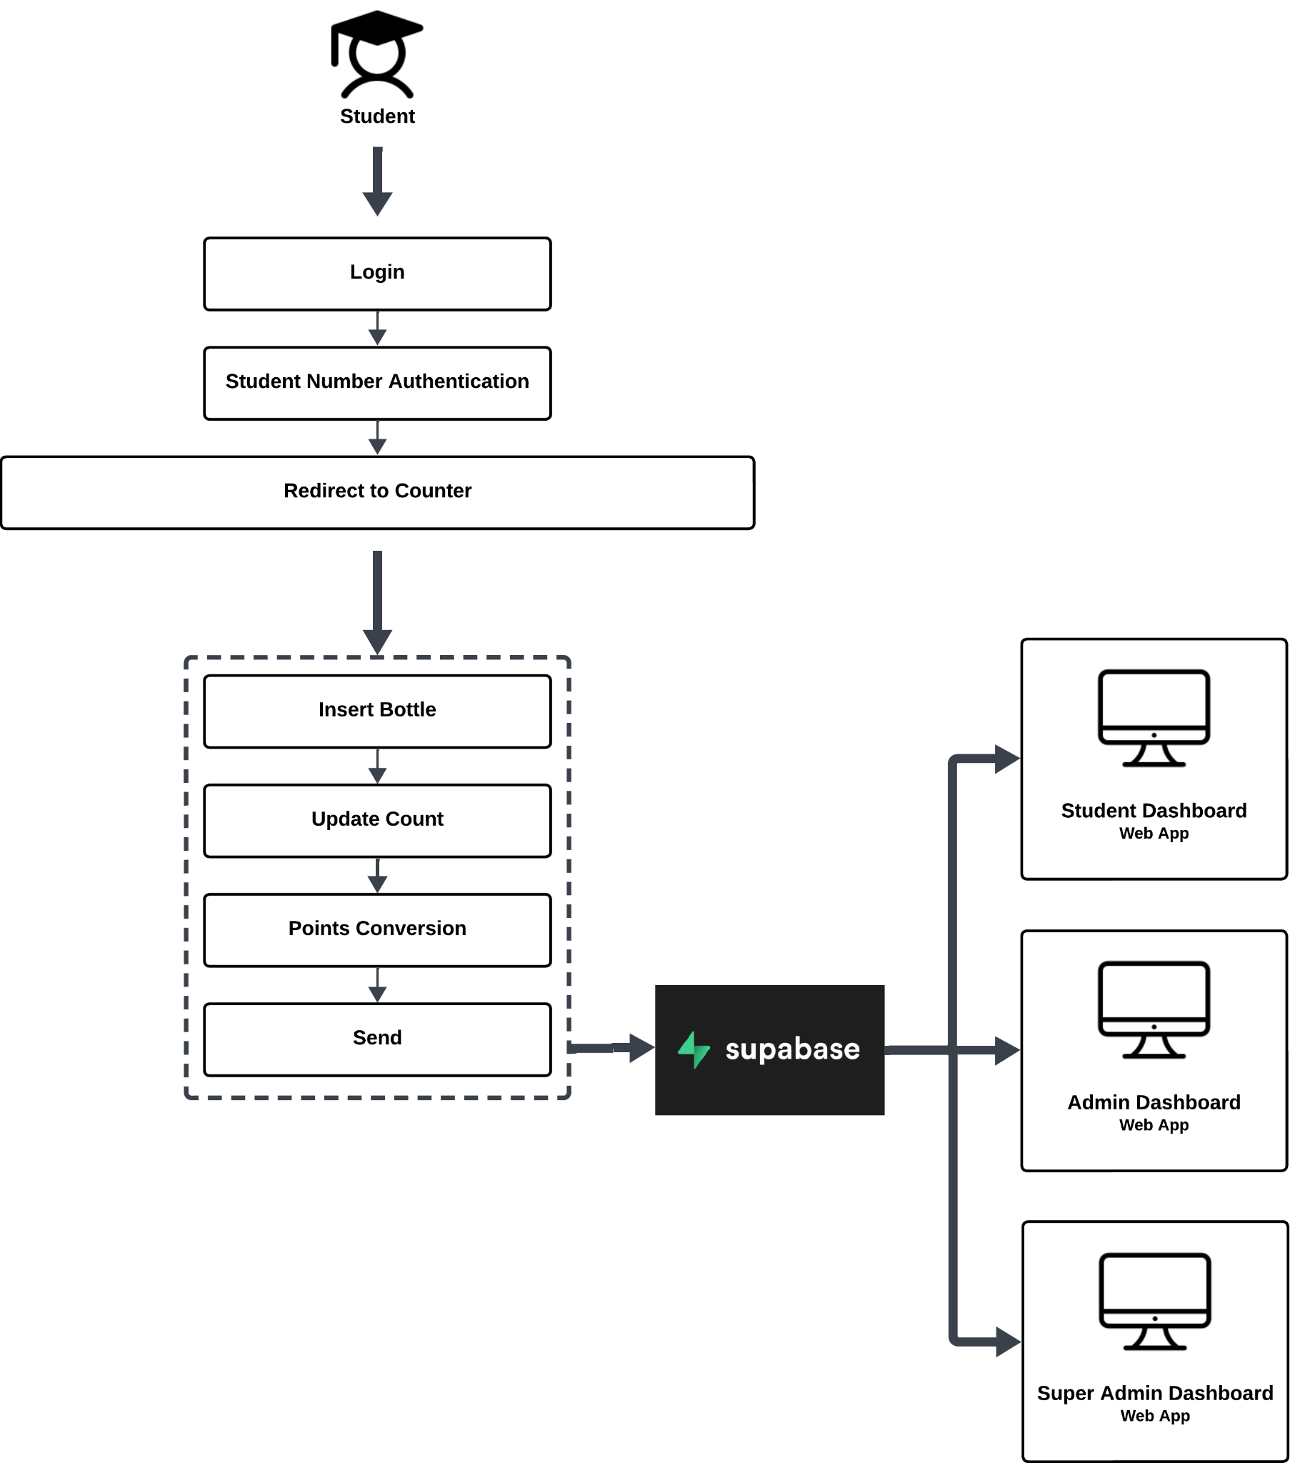

**Figure 8 Hardware System Architecture of Smart Plastic Bottle Bin:**

**A Reverse Vending Machine**

Figure 8 shows the Hardware System Architecture of Smart Plastic Bottle Bin: A Reverse Vending Machine showing the conceptual model that defines the structure and view of the machine. To navigate the machine, the student will start at the authentication using their student number as the key. Once logged in, the plastic bottle counter will appear which directly convert the number of inserted bottles into points. Once done, the number of bottles and the converted points will be sent directly to the student, admin, and super admin dashboard.

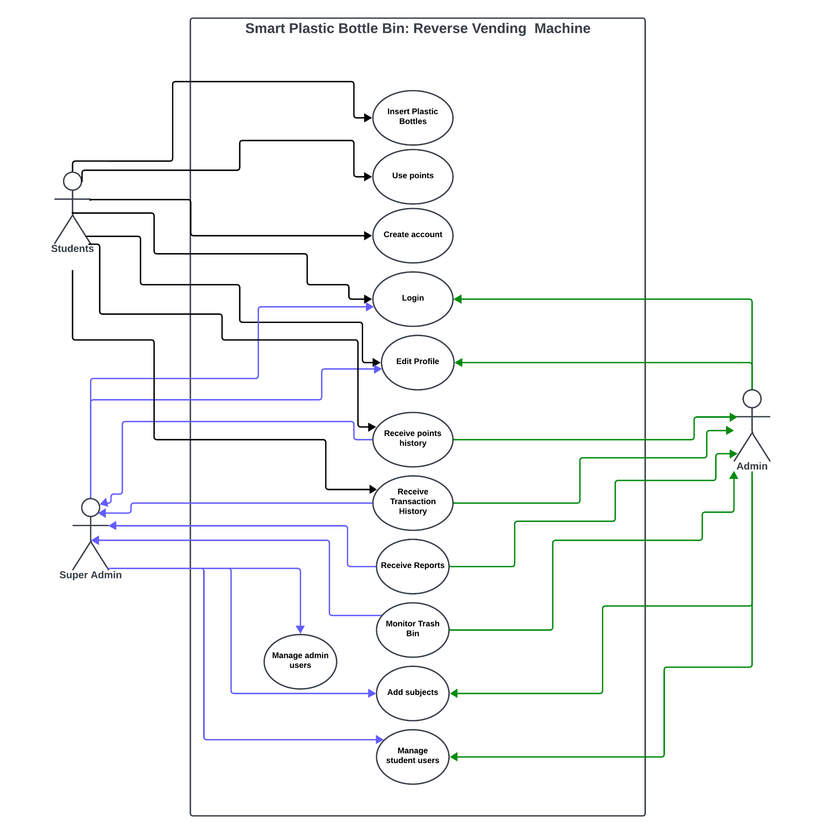

**Figure 9 Use Case Diagram of Smart Plastic Bottle:**

**A Reverse Vending Machine**

Figure 9 shows how the student, admin, and super admin use the Smart Bin. The students are able to insert bottles to the machine which are converted to points that are sent directly to the database and fetched to the dashboard. The students are also able to register to create their own account and login to store all of their points. Once logged in, the students are able to use their points to allocate into subjects that are participating in the project. The allocated points, as well as the transactions made are stored to points allocation and transaction history which can be viewed and downloaded by the students. They are also able to update their profile, specifically, their image, name, email, and password.

For the admin, they are able to login their account and view the monitoring system. In the admin dashboard, all of the data such as number of bottles per day, week, and month can be viewed, as well as the capacity of the bin. The admins are also able to view all of the transactions and points allocation made by the students and they can also add, update, and delete. Furthermore, the admins are able to generate reports for all of the transactions and points allocation. Also, they are able to view, add, update, and delete the registered students as well as the participating subjects. As for the super admin, they are able to use all of the capabilities of admin while also having the ability to view, add, update and delete admin users.

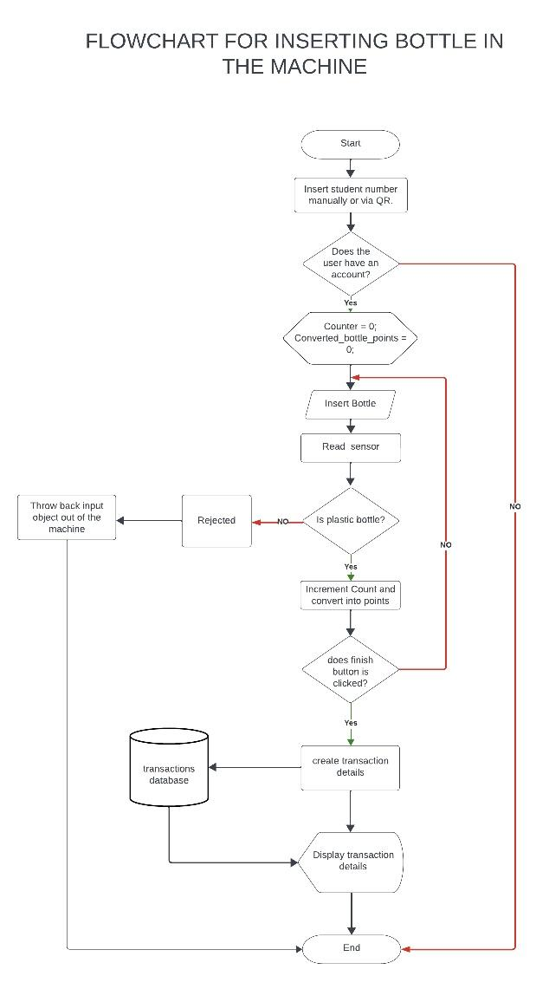

**Figure 10 System Flowchart of Smart Plastic Bottle Bin:**

**A Reverse Vending Machine**

The system flowchart shown in Figure 10 illustrates the entire process of the system from start to finish. The process starts when the user logs in to their account by inserting their student number, which the system will verify whether the user has an account. If it is not, it will not proceed. The system will only allow them to insert plastic bottles if they have an account. When the user inserts a plastic bottle, the sensor will verify whether it is a plastic bottle. If it is not, the machine will eject the bottle. If it is a plastic bottle, it will count the inserted bottle and convert it into points. After the finish button is pressed, the system will create transaction details and store them in the transaction database; then, the monitor will display the transaction details, and the process will end.

**Figure 11 System Flowchart of Monitoring System for Smart Plastic Bottle Bin:** 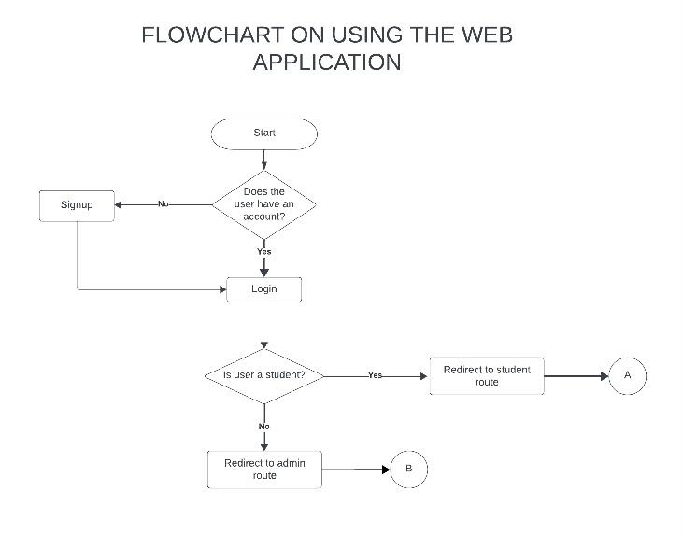

**A Reverse Vending Machine**

The system flowchart shown in Figure 11 illustrates the entire process of the web system from start to finish. The process starts by verifying if the user has an account or not. If not, they will require them to sign up. If they have an account, they have to log in to their account. If the user is a student, it will redirect them to the student route; If not, it will redirect to the admin route.

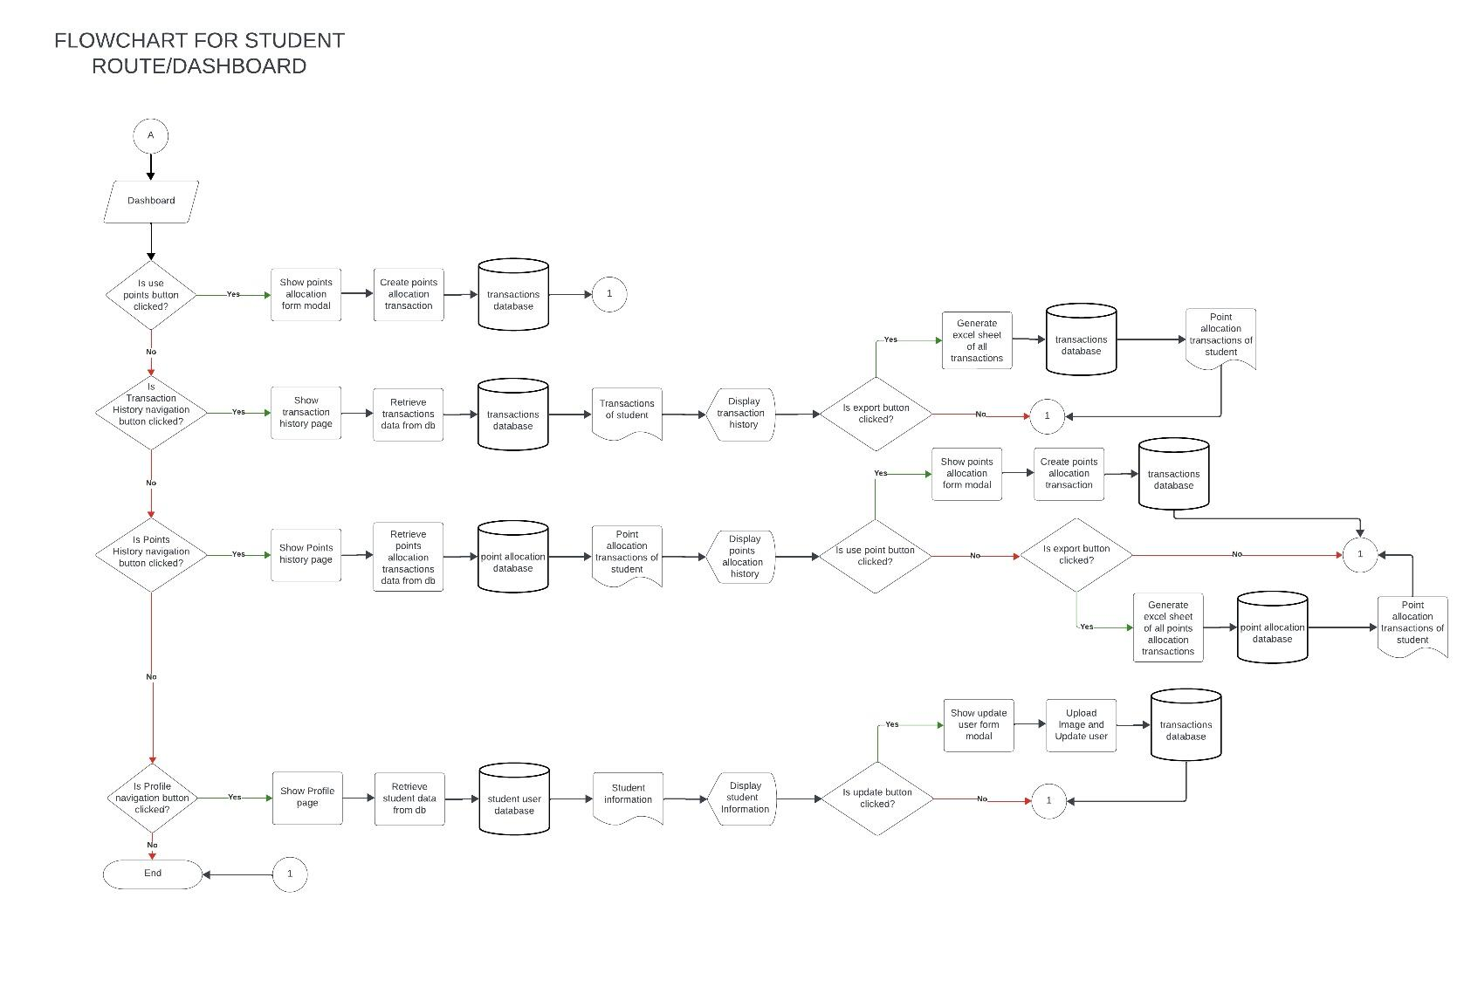

**Figure 12 System Flowchart of Student Dashboard Monitoring System for Smart Plastic Bottle Bin: A Reverse Vending Machine**

The system flowchart shown in figure 12 illustrates the entire process of the web system from start to finish for student users. The process starts when the student is redirected to the dashboard after logging in and checking if the use points button is clicked. If the use points button is clicked, show points allocation modal which creates points allocation transaction which is inserted to the transaction table. If the use points button is not clicked, another decision will be triggered, is the transaction navigation history button clicked. If yes, show the transaction history page where the data is retrieved from the database. If the export button is clicked, generate an excel sheet with the data of transactions from the database, if not, redirect to the end. If no, check if points history navigation clicked, if yes show the points allocation history page where the data is retrieved from the database. If use points button clicked, how points allocation modal which creates points allocation transaction which is inserted to the transaction table if not clicked, check if export button is clicked .If the export button is clicked, generate an excel sheet with the data of points allocation from the database, if not, redirect to the end. If point history navigation is not clicked, check if profile navigation is clicked, if yes, show profile page then show student data that is fetched from the database, then check if the update profile is clicked, if yes, show update user profile modal then update image and user information, if no, redirect to end. If profile navigation is not clicked, redirect to the end.

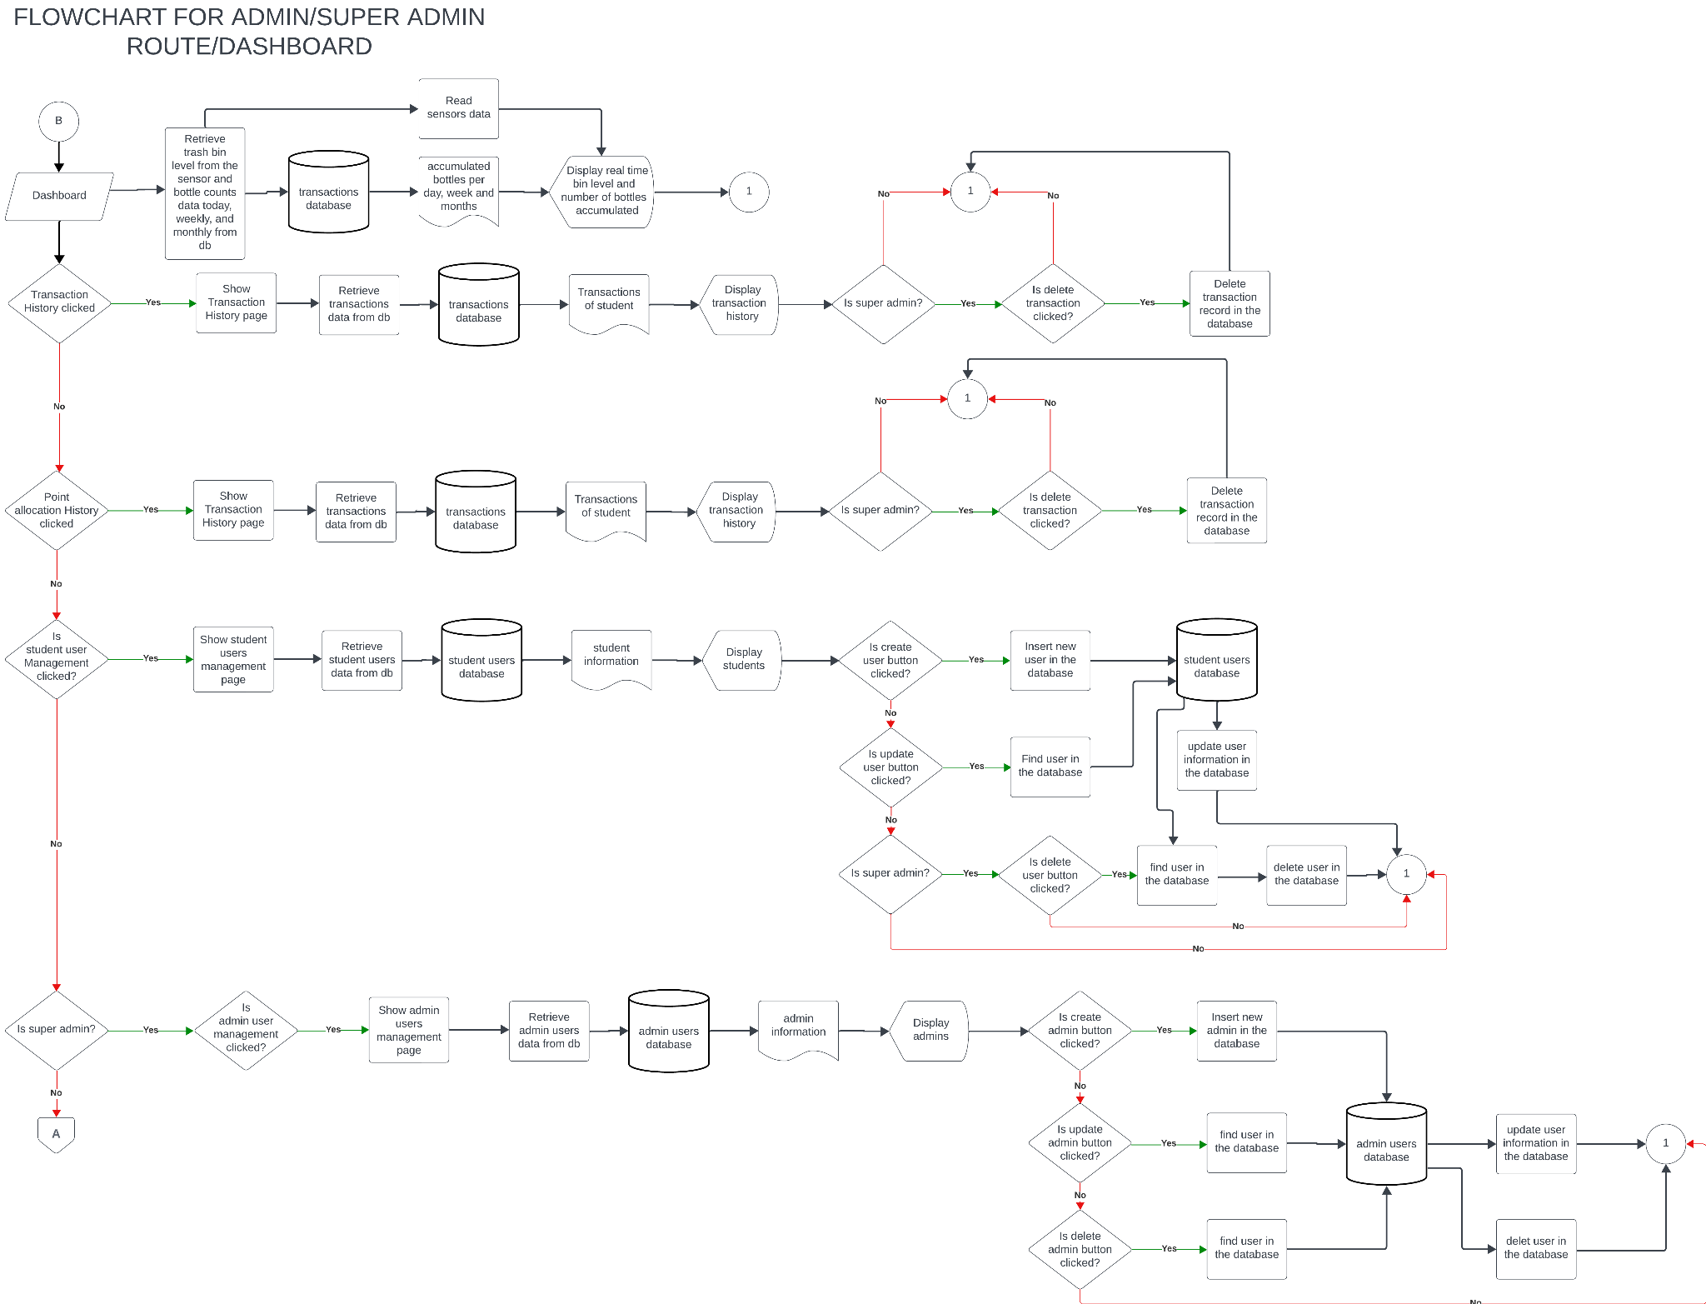

**Figure 13 System Flowchart of Monitoring System for Smart Plastic Bottle Bin:   
A Reverse Vending Machine**

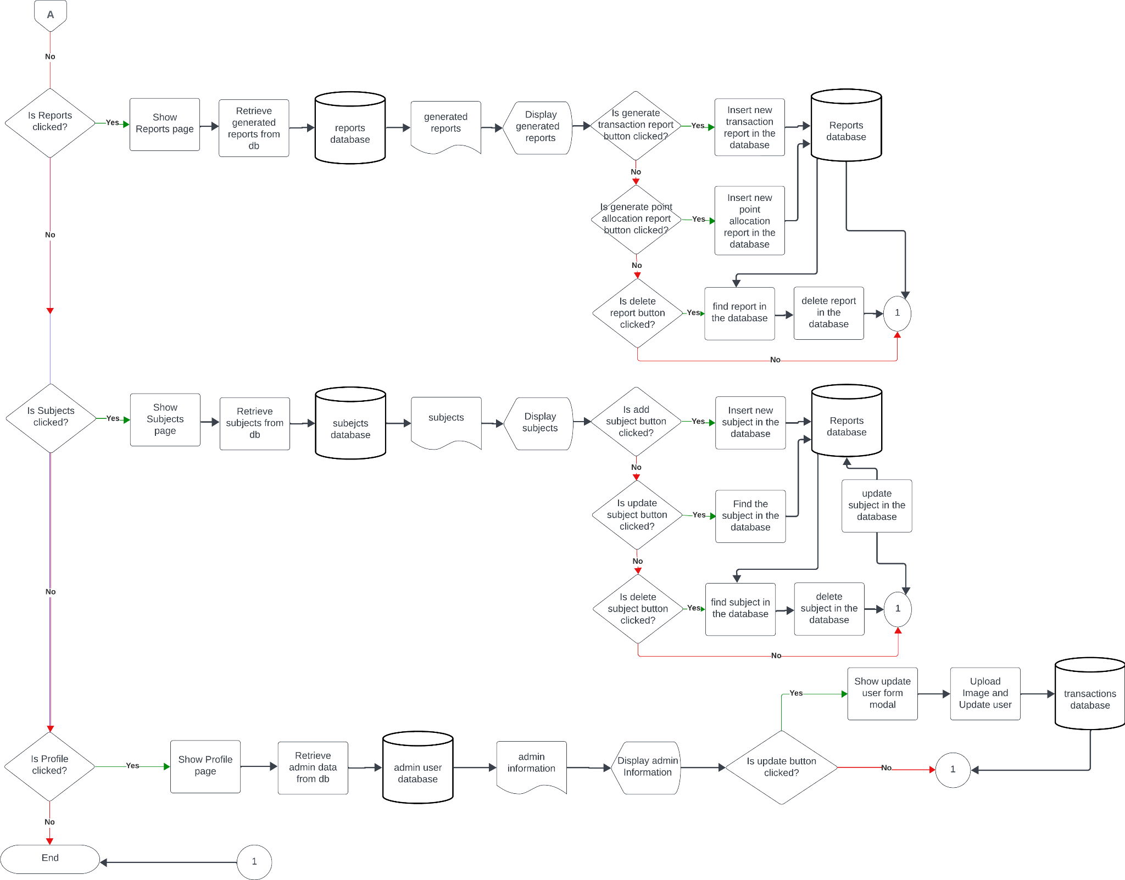

**Figure 14 System Flowchart of Monitoring System for Smart Plastic Bottle Bin:   
A Reverse Vending Machine**

The system flowchart shown in figure 13 and 14 illustrates the entire process of the web system from start to finish for admin and super admin users. The process starts when the admin/super admin is redirected to the dashboard after logging in. While in the dashboard, it will retrieve all of the data from the database such as transactions, accumulated bottles per day, week, and month, and using the sensors from the machine, update the capacity before retrieving the capacity level. Then, check if the transaction history is clicked, if yes, show all of the transactions of the users from the database and if it is a super admin and the delete transaction button is clicked, delete transaction. If transaction history is not clicked, redirects point allocation history. If points allocation history is clicked, show all of the points allocation transactions of the users from the database and if it is a super admin and the delete points allocation transaction button is clicked, delete transaction. If points allocation history is not clicked, redirect to student users management. If student users management is clicked, show all of the student users from the database. While in student user management, if the user button is clicked, add user to the database, if update user button is clicked, find the user data and update, if the delete user button is clicked, delete user from the database. If student user management is not clicked, check if the user is super admin, if yes, redirect to admin management. If admin management is displayed, retrieve all of the admin users from the database. While in admin user management, if the user button is clicked, add user to the database, if update user button is clicked, find the user data and update, if the delete user button is clicked, delete user from the database. If admin management is not displayed, redirect to reports. If reports are clicked, retrieve reports from the database. While in reports, if the generate transaction report is clicked, download all transactions from the database, if the generate points allocation report is clicked, download all points allocation transactions from the database, if the delete report button is clicked, delete the selected report. If the report button is not clicked, redirect to the profile button. If the profile button is clicked, retrieve all of the data of the admin/super admin user. While in profile, if the user clicks the update profile button, update the displayed data as well as the admin users database. If the profile button is not clicked, end the session.

**Figure 15 Schematic Diagram of Smart Plastic Bottle Bin:** 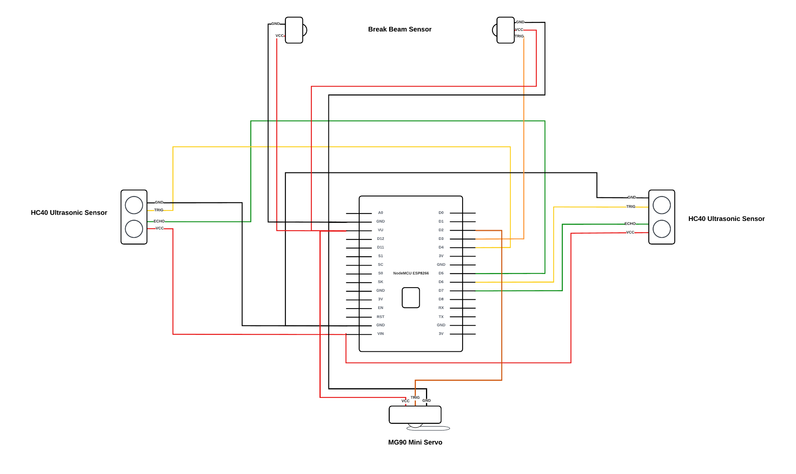

**A Reverse Vending Machine**

The schematic diagram shown in Figure 12 shows all of the connections of all the hardwares found in the machine. For the microcontroller, the researchers used a NodeMCU ESP8266 v3 wifi module and used it to connect the hardware to the WiFi and send data to the database. Then, for the validation, the researchers used a Break beam sensor and an ultrasonic sensor. The break beam sensor has a transmitter and receiver, its VCC pin or the positive charge is connected to VU which transfers 3.3v of power to the sensor, then the GND is connected to GND pin, and lastly, the transmitter pin is connected to D3 pin. As for the ultrasonic sensor, it has VCC pin which is also connected to the VIN pin, GND pin which is connected to GND pin, then a TRIG pin which is connected to D6 pin, and lastly, an ECHO pin which is connected to D7 pin. After validating, the servo motor will rotate and as for its connection, the servo motor has a VCC pin which is connected to VU, a GND pin which is connected to the GND pin, and a TRIG pin which is connected to the D2 pin. Lastly, to detect the capacity of the bin, the researchers used another ultrasonic sensor which has it VCC pin which is connected to VIN pin, GND pin which is connected to GND pin, TRIG pin, which is connected to D4, and an ECHO pin which is connected to D5 pin. These hardware components are the one that the researchers used to detect plastic bottles and send data to the database.

**Testing**

To obtain the desired data, the researchers of this study will use survey questionnaires as the major instrument, which will utilize researcher-made questionnaires. The respondents of the study are located at Bulacan State University Hagonoy Campus. The researcher will adopt the ISO (International Organization for Standardization) questionnaire specifically ISO/IEC 25010 to determine the level of acceptance by the respondents on the development of a Smart Plastic Bottle Bin: A Reverse Vending Machine. The criteria of acceptance will be limited to functionality, reliability, usability, maintainability, portability, workability, safety, and training and documentation. The results provided by the respondents will be organized and counted by the researchers based on the frequency of their answers. Lastly, different statistical methods will be employed by the researchers to interpret the data once it has been tabulated and tallied.

To be able to identify the respondents of the study, the researchers will use random sampling techniques. According to Cherry K. (2021), a random [sample](https://www.verywellmind.com/what-is-a-sample-2795877) is a subset of individuals [randomly selected](https://www.verywellmind.com/what-is-random-selection-2795797) by researchers to represent an entire group as a whole. It focuses on the “randomness” of the respondents which will give the researchers a diverse set of information which will be used to meet the study’s goal.

The population of the respondents will consist of the admin, students from different departments, IT Software Experts from the industry, and Hardware experts from the industry.

| **Respondents** | **Frequency (N)** | **Percentage (%)** |
| --- | --- | --- |
| BulSU Hagonoy Campus Admin | 4 | 8.51 % |
| BulSU Hagonoy Campus Students | 40 | 85.11 % |
| IT Software Expert | 1 | 2.13 % |
| Hardware Experts | 2 | 4.25 % |
| **Total** | **47** | **100 %** |

**Table 3**

**Respondents of the Smart Plastic Bottle Bin: A Reverse Vending Machine**

Table 3 shows the respondents and their corresponding frequency for the study. The developed prototype will be tested by forty-seven (47) respondents which includes four (4) BulSU Hagonoy Campus Admins, forty (40) BulSU Hagonoy Campus Students, one (1) IT Software Experts, and two (2) Hardware Experts.

The researcher will use random sampling techniques to randomly select respondents that will give a diverse set of information which will be used to meet the study’s goal.

The forty (40) students from different departments will be selected and consulted on their feedback regarding their experiences while using the prototype. Meanwhile the four (4) admins will be providing their feedback on the reliability and correctness of the monitoring system of the prototype.

The one (1) BSIT Faculty in any department will be consulted on their assessment regarding the process of the hardware and software components of the prototype.

The one (1) IT Software expert with a Software Engineering background will be consulted on the efficiency, correctness, and workability of the software components of the prototype, mainly the monitoring system. Conversely, the two (2) Hardware experts with knowledge and skills on IoT and embedded systems will provide us their thoughts on the hardware components of the prototype.

To determine the level of acceptance of the Smart Plastic Bottle Bin: A Reverse Vending Machine that will be developed for the BulSU Hagonoy Campus, the researchers will be using a survey questionnaire to gather the evaluation of the Campus Admin, Students, and the Software and hardware experts from the industry.

The questionnaire type that will be used is the Likert scale because it facilitates easy survey response from participants. Additionally, it enables researchers to effectively employ quantitative approaches, using statistical methods for data interpretation. The Likert five-point scale as shown below is composed of ranges and descriptive ratings of 4.50 – 5.00 for Excellent, 3.50 – 4.49 for Very Good, 2.50 – 3.49 for Good, 1.50 – 2.49 for Fair, and 1.00 – 1.49 Poor. The respondents will need to test or use the Machine to be able to answer the questions or statements based on their own opinions after using the Machine.

| **Range** | **Descriptive Rating** |
| --- | --- |
| 4.50 - 5.00 | Excellent |
| 3.50 - 4.49 | Very Good |
| 2.50 - 3.49 | Good |
| 1.50 - 2.49 | Fair |
| 1.00 - 1.49 | Poor |

**Table 4**

**Frequency and Percentage**

The frequency and percentage were used to categorize the respondents. The researchers used the formulas below to determine the proportion of residents who answered in a certain way in the questionnaire.

Formula:

P = $\frac{F}{N}$ $× 100$

Where:

P = Percentage

F = Frequency

N = No of Respondents

**Weighted Mean**

The process of findings which is referred to as the central tendency was used in the formula.

M = $\frac{5\left(r\right)+4\left(r\right)+3\left(r\right)+2\left(r\right)+1(r)}{R}$

Where:

M – Mean

$r$– Number of all respondents

R – Total Number of respondents

**Description of the Prototype**

The Smart Plastic Bottle Bin: A Reverse Vending Machine will be an integration of software and hardware components specifically, web development technologies and Arduino. The following figures represent the current design of the web-based monitoring system and the prototype of the Smart Plastic Bottle Bin.

**TABLET (GUI)**

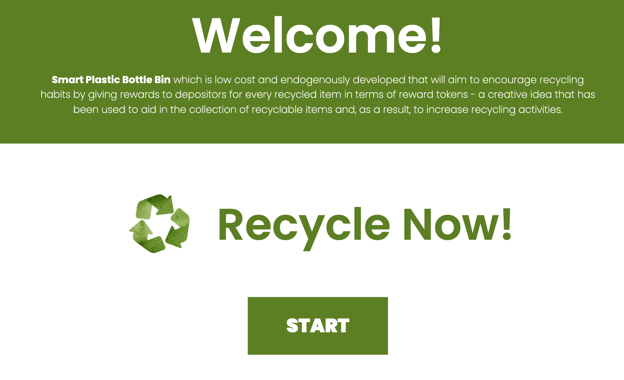

**Figure 16 Smart Plastic Bottle Bin: A Reverse Vending Machine**

In Figure 16, this GUI is the interface that a user sees when they first use the system. The user must click the "START" button to sign in and proceed to the next page.

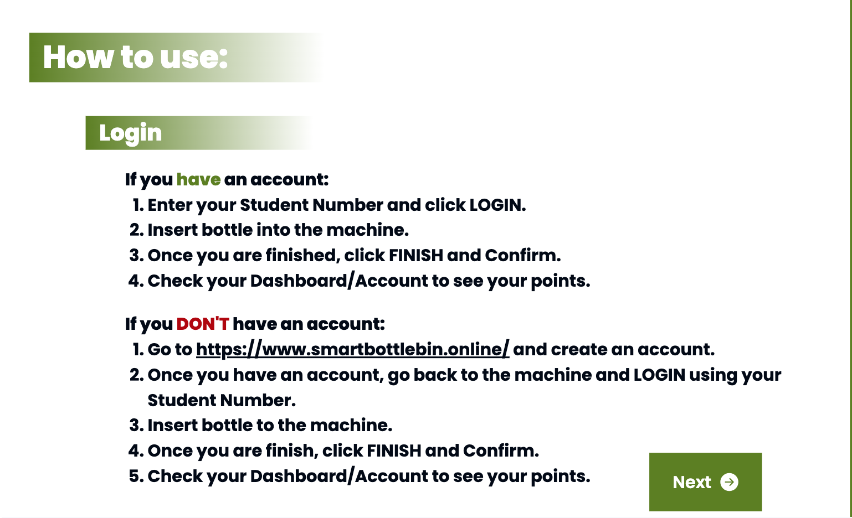

**Figure 17 Smart Plastic Bottle Bin: A Reverse Vending Machine**

In figure 17 shows a manual on how to use the machine and what the requirements are to move on, the user must click the “next” button.

**Figure 18 Smart Plastic Bottle Bin: A Reverse Vending Machine**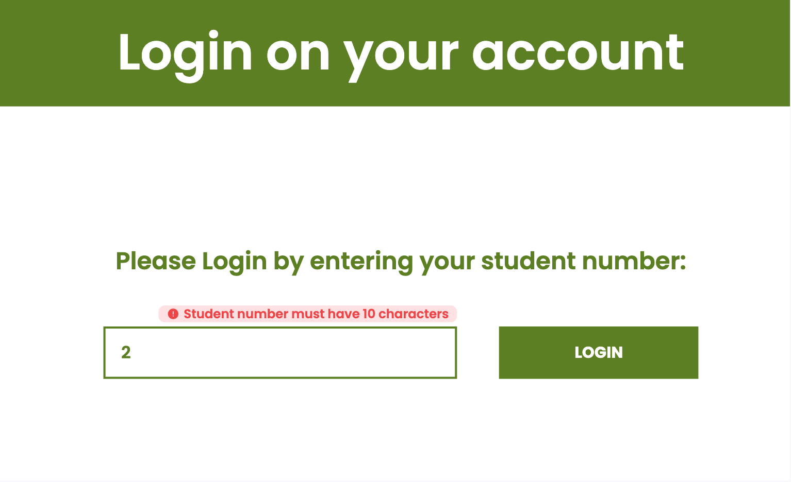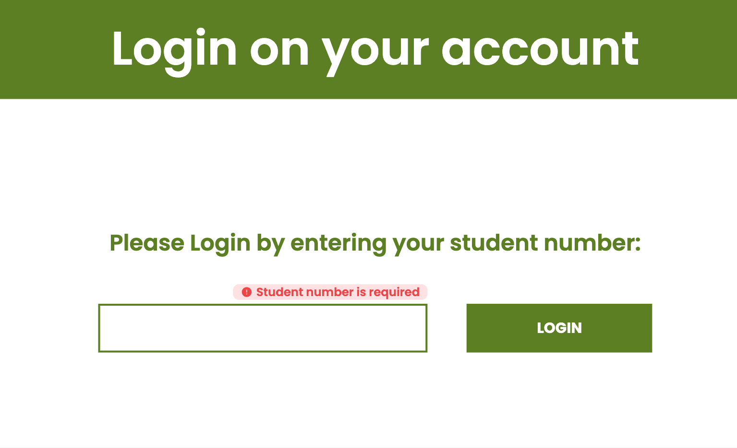

In figure 18, Users must have an account to participate and receive points. To proceed and move on to the next page, the user must login his registered student number. Users must enter complete designated student information. The ‘warning message’ indicates that the user provided an incomplete student number.

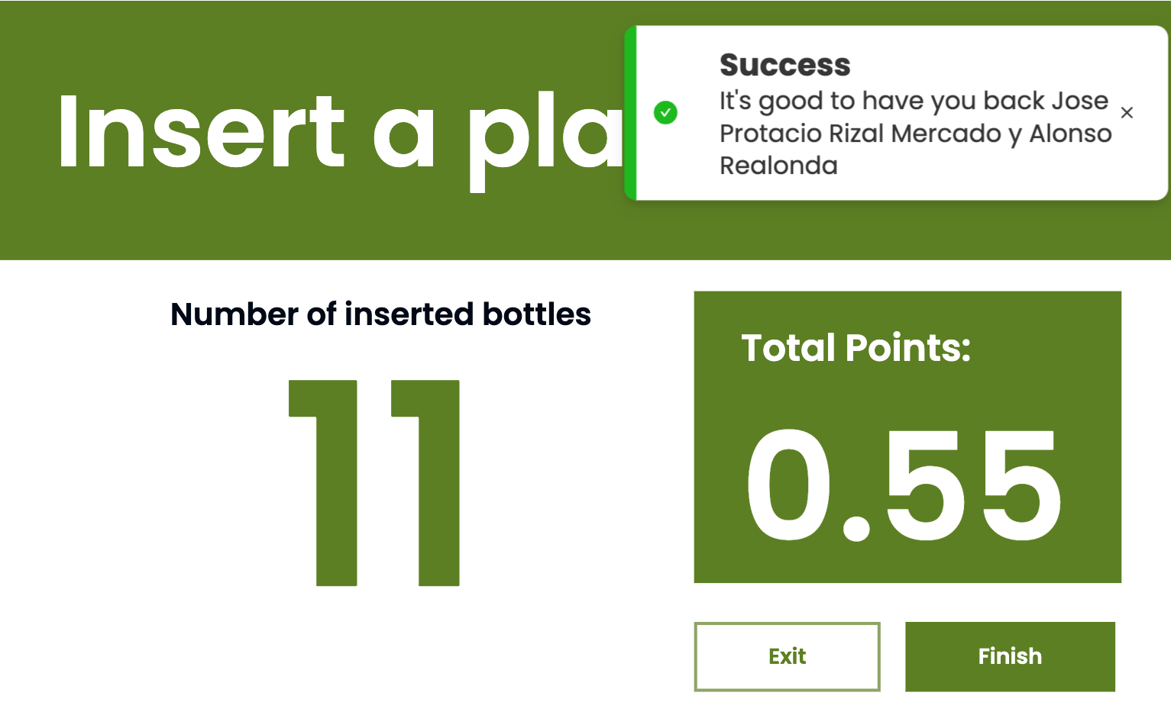

**Figure 19 Welcome Notification of Inserted Bottles Page for User GUI of Smart Plastic Bottle Bin: A Reverse Vending Machine**

In Figure 19, The "success toast notification" is represented which typically refers to a small pop-up or message on a device's screen that alerts the user about the successful completion of an action or task. It's a way for the system or machine to communicate positive feedback to the user.

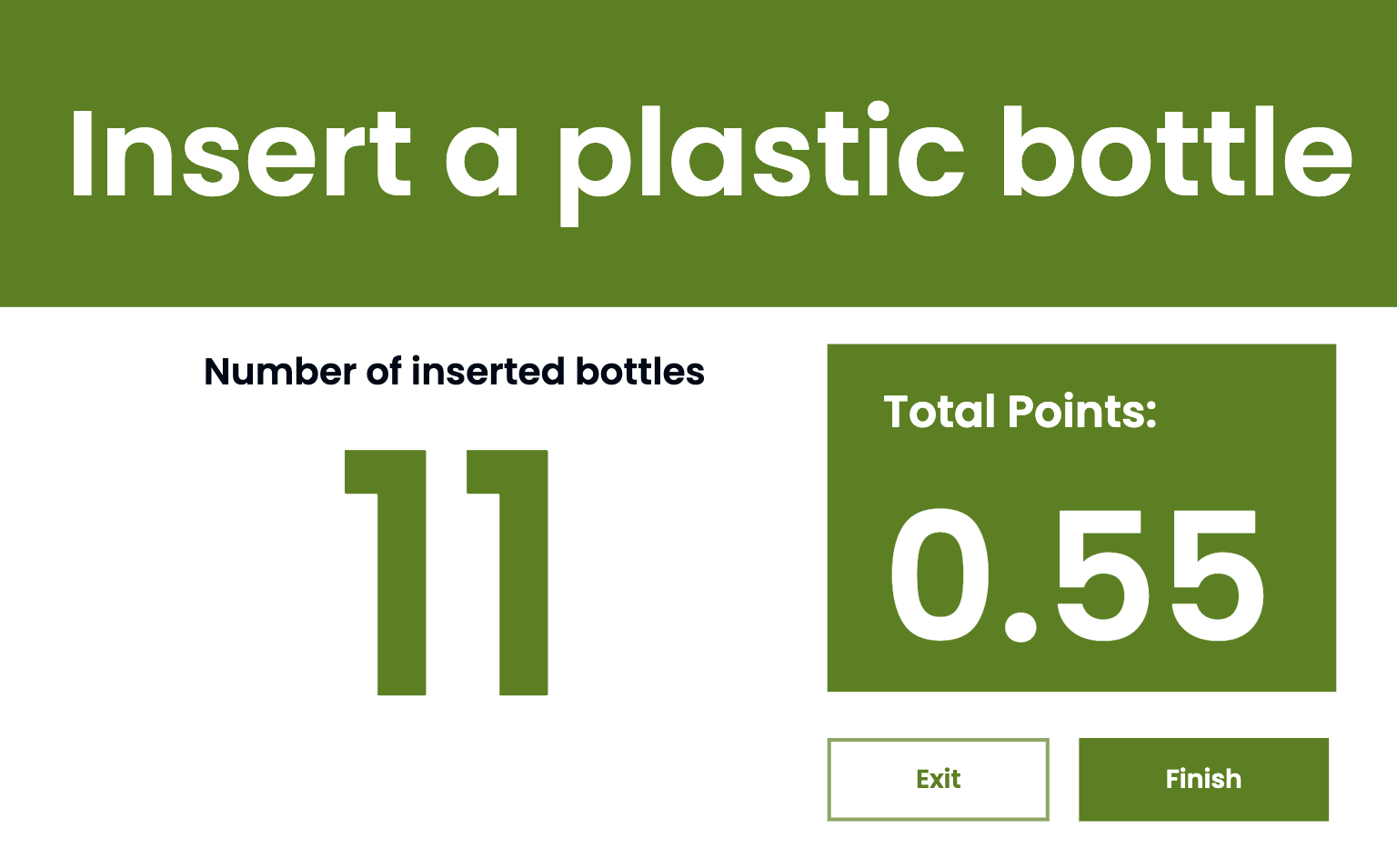

**Figure 20 Insert Bottles Page for User GUI of Smart Plastic Bottle Bin:**

**A Reverse Vending Machine**

In Figure 20, After logging in with their student number, users can proceed to insert bottles into the machine. Each plastic bottle earns 0.05 points. In the image, 11 inserted bottles are depicted, totaling 0.55 points. Additionally, there's a monthly limit of 60 bottles per user, amounting to a total of 3 points.

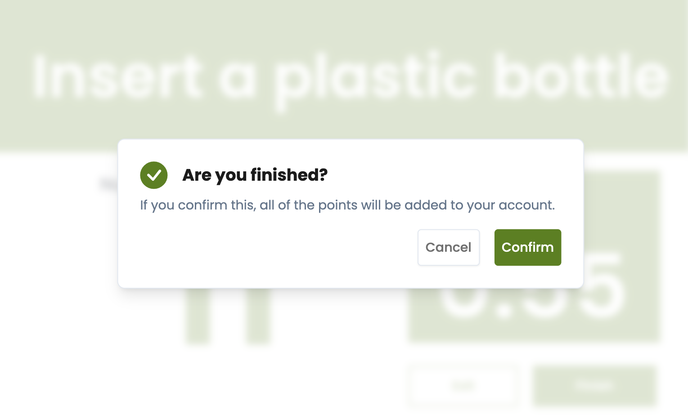

**Figure 21 Confirmation Modal of Inserted Bottles Page for User GUI of Smart Plastic Bottle Bin: A Reverse Vending Machine**

In Figure 21, After completing the bottle insertion process, users can click the 'Finish' button. This action triggers a modal confirmation, ensuring that the user acknowledges the completion. Upon confirmation, all earned points will be seamlessly added to the user's account.

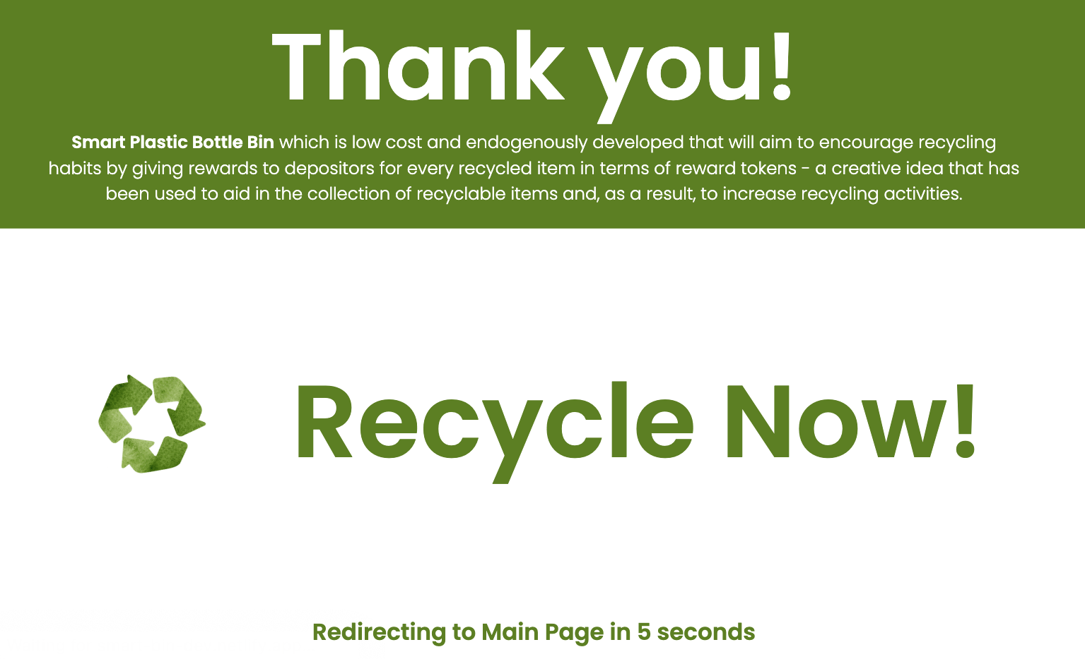

**Figure 22 End Page for User GUI of Smart Plastic Bottle Bin:**

**A Reverse Vending Machine**

In Figure 22, The recycling logo features a loading animation, signaling that the screen will automatically redirect to the main page in 5 seconds.

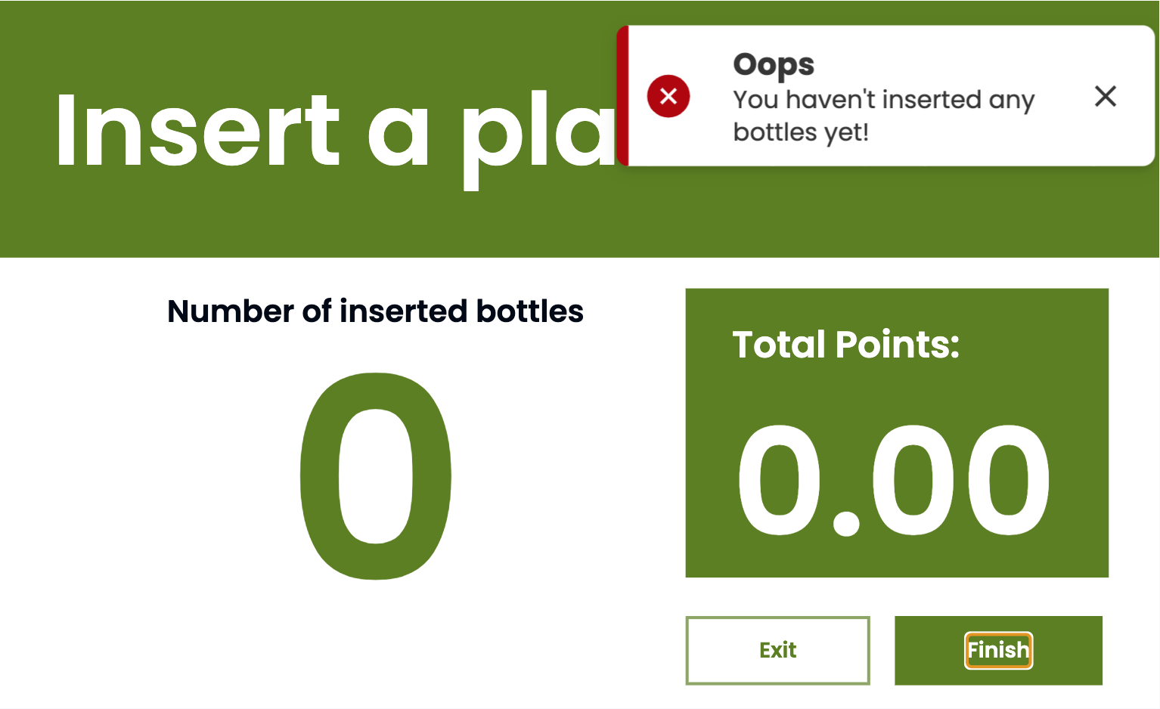

**Figure 23 Error Notification of Insert Bottles Page for User GUI of Smart Plastic Bottle Bin: A Reverse Vending Machine**

In Figure 23, The appearance of the 'oops toast notification' indicates that the finish button cannot be clicked until at least one bottle has been inserted by the user.

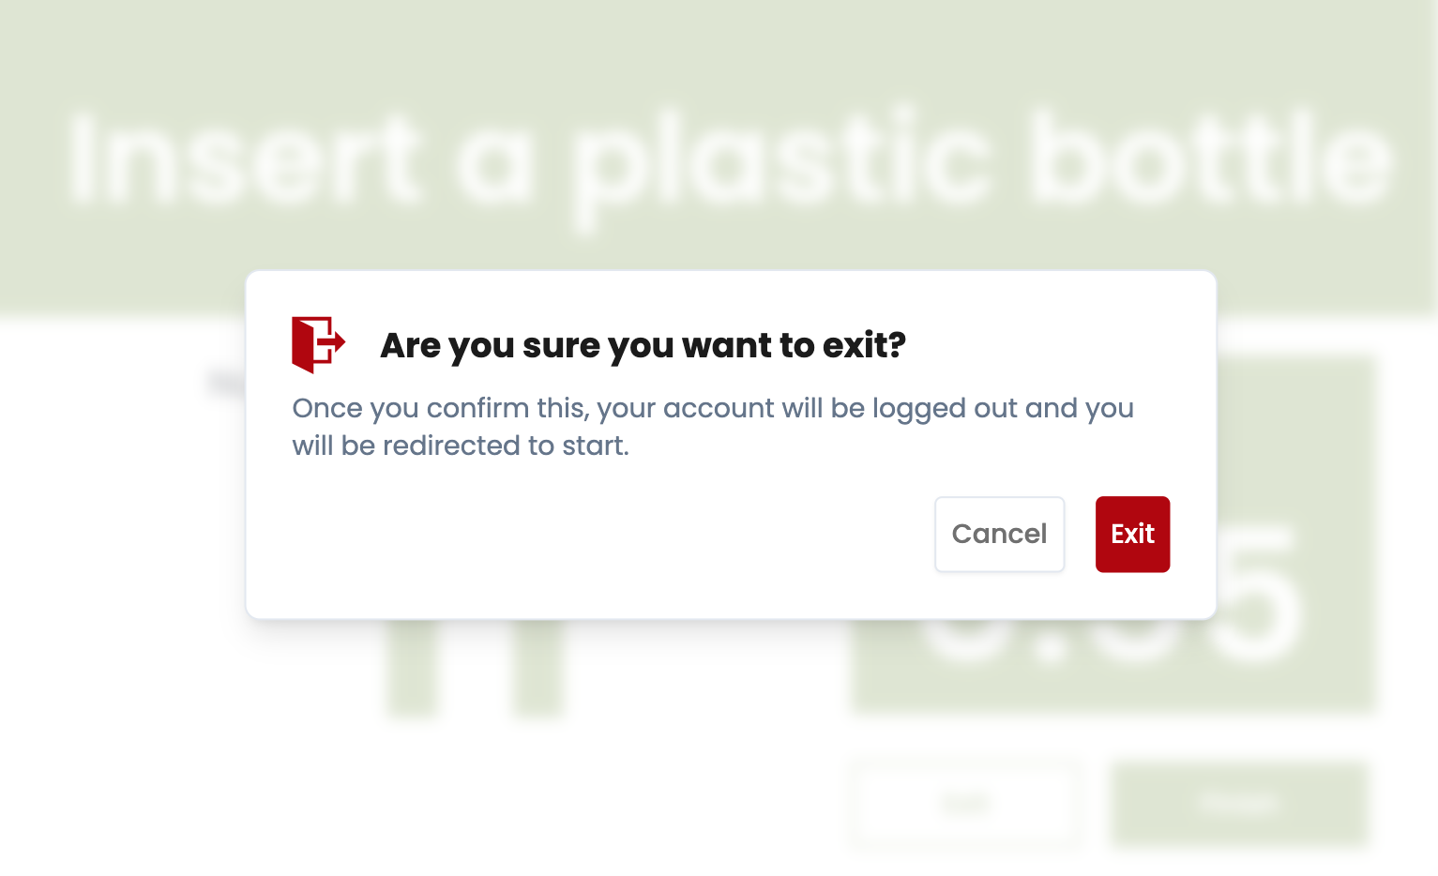

**Figure 24 Exit Modal of Insert Bottles Page for User GUI of Smart Plastic Bottle Bin: A Reverse Vending Machine**

In Figure 24, Hence, if the user chooses not to insert any bottles, they can click the 'Exit' button, prompting a modal confirmation for logging out and redirection to the start page.

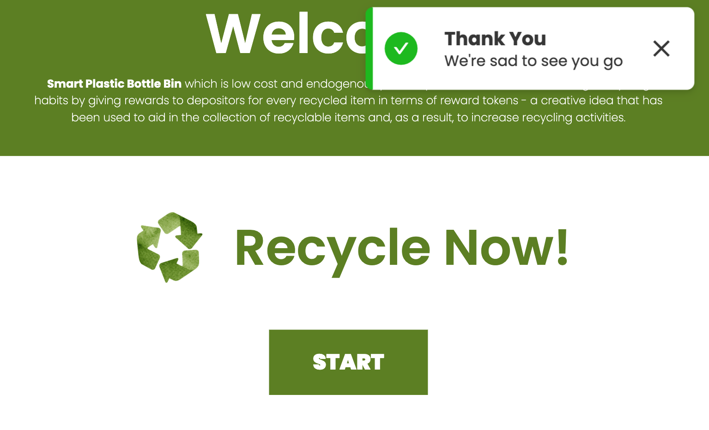

**Figure 25 Start Page With Appreciation Notification for User GUI of Smart Plastic Bottle Bin: A Reverse Vending Machine**

In Figure 25, When redirected to the start page, a toast notification will express gratitude to you, accompanied by a heartfelt message. This gesture serves as a means for the system or machine to convey appreciation and warmth to the user.

**WEB, MOBILE, TABLET (STUDENT)**

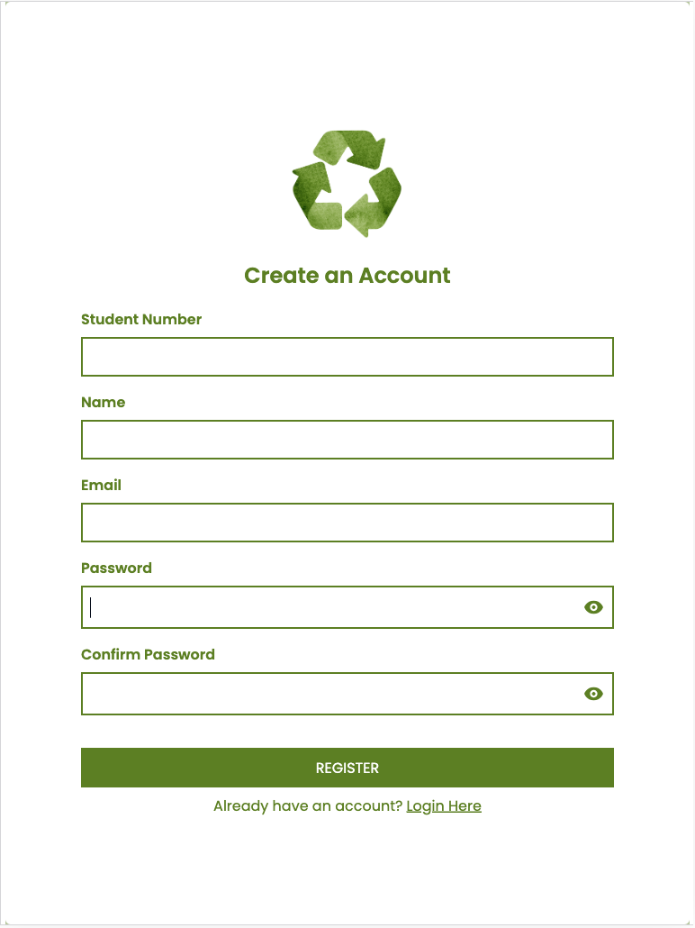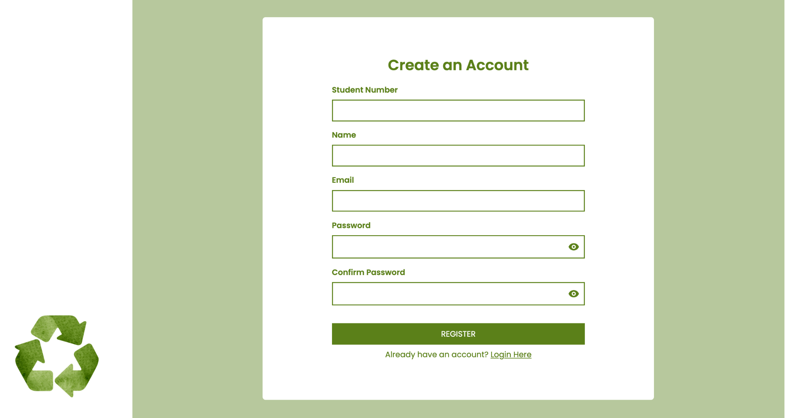

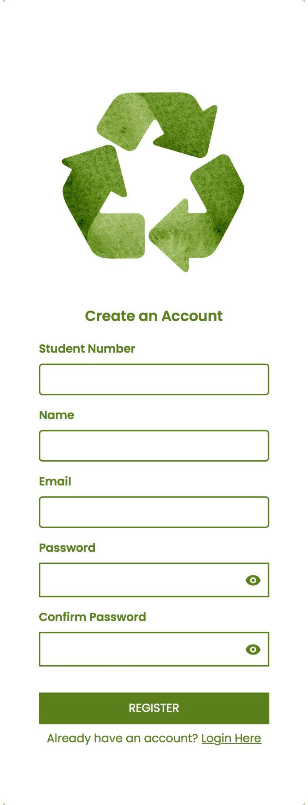

**Figure 26 Create an Account Page for User GUI of Smart Plastic Bottle Bin:**

**A Reverse Vending Machine**

In Figure 26, To use the reverse vending machine, an account is essential. Without one, inserting bottles isn't possible. Registering as a student is the first step, and it's advisable to use an active email for the system's email verification process.

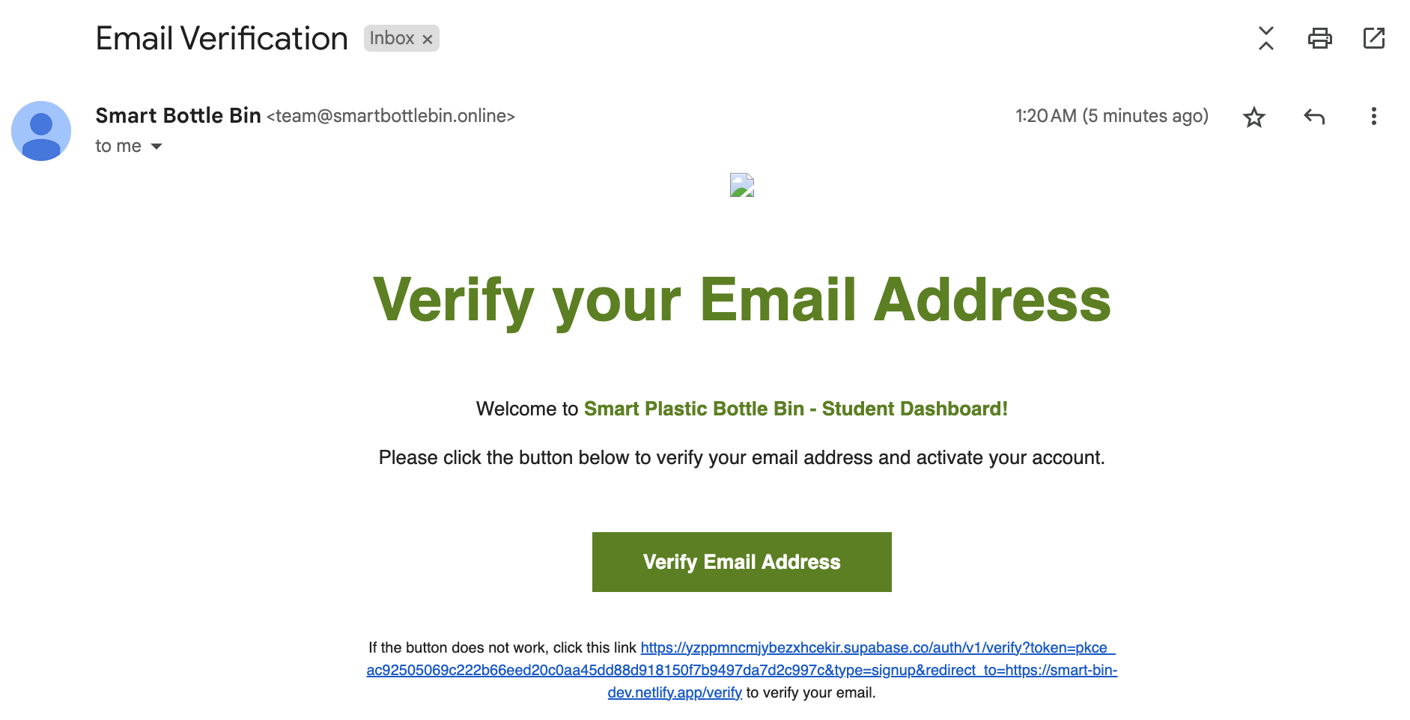

**Figure 27 Email Verification for User GUI of Smart Plastic Bottle Bin:**

**A Reverse Vending Machine**

In Figure 27, Upon successful account creation, an email verification will be sent by the system. Once verified by clicking the link provided in the email or the verify email address button, the user will be directed to a confirmation page, acknowledging that their email has been successfully verified.

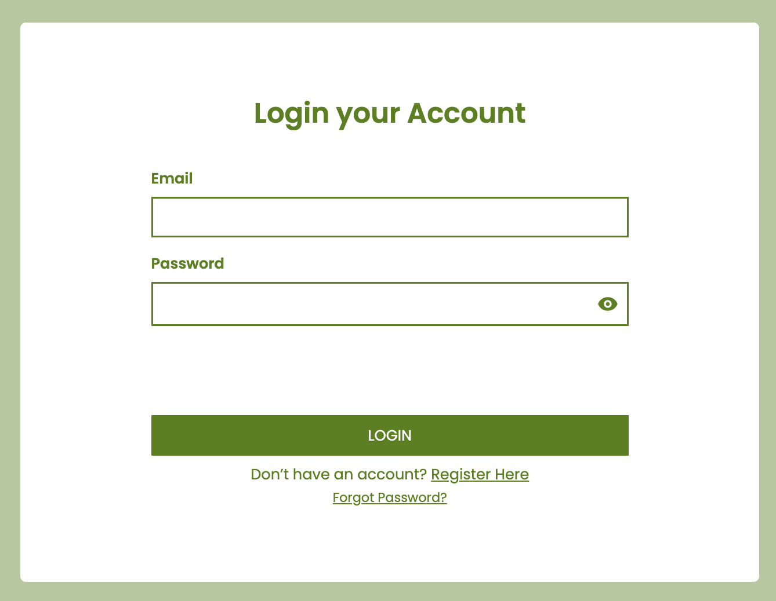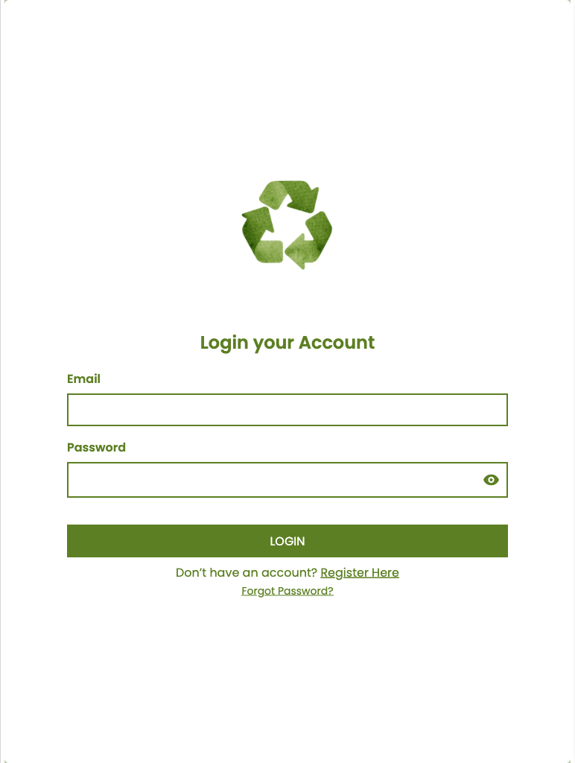

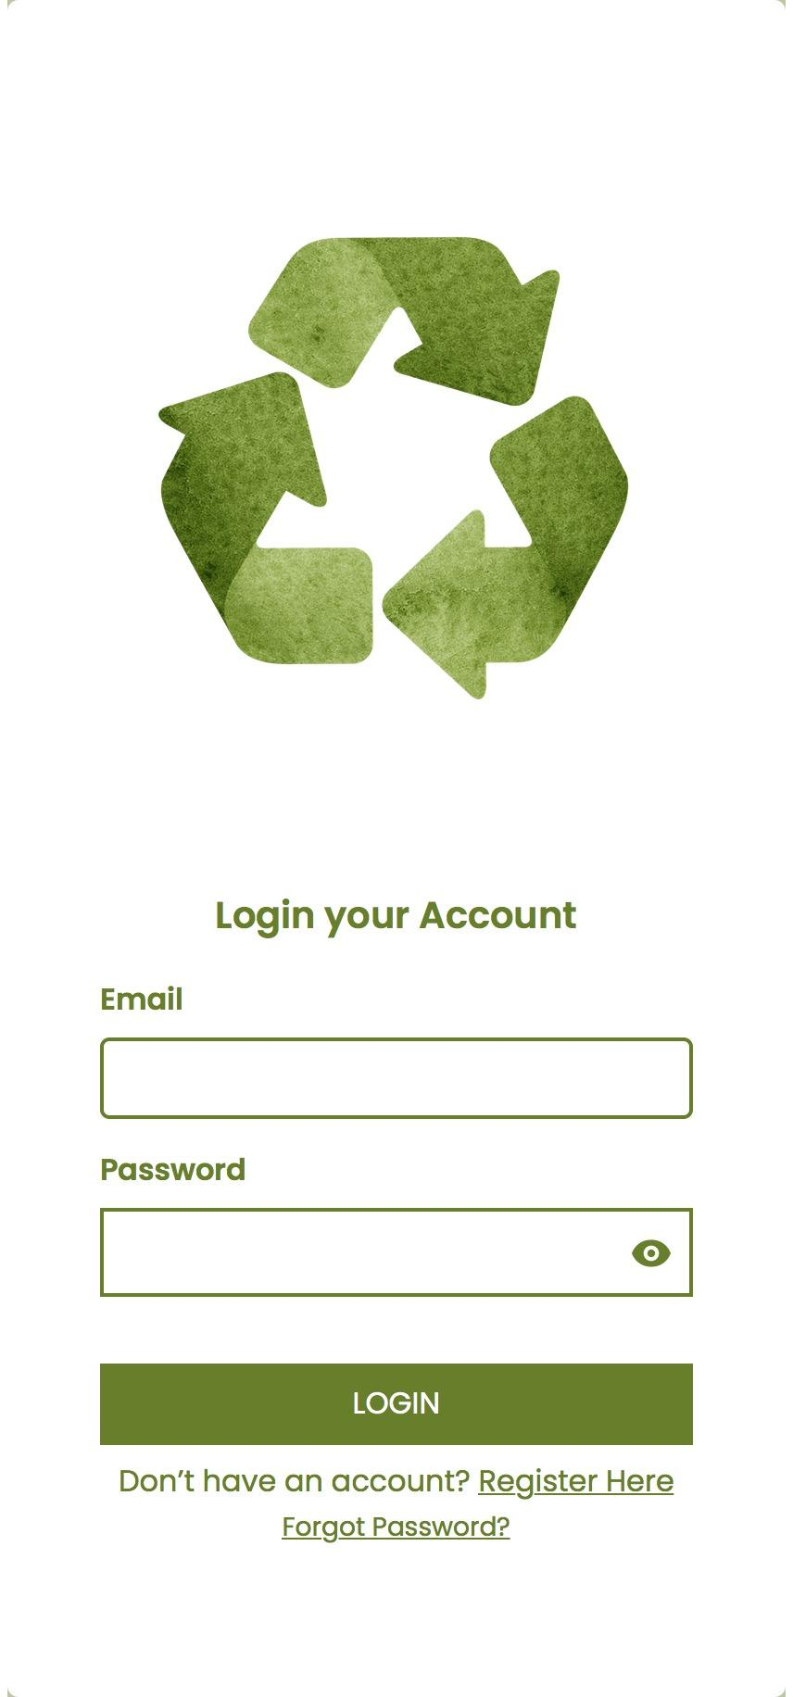

**Figure 28 Login Account Page for User GUI of Smart Plastic Bottle Bin:**

**A Reverse Vending Machine**

In Figure 28, Prior to accessing the login page, users must complete registration and email verification. Upon completion, they can log in by entering their email and password.

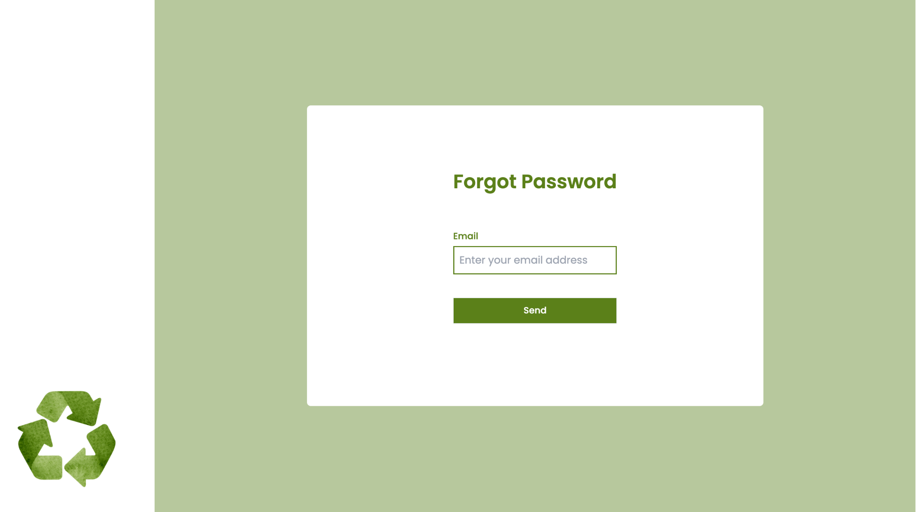

**Figure 29 Forgot Password Page for User GUI of Smart Plastic Bottle Bin:**

**A Reverse Vending Machine**

In Figure 29, If the user forgets his or her password, the user can change it with his verified email address. By utilizing the email verification process, users can initiate the password change procedure, ensuring a seamless and reliable method to regain access to their account.

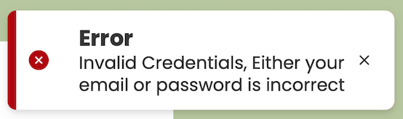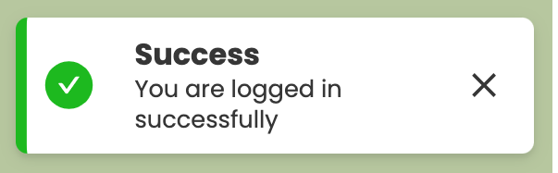

**Figure 30 Logged in Successfully Notification for User GUI of Smart Plastic Bottle Bin: A Reverse Vending Machine**

In Figure 30, shows the “success toast notification” signifies when the user has successfully logged-in.

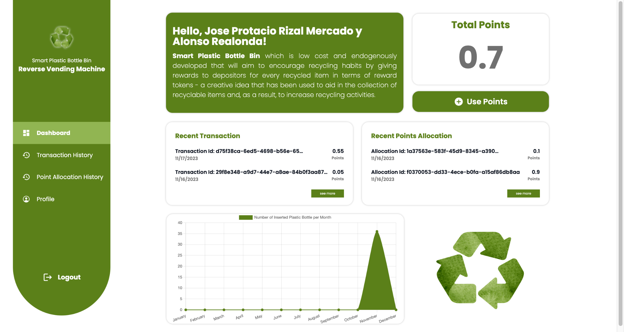

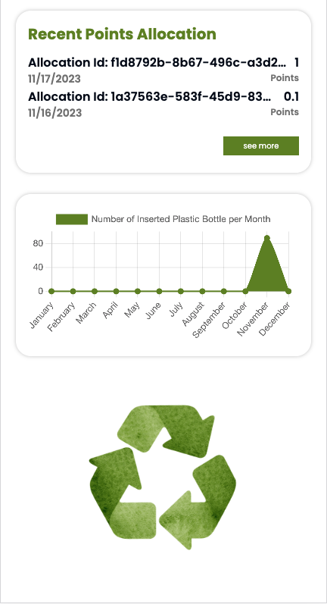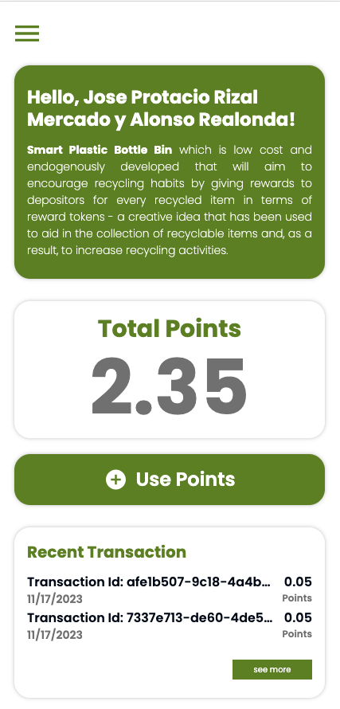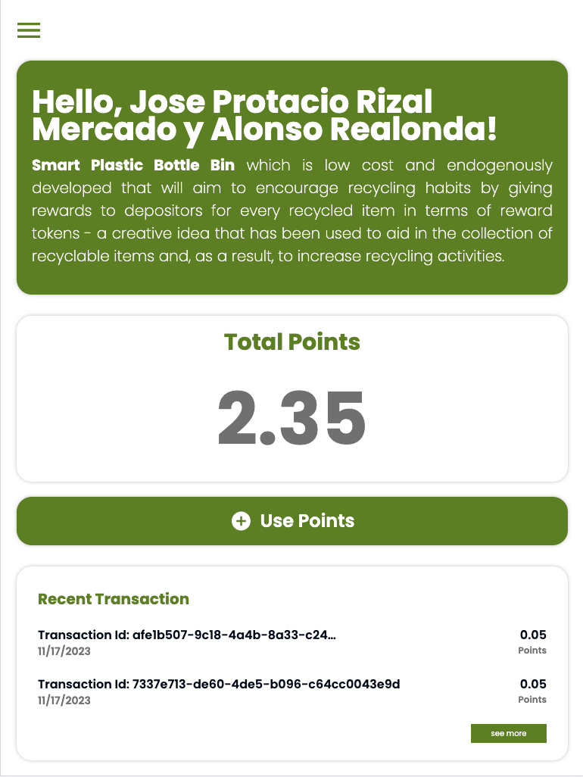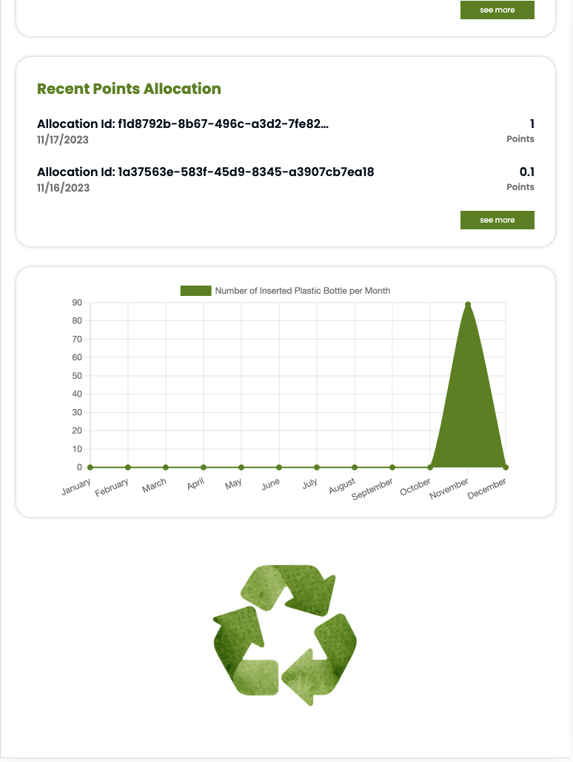

**Figure 31 Dashboard Page for User GUI of Smart Plastic Bottle Bin:**

**A Reverse Vending Machine**

In Figure 31, the page includes key elements such as total points, recent transactions, recent points allocation, and a chart for a comprehensive and visually informative display. The "Use Points" button will display the modal which is a streamlined process for users to increment points in a specific subject. This modal encompasses key features such as available points, student number, a scrollable list of subjects, and an input field for entering the desired points.

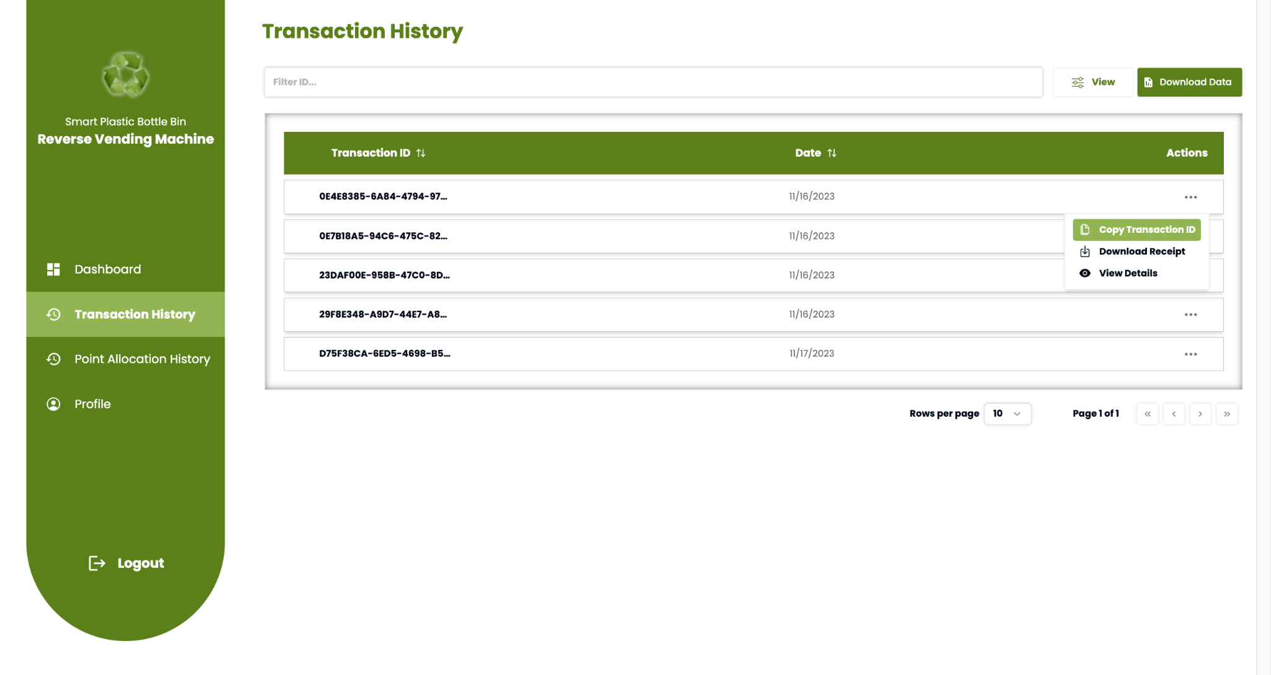

**Figure 32 Transaction History Page for User GUI of Smart Plastic Bottle Bin:**

**A Reverse Vending Machine**

In Figure 32, the transaction history page shows every plastic bottle insertion by the user. The "In View" button, when interacted with, presents three distinct sections—ID, date, and action. The transaction history page features a dynamic table with data filtering capabilities. For individual transactions, users can effortlessly copy the transaction ID by selecting the copy transaction id button.

**Figure 33 Point Receipt for User GUI of Smart Plastic Bottle Bin:** 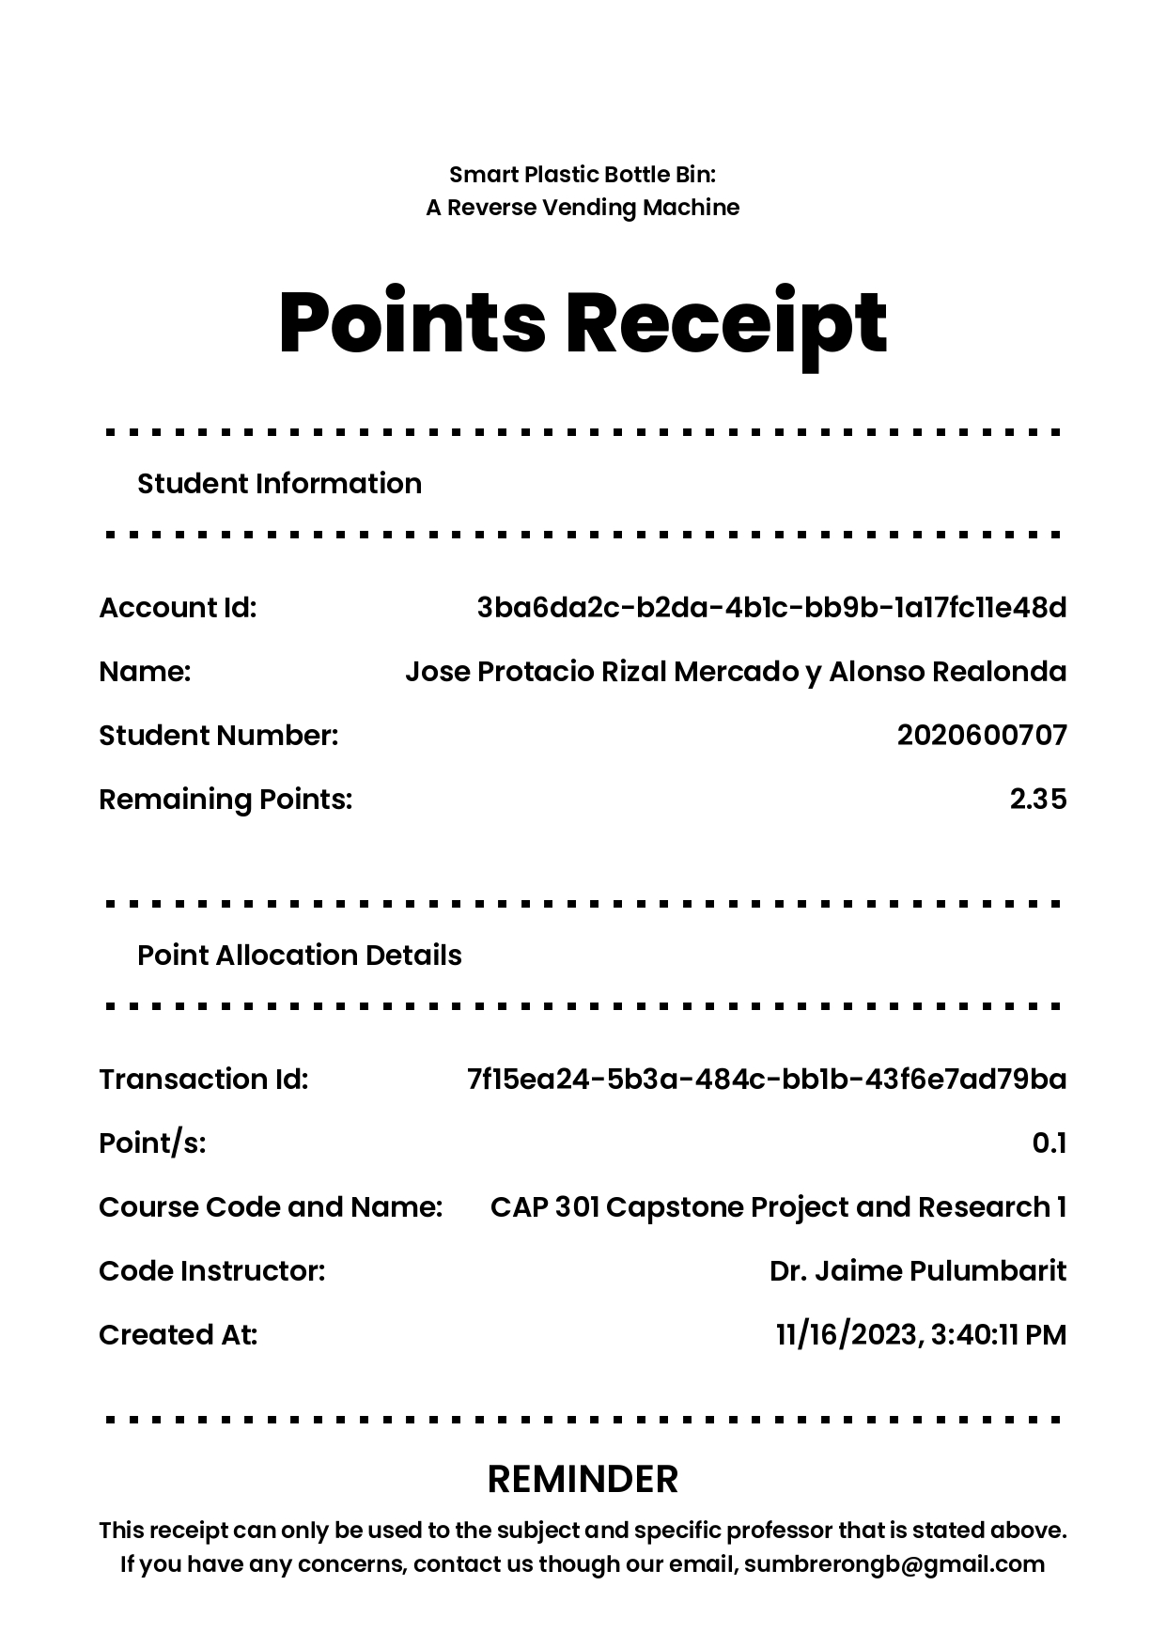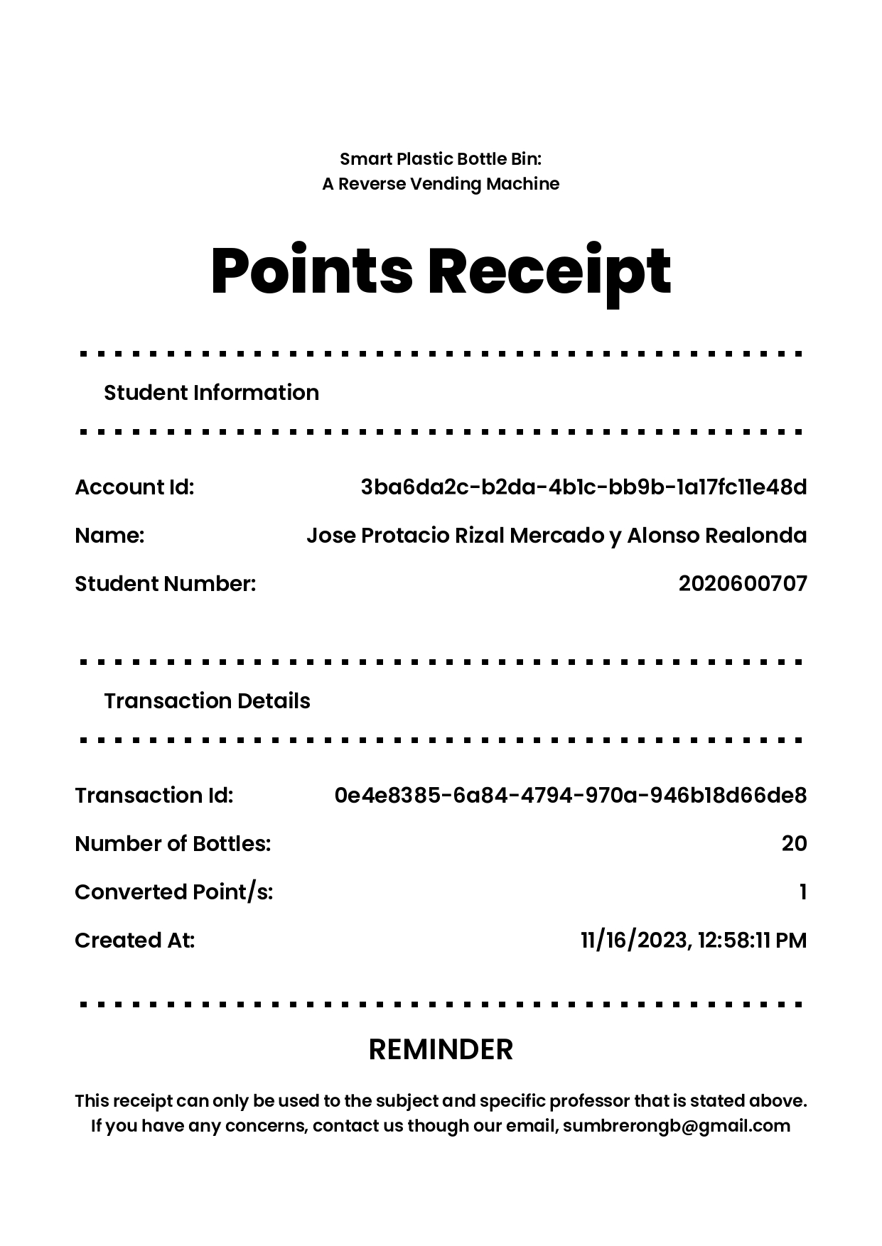

**A Reverse Vending Machine**

In Figure 33, within the "Actions" section, users can access a three-dots menu offering a range of options. This includes the ability to download a receipt which is conveniently viewable in PDF format. The Points Receipt section includes essential student details like account ID, name, student number, and remaining point+s. Additionally, the Point Allocation Details section presents transaction-specific information such as transaction ID, allocated points, course code and name, instructor code, and the creation date.

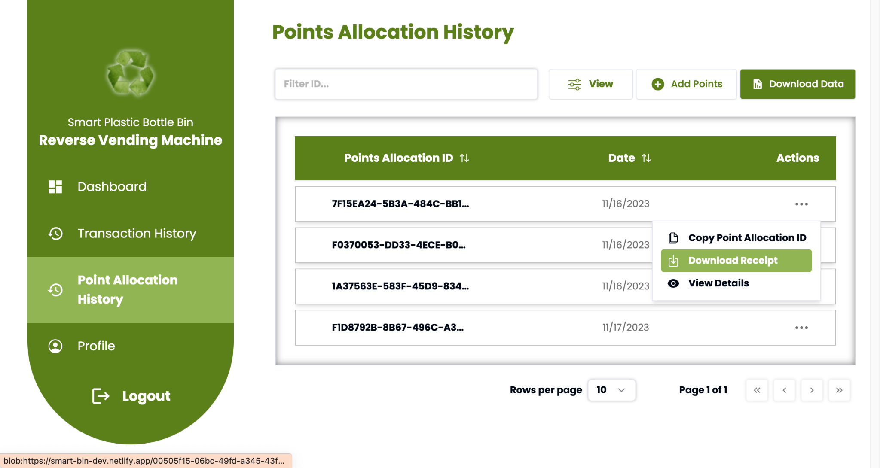

**Figure 34 Point Allocation History Page for User GUI of Smart Plastic Bottle Bin: A Reverse Vending Machine**

In Figure 34, the point allocation history page features a dynamic table with data filtering capabilities.The "Download Receipt" button is strategically positioned within the three-dots menu in the Actions section. Upon selection, the system seamlessly initiates the automatic download of the receipt in PDF format.

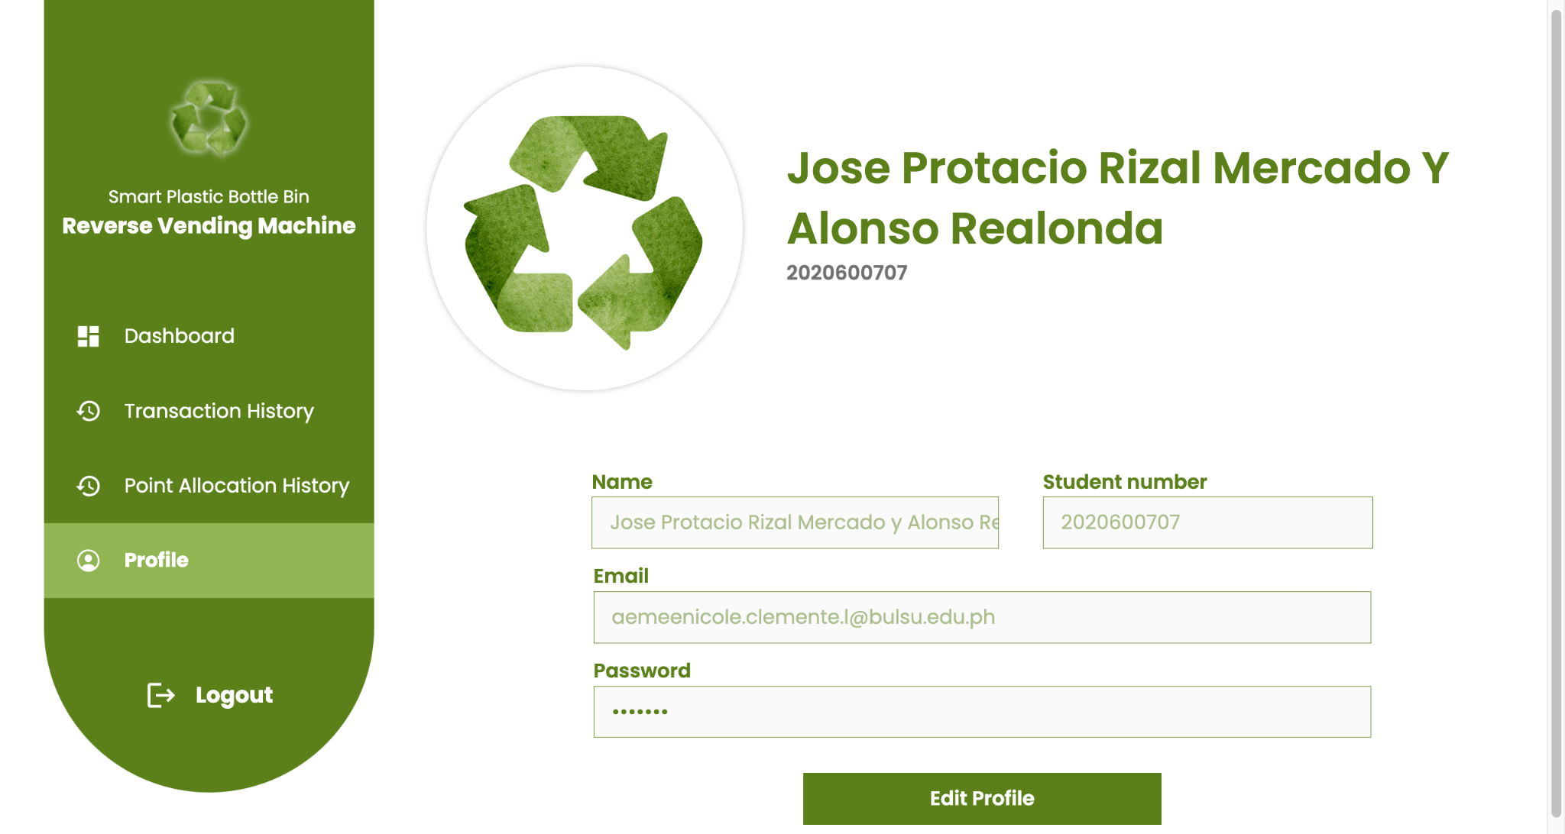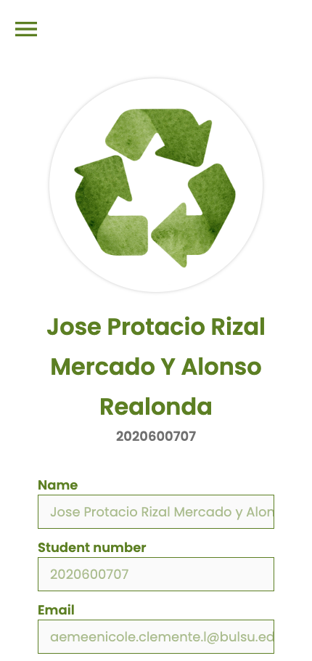

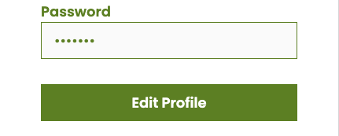

**Figure 35 Profile Page for User GUI of Smart Plastic Bottle Bin:**

**A Reverse Vending Machine**

In Figure 35, the user is presented with the Student Information section, providing a seamless interface to edit their profile. This user-centric profile page is accessible for most devices and includes essential details such as name, student number, email, password, and the personal display, empowering users with easy customization and maintenance of their personal information.

**WEB (ADMIN & SUPER ADMIN)**

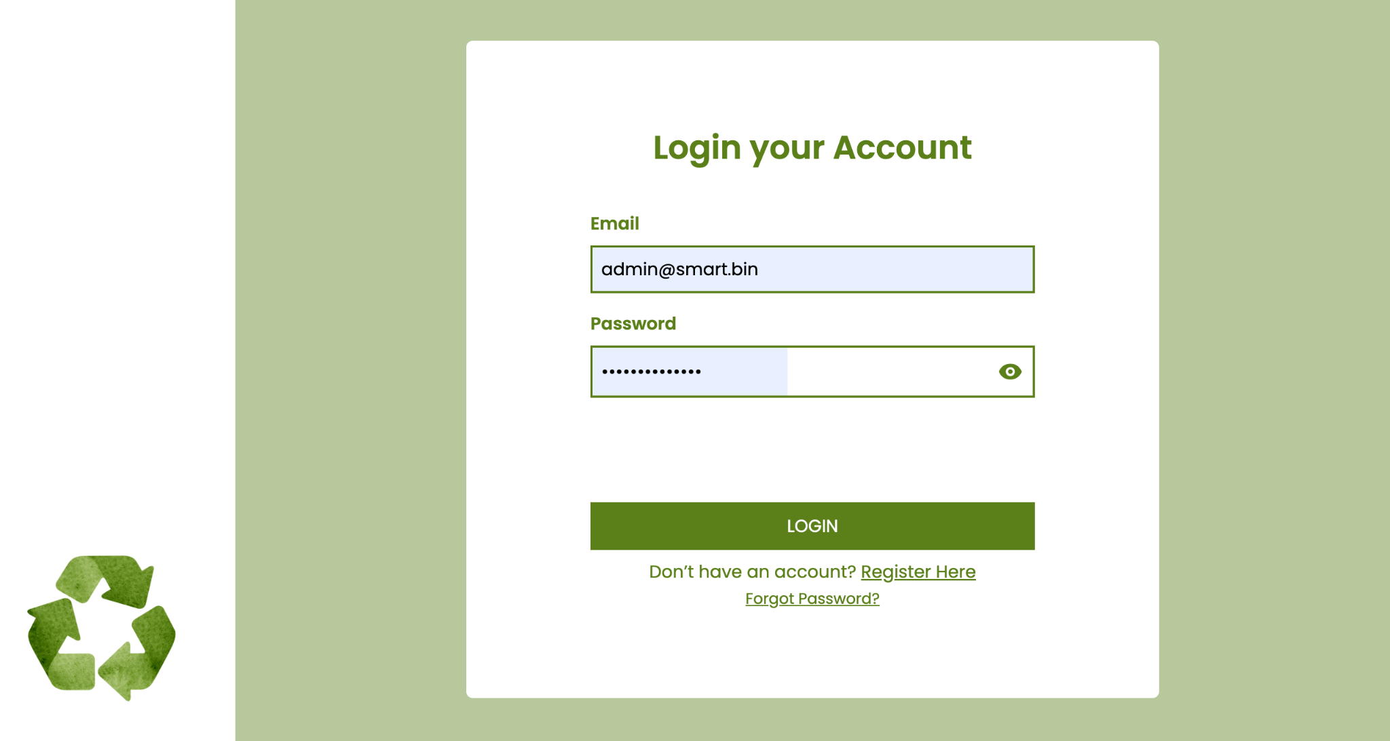

**Figure 36 Admin and Super Admin Account Login Page for User GUI of Smart Plastic Bottle Bin: A Reverse Vending Machine**

InFigure 36, displays the admin login interface. Additional admin accounts can be created within the super admin account. Admins and Super Admins have access to transaction and point allocation histories, along with the ability to manage student and subject information—enabling creation, reading, updating and deletion of these records.

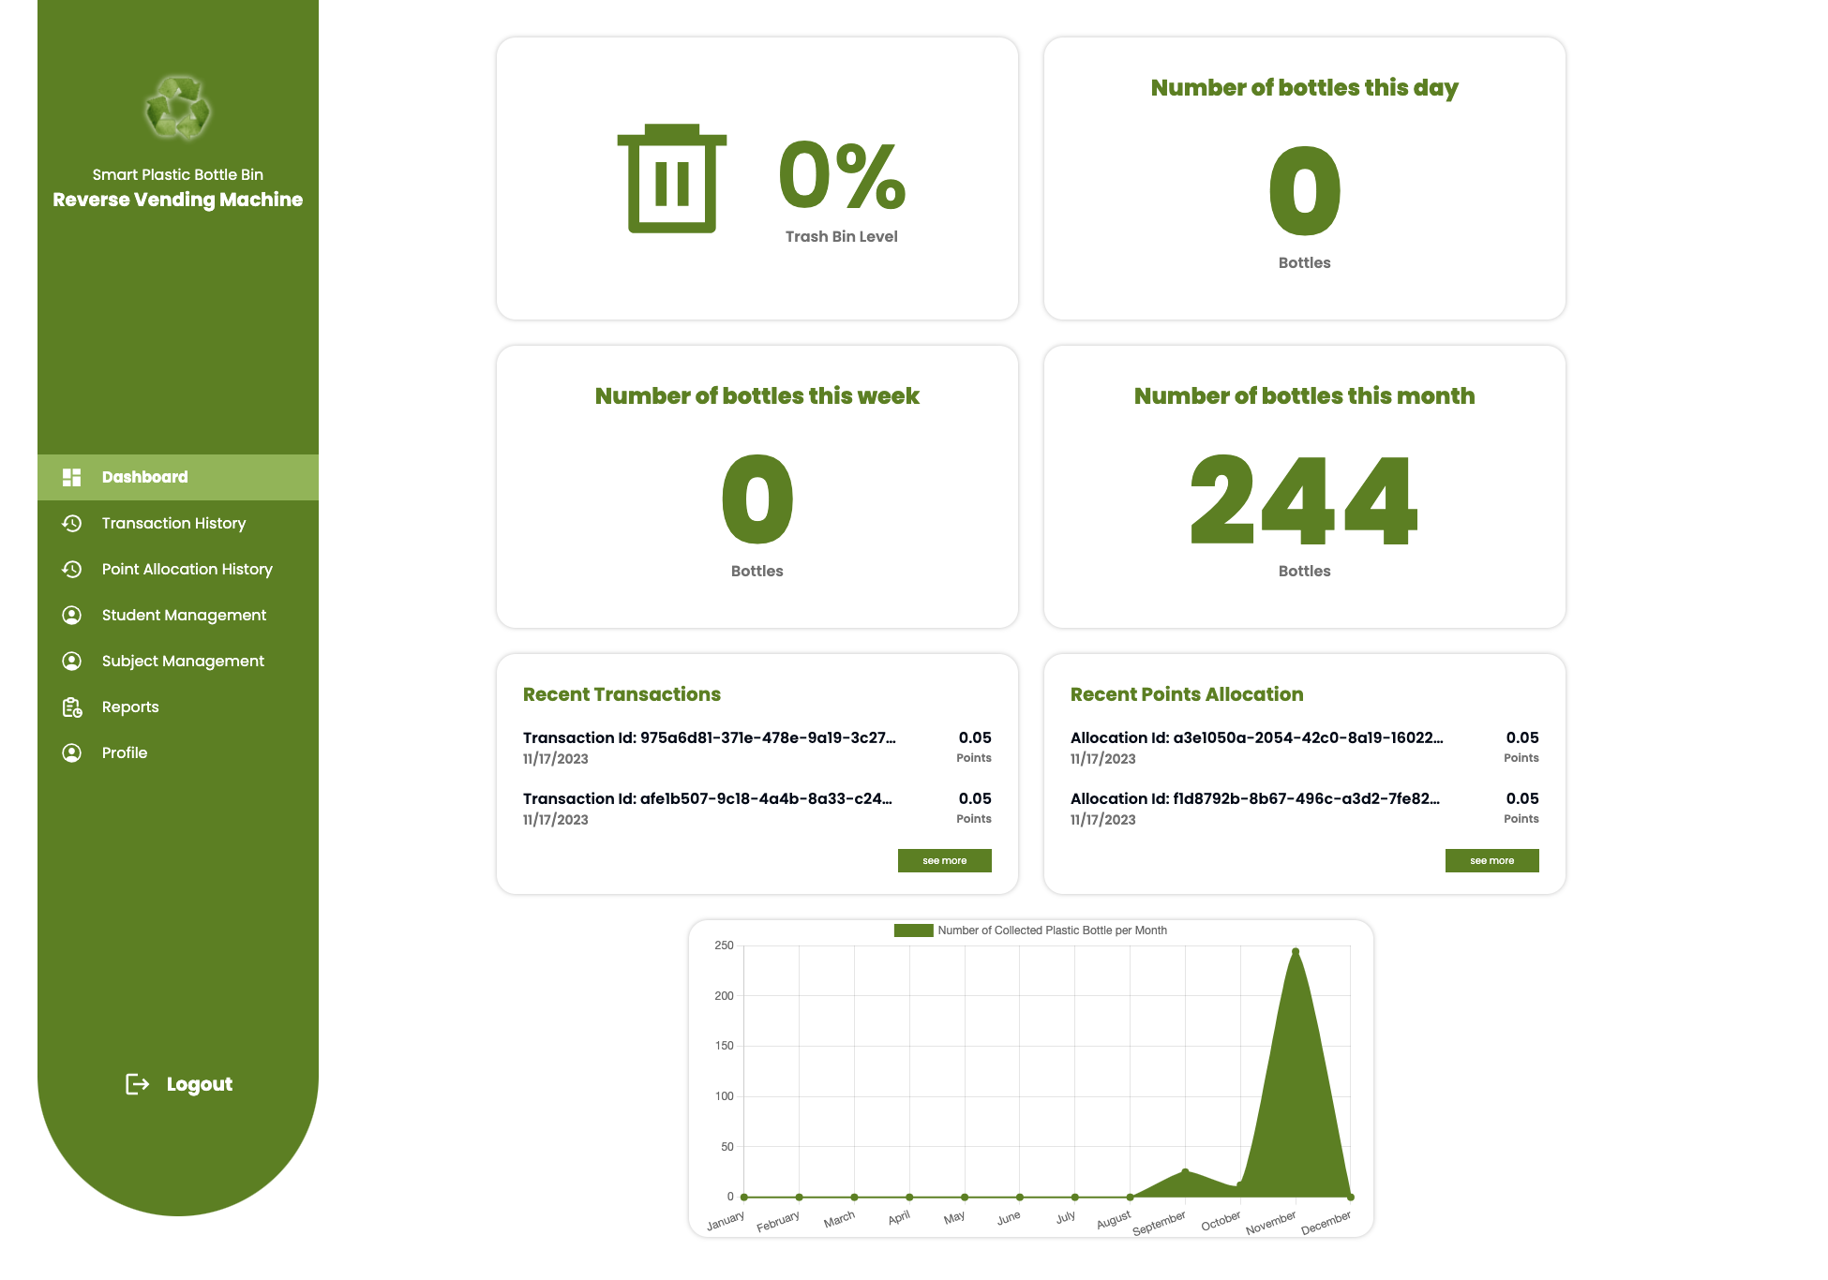

**Figure 37 Admin and Super Admin Dashboard for User GUI of Smart Plastic Bottle Bin: A Reverse Vending Machine**

InFigure 37, exhibits real-time updates on the trash bin level, the daily, weekly, and monthly count of bottles. Similar to the student dashboard, it provides an overview of recent transactions, point allocation history, and graphical representations.

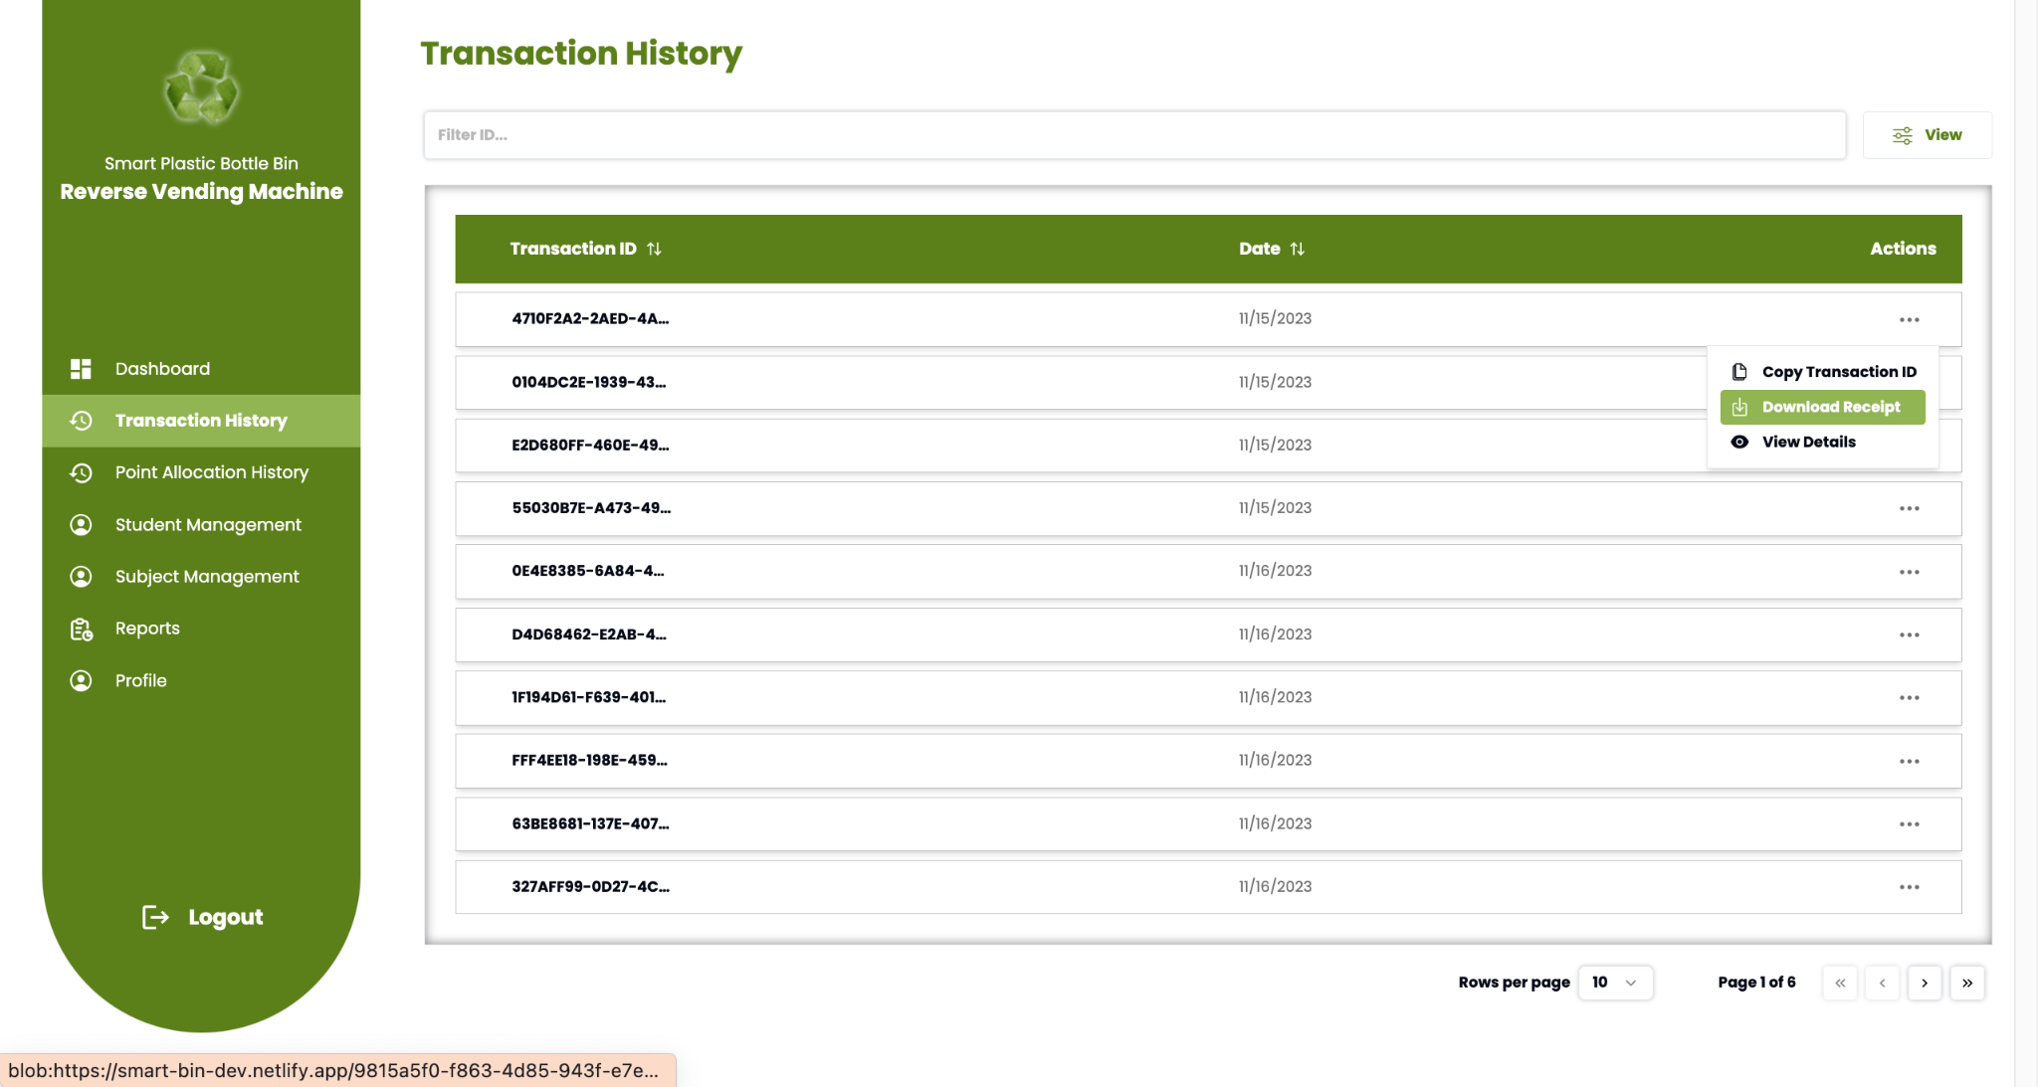

**Figure 38 Admin and Super Admin Transaction Reports for User GUI of Smart Plastic Bottle Bin: A Reverse Vending Machine**

In Figure 38, displays each and every bottle insertion for all the users, It also shows the date and transaction id. On “view details”, admins and super admins can also view further information for every single transaction.

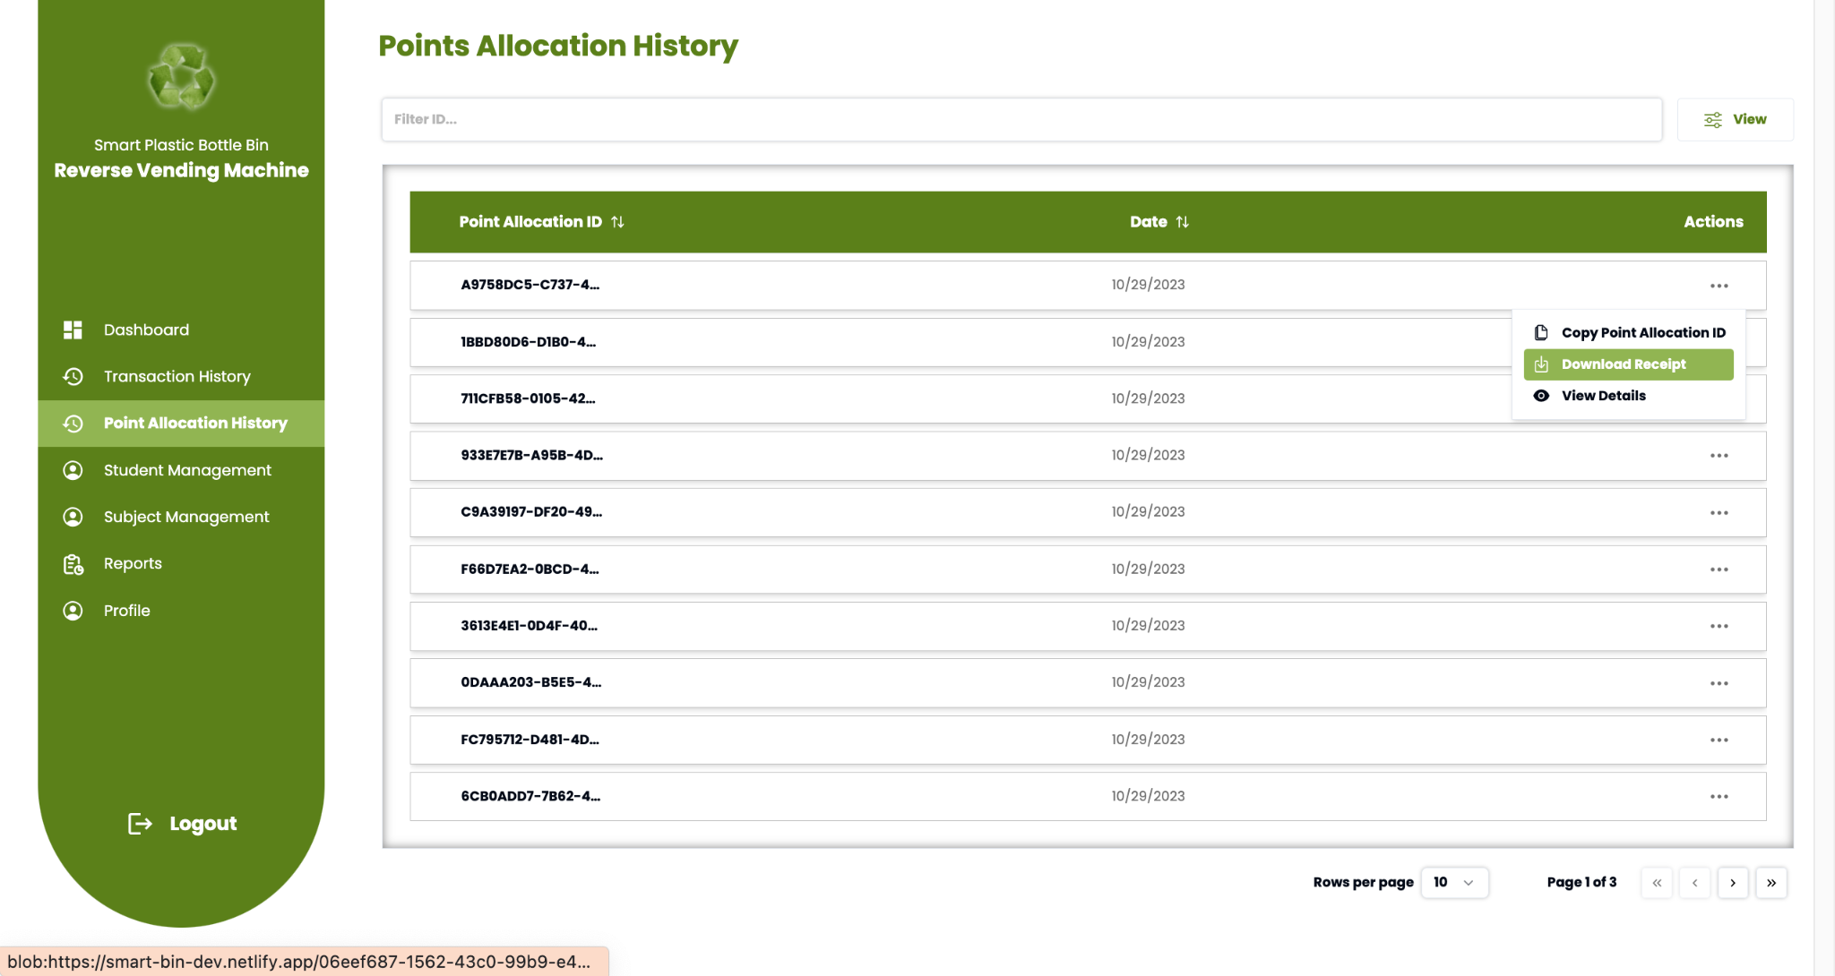

**Figure 39 Admin and Super Admin Point Allocation History for User of Smart Plastic Bottle Bin: A Reverse Vending Machine**

In Figure 39, Point allocation history shows users point allocation upon all the included subjects. Regarding “view details”, admins and super admins can also view further information among every student's point allocations.

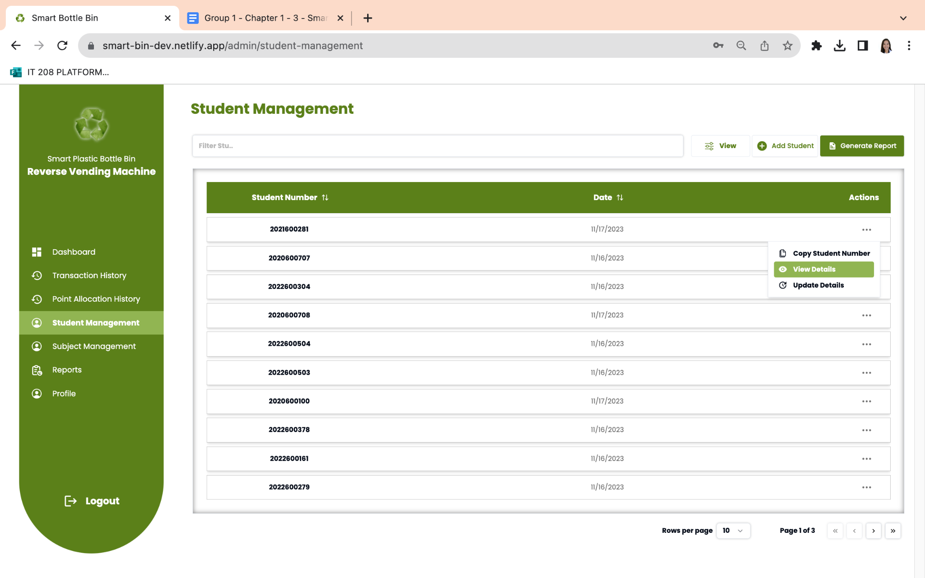

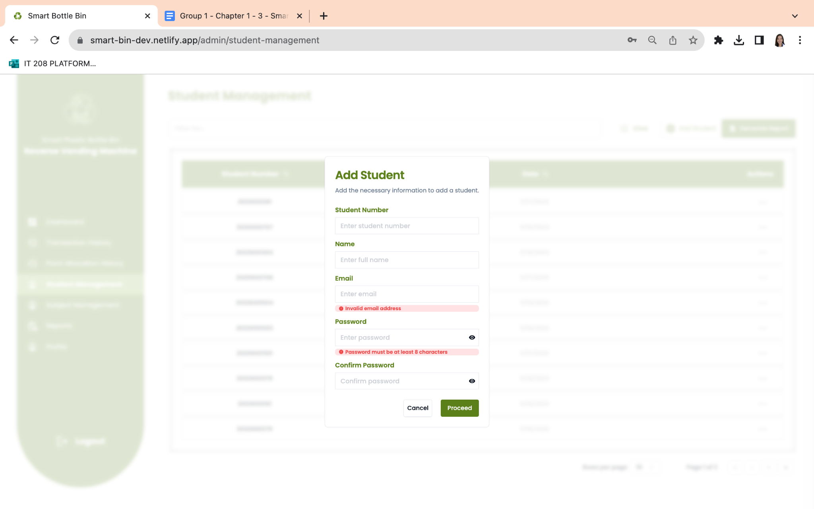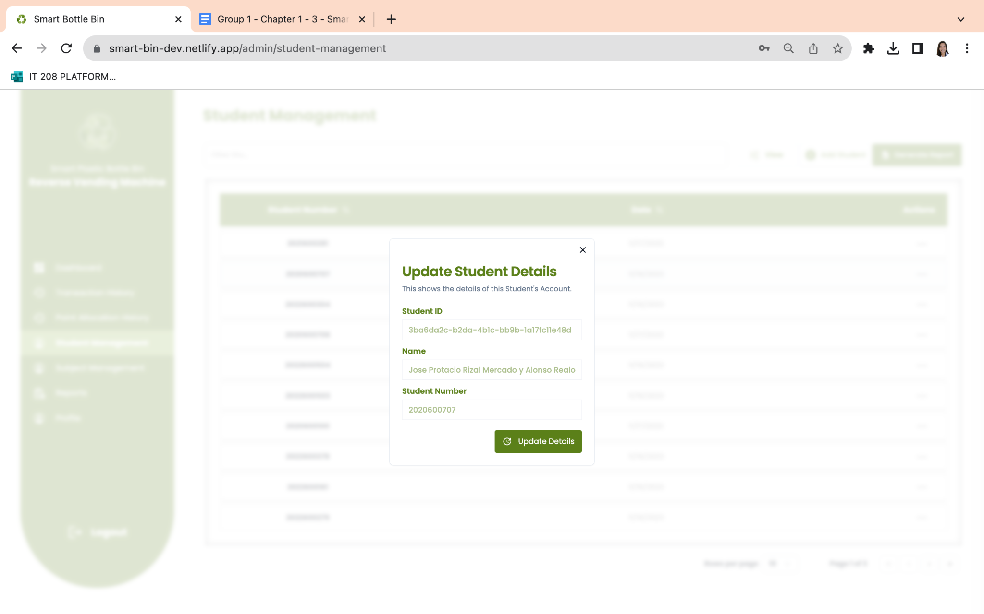

**Figure 40 Student Management Page for User GUI of Smart Plastic Bottle Bin:**

**A Reverse Vending Machine**

In Figure 40, displays a dynamic table containing the student records, showcasing their student numbers and creation dates. To access further details about a student, users can download the data or view individual student profiles. This page also facilitates the creation of new student accounts and allows updates to specific student details.

**Figure 41 Subject Management Page for User GUI of Smart Plastic Bottle Bin:** 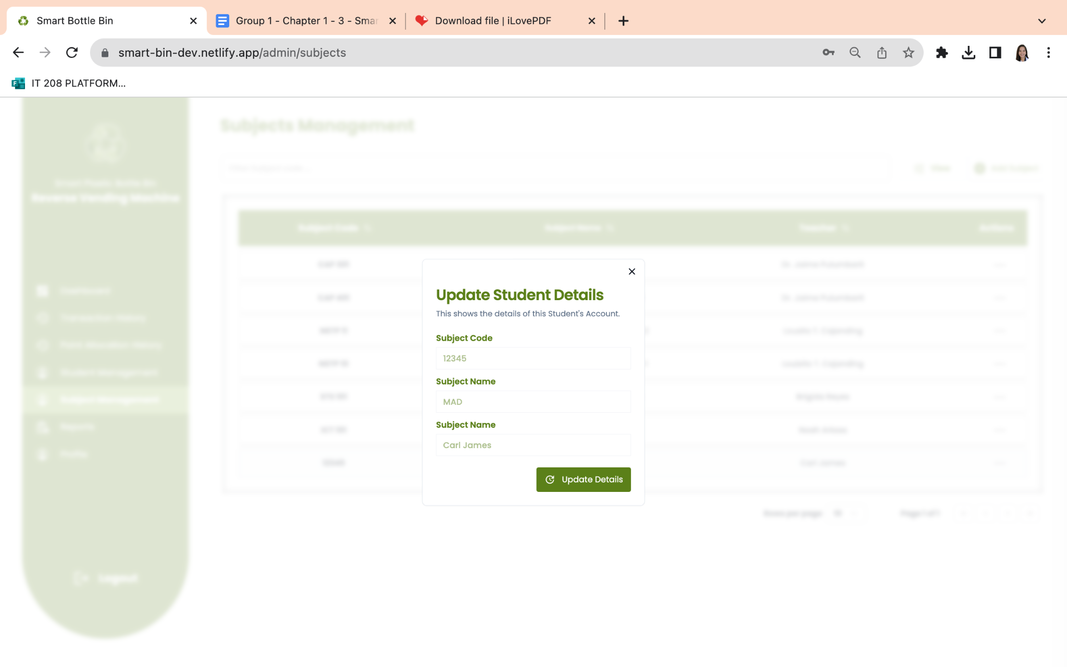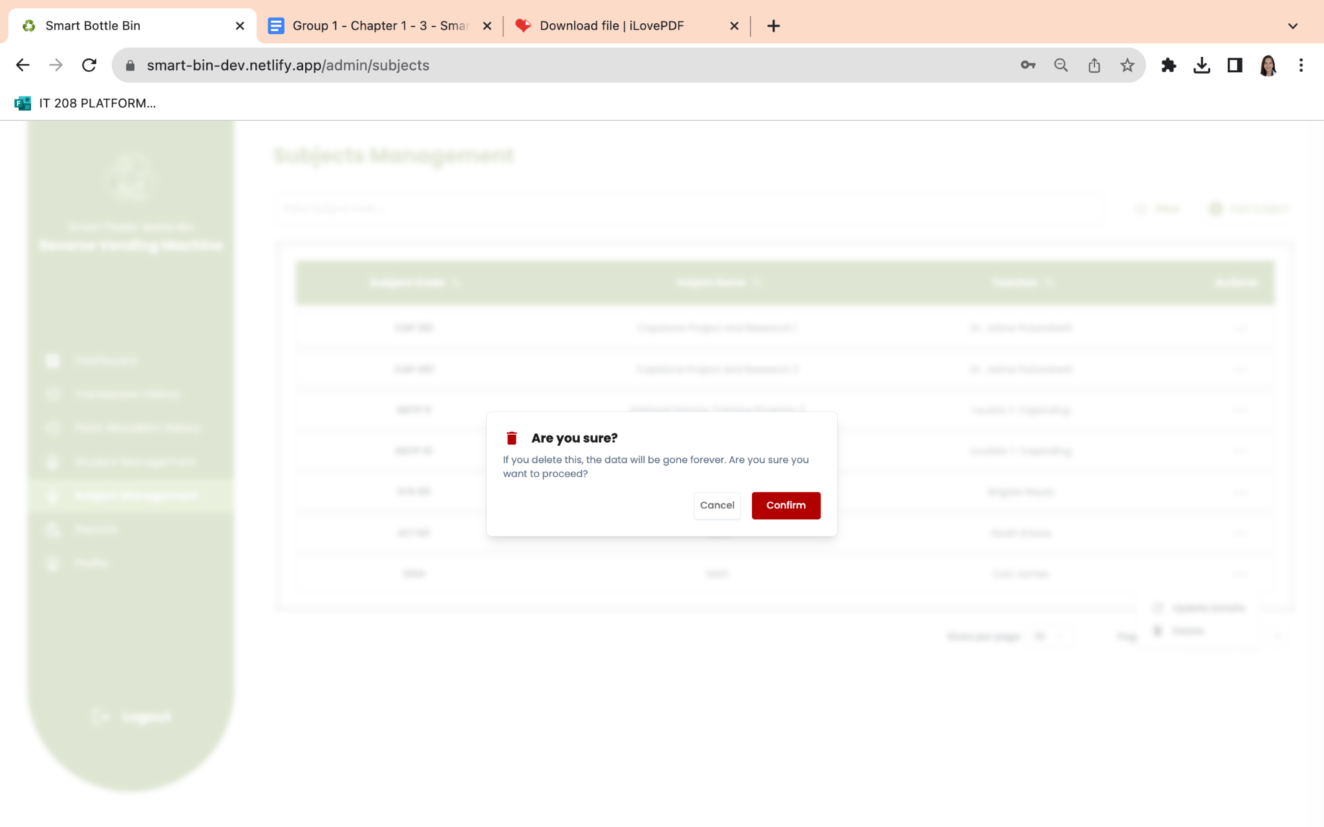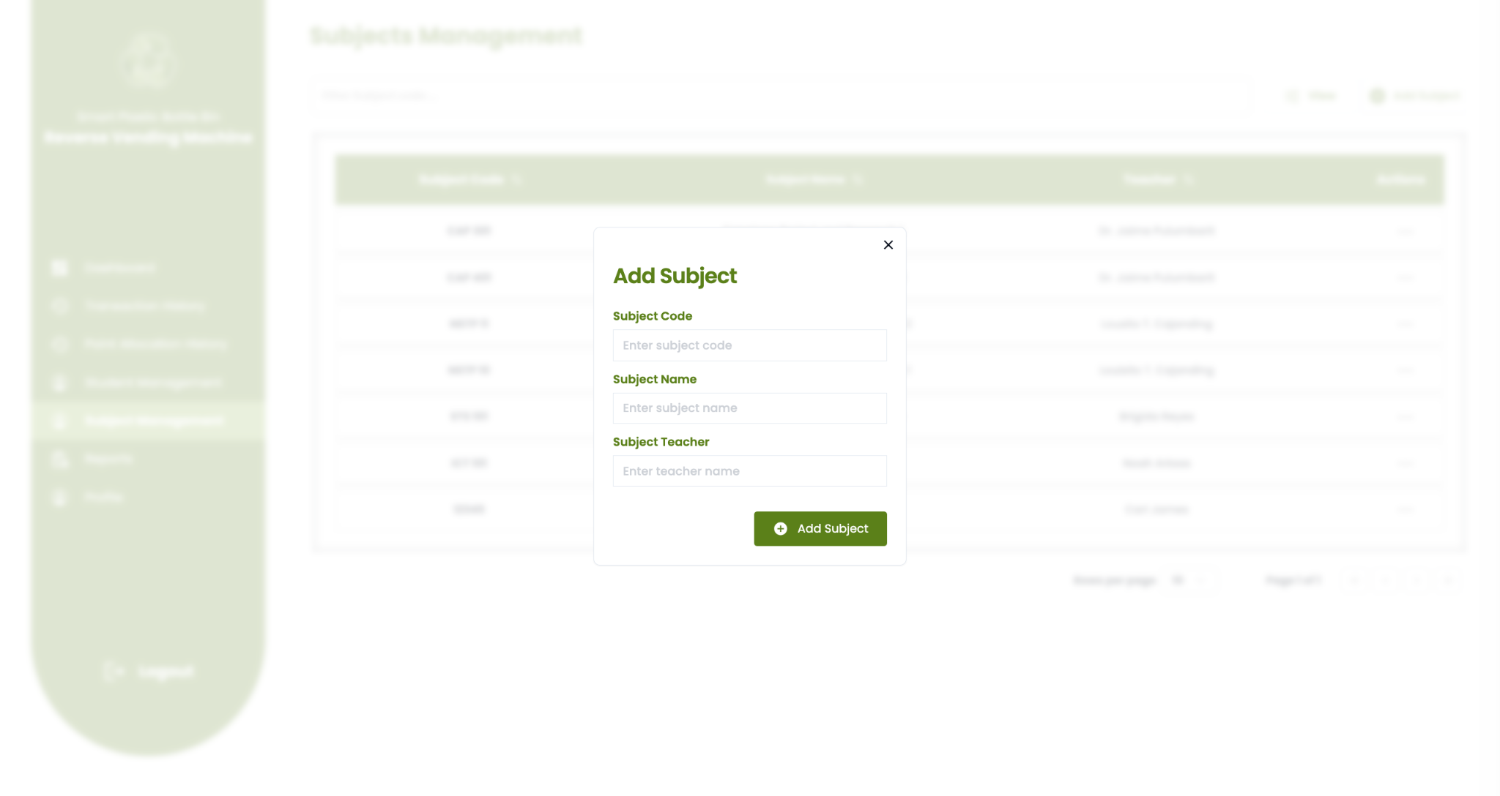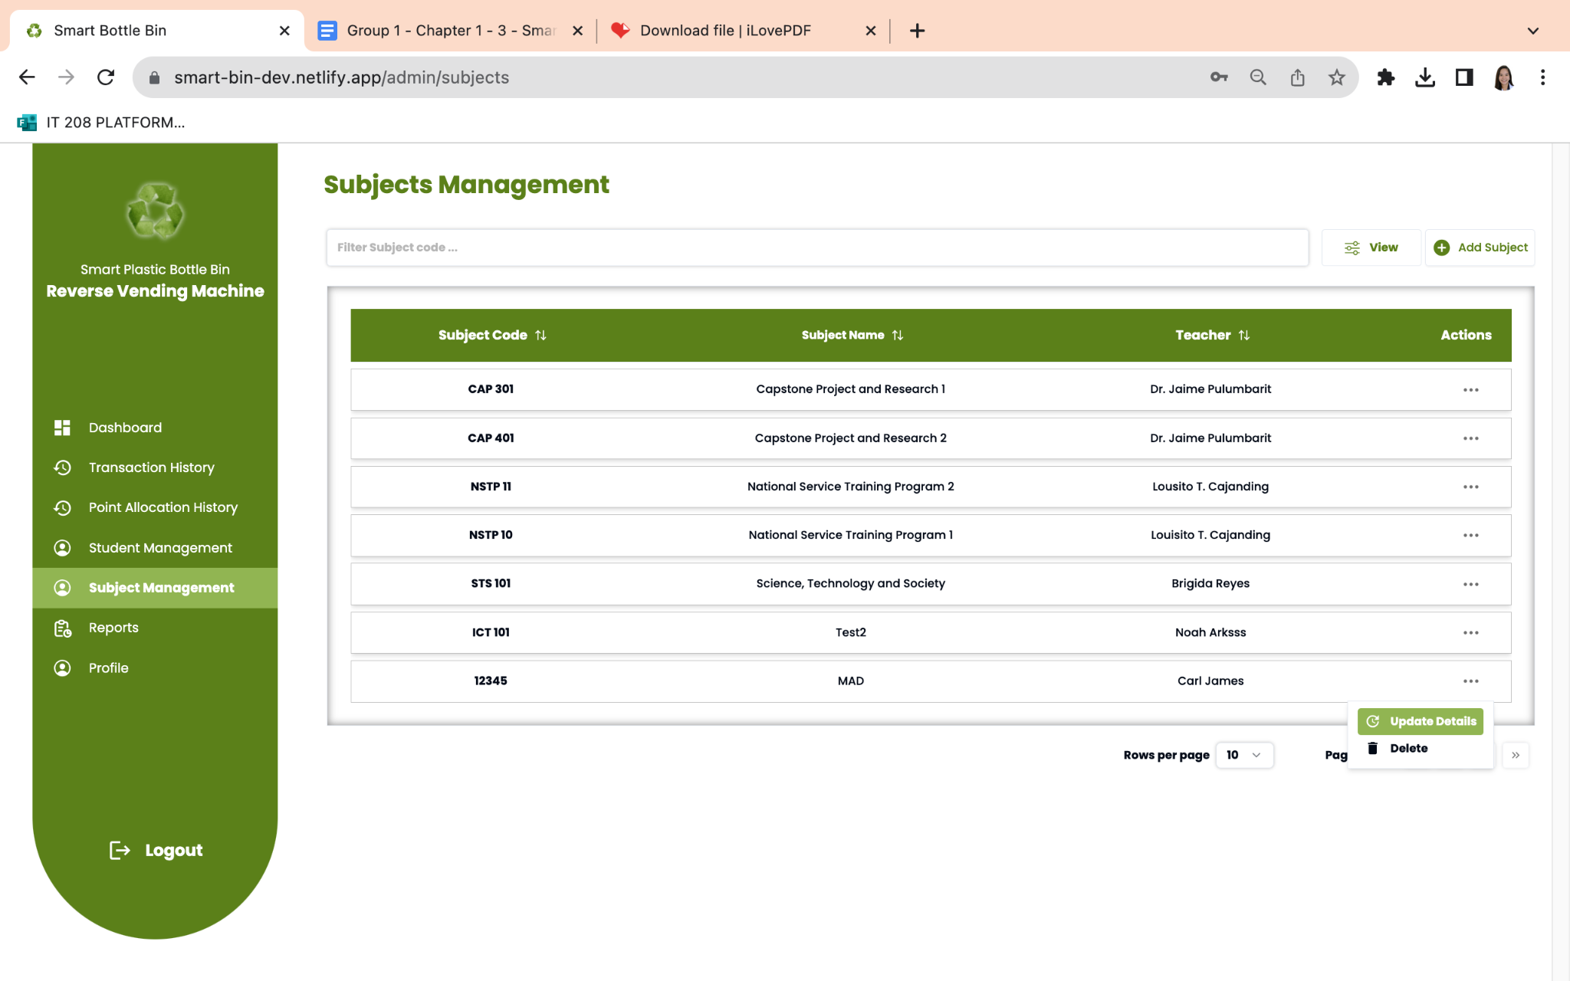

**A Reverse Vending Machine**

In Figure 41, presents a dynamic table with subject records, featuring their codes, names, and associated teachers. To access further details about a subject, users can download the data. This page offers options to create new subjects, update specific subject information, and delete individual subjects as needed.

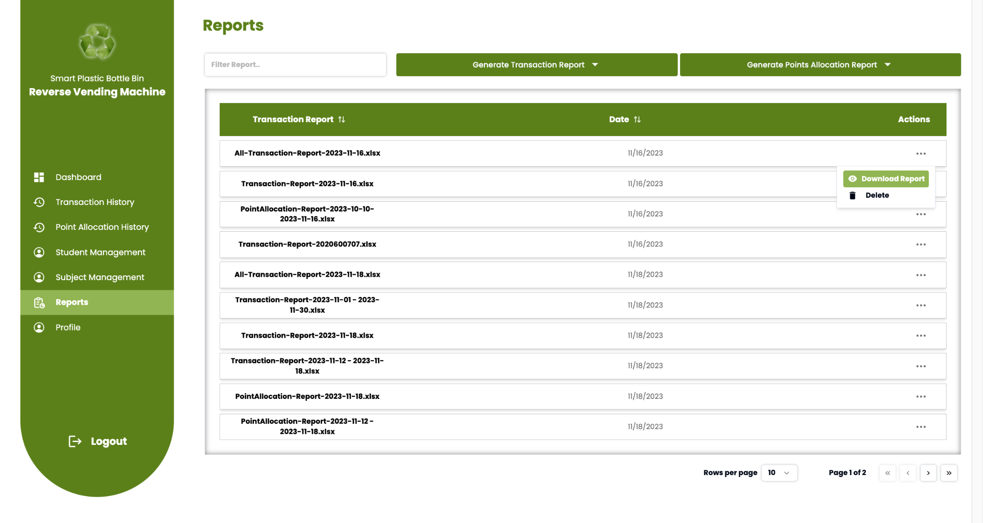

**Figure 42 Reports Page for User GUI of Smart Plastic Bottle Bin:**

**A Reverse Vending Machine**

In Figure 42, These reports contain the daily report of the transaction history and point allocation history which this page has an ability to download the data and delete each record.

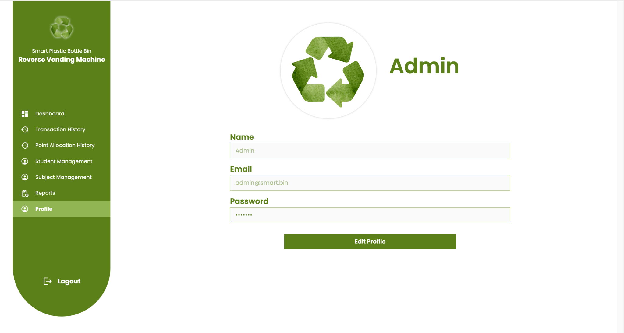

**Figure 43 Profile Page for User GUI of Smart Plastic Bottle Bin: A Reverse Vending Machine**

In Figure 43, the user is presented with the Admin and Super Admin Information section, providing a seamless interface to edit their profile. This user-centric profile page is accessible for most devices and it includes essential details such as name, email, password, and the personal display, empowering users with easy customization and maintenance of their personal information.

**WEB (SUPER ADMIN)**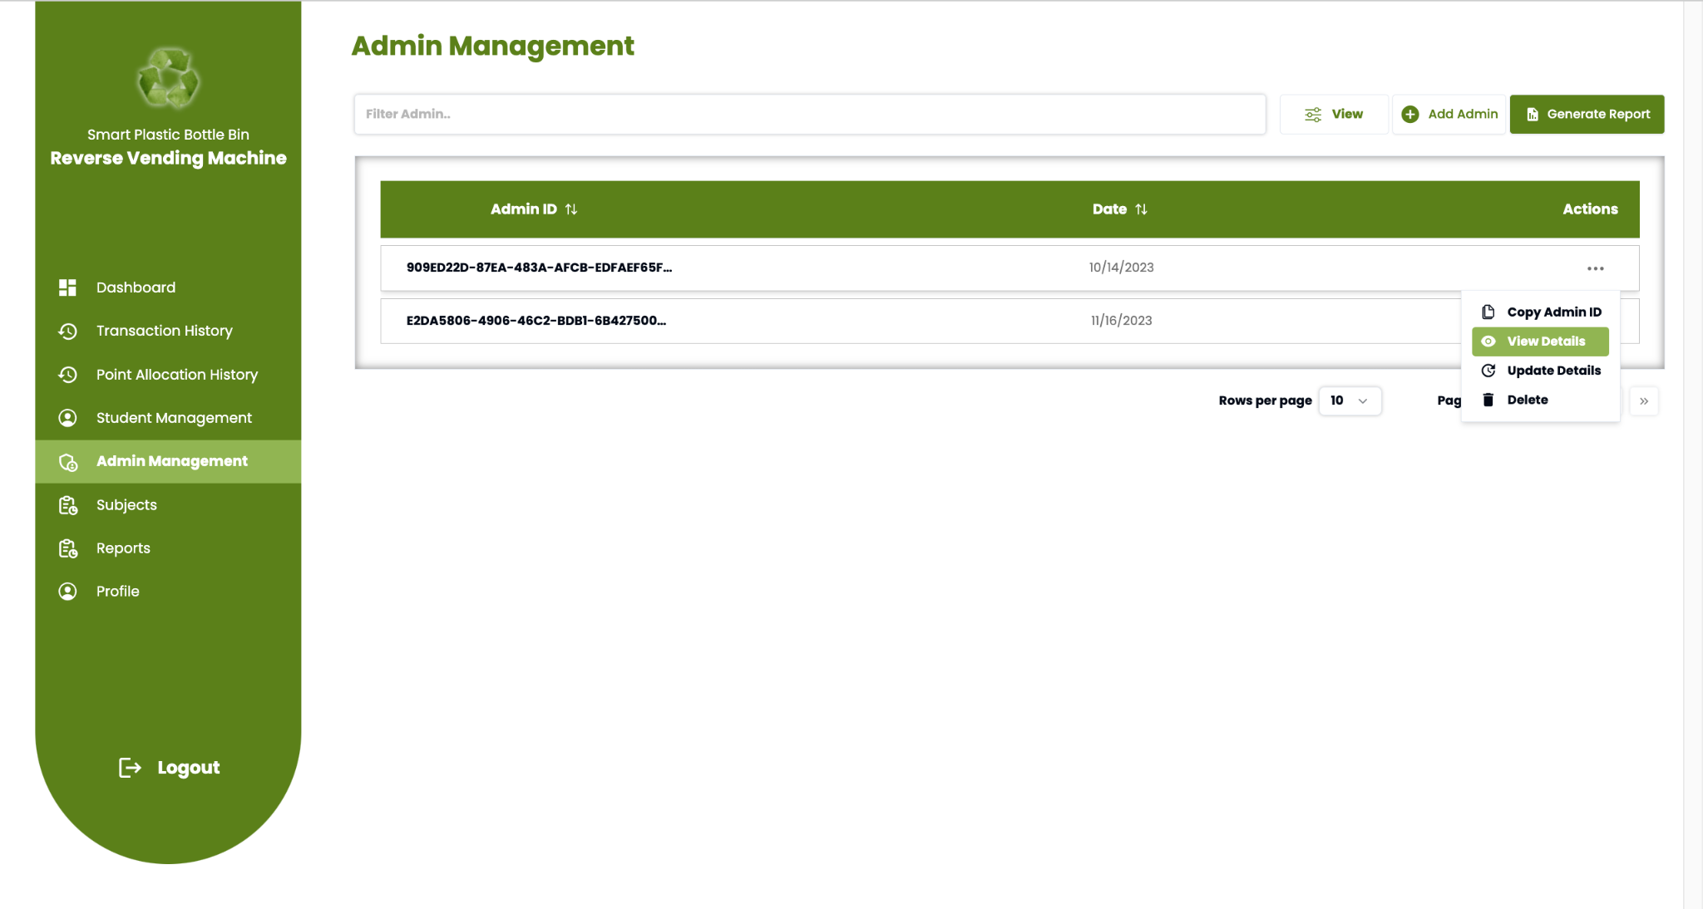

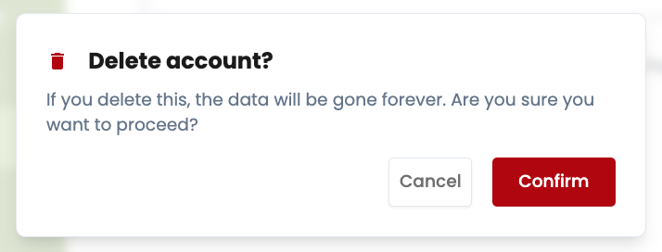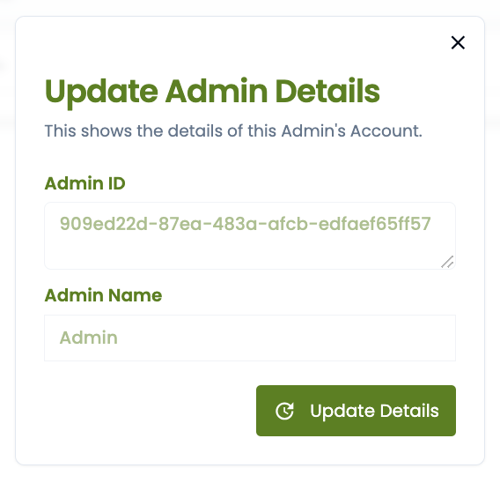

**Figure 44 Super Admin: Admin Management Page for User GUI of Smart Plastic Bottle Bin: A Reverse Vending Machine**

In Figure 44, the interface aligns with the functionality of admin student management, providing the ability to monitor all student users, download comprehensive data, and facilitate the creation of new student accounts. Notably, super admins enjoy an added advantage over regular admins by having the unique capability to delete individual admin users. This exclusive feature enhances the super admin's control and precision in managing the admin user base, offering a robust and tailored administrative experience.

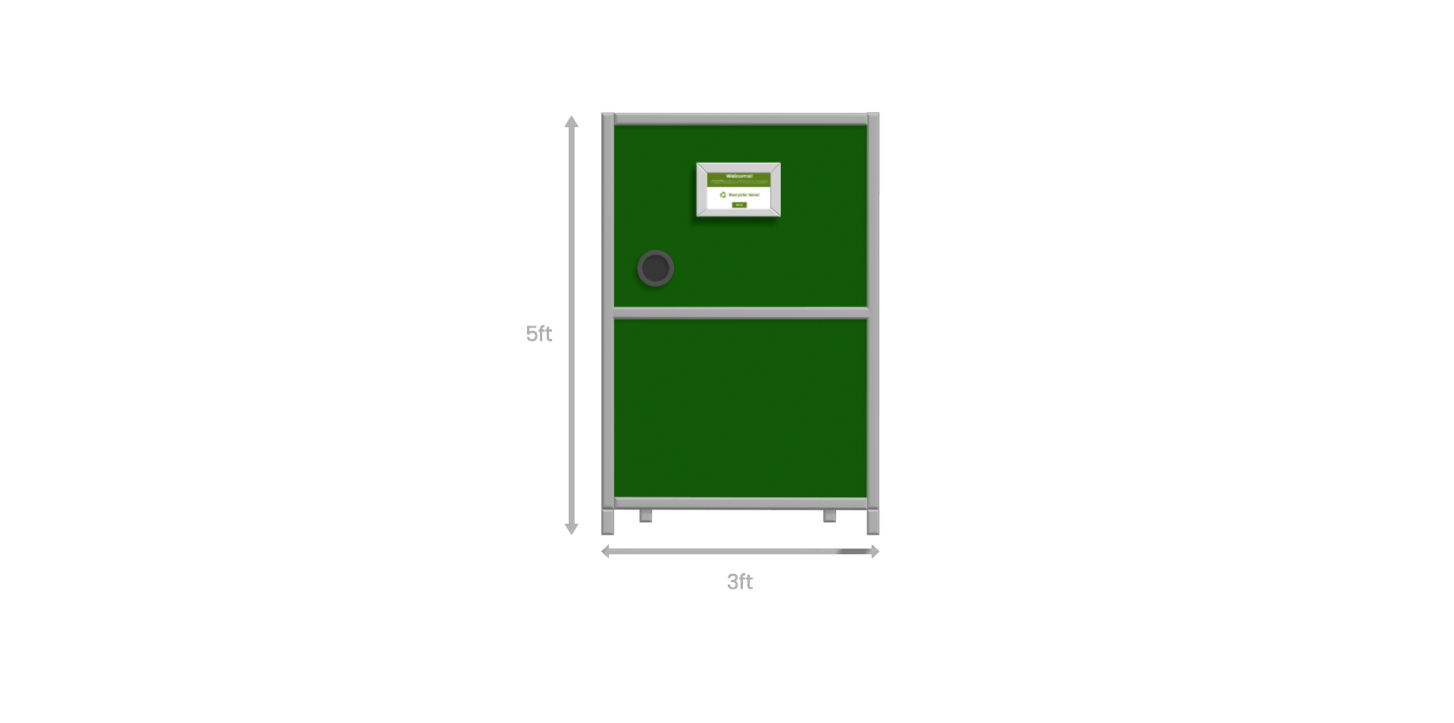

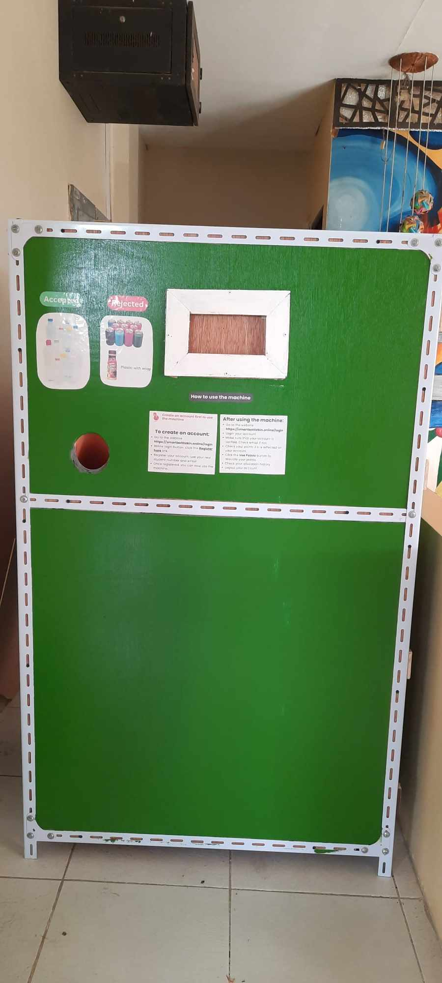**Figure 45 Model of the Prototype for Smart Plastic Bottle:**

**A Reverse Vending Machine**

Figure 45 shows the External view of the hardware prototype. The prototype contains an insertion hole where the plastic will be inserted by the users. It will also have a monitor which will display the number of plastic bottles collected and serve as the button to receive the receipt. Its last component is the ticketing machine which will print out the total amount accumulated.

**Implementation Plan**

The implementation plan is a critical component of the deployment of a system. The researchers believe that adequate implementation ensures that the system is fully utilized. Before deploying the system, the researchers offer the user the appropriate demonstration and ensure that each step is thoroughly addressed. The researchers actively supported the optimal utilization of the technology by offering necessary assistance. Ensuring comprehensive user considerations, the researchers prioritized user needs throughout the deployment of the proposed system. Additionally, careful attention was given to selecting an implementation location that provides the best conditions for both machine maintainability and safety, while also ensuring convenient access for users.

Bulacan State University - Hagonoy Campus is the client of this project, this is where it will be implemented. The researcher will be having a testing phase to guarantee the efficiency of the project. The researcher will demonstrate to the client how to use and maintain the project. The system machine will require a strong network connection and direct access to the electricity, to achieve this, the system will be implemented besides the guard house at Gate 1 and the researchers provided an internet connection through pocket wifi. The smart plastic bottle bin monitoring system will be deployed to a dedicated admin computer with internet access. An admin personnel will receive training and a demonstration on utilizing the monitoring system. The researcher will be giving all that information that the client needs for him to know the process of implementation and how everything will start.

**CHAPTER IV**

**RESULTS AND DISCUSSIONS**

This chapter will present the significant findings of the study based on the results of the order of the general and specific objectives raised in Chapter I. The presentation includes a discussion of the statistical results obtained and the level of significance in the context of the study and discusses the representation of data, the statistical treatment and the output analysis conducted and the interrelated connections and significance between and among data in the context of the study. This will show the summary report of what happened in the research and discuss the following objectives in the previous chapters and explain why there are some objectives not met if there are any. Likewise, this will deliberate the possible improvements to be made as well as the future direction of the research.

**General Objective**

The general objective of the study is to develop and design a Smart Plastic Bottle Bin: A Reverse Vending Machine, which is a waste management system that can lessen the number of plastic bottles at Bulacan State University Hagonoy Campus.

**Specific Objectives**

Specifically, the study seeks to achieve the following specific objectives:

1. To be able to create a Smart Plastic Bottle Bin as a plastic bottle waste management system that integrates the following functions:

The researchers created a Smart Plastic Bottle bin that collects a plastic bottle with the guidance of software and hardware experts, to help the researchers that involves a combination of hardware, software, and integration of various technologies to efficiently manage plastic bottle waste.

* 1. Collects Plastic Pet Bottles

In the development, the researchers used ultrasonic sensors and break beam sensor to collect and detect the plastic bottle inputs and reject other products such as metals, papers, glass, etc.

* 1. Notify if the trash bin is full

To notify the admins and users, the researchers use another ultrasonic sensor to measure the capacity of the bin and send the data to the database for monitoring.

* + 1. Web notification in the admin/super admin dashboard.

The researchers implemented a web notification system within the admin and super admin dashboards. This system generates notifications that promptly inform administrators when the Smart Plastic Bottle Bin reaches its full capacity. This feature enhances real-time monitoring and allows administrators to take timely actions, contributing to more effective waste management.

* + 1. Warning modal on the GUI that stops the user from using the machine.

To enhance user experience and prevent further usage when the Smart Plastic Bottle Bin exceeds its capacity, the researchers integrated a warning modal into the GUI. This warning modal serves as a visual alert to users, notifying them that the bin is full. The modal is designed to temporarily halt user interactions with the machine, ensuring that no more plastic bottles are inserted until the issue is addressed. This proactive measure helps maintain the efficiency of the waste management system and prevents potential disruptions caused by an overloaded bin.

* 1. Reward the users based on the number of their inserted plastic bottles in a form of Grade-based token where every bottle is equal to 0.05 in activity or participation. Twenty bottles are needed to complete a whole point. Over the course of a month, participants can earn up to three points, equivalent to sixty bottles. Only one whole point per participant per subject can be utilized. The total number of token per student will be shown in the student dashboard;

The grade-based rewards are used as a token of appreciation for the users. In each bottle, it is equivalent to 0.05 in activity or participation. The users need to accumulate twenty bottles to complete a whole point. The users can allocate their points using the student dashboard. In the student dashboard, the total points of the user are displayed in real-time, and below it, there is a use points button to help them allocate their points in their chosen subject and the users can also allocate their points on the point allocation history page.

1. Develop a web application that is integrated to the hardware for effective plastic bottle waste management with the following modules:
   1. User authentication for different access controls.

The researchers developed the system with role-based authentication for different users, such as students, admins, and superadmins. Each role has its own specific features to ensure that we provide varying levels of access based on their roles and responsibilities. This role-based approach enhances security, streamlines functionality, and tailors the user experience to the specific needs of each user category.

* 1. Student Modules

The researchers designed a system that has essential features related to their accumulated reward points. In the student dashboard, users have access to a view of their points, recent transactions, recent point allocation history, and a linear data presentation illustrating the number of inserted plastic bottles per month.

Within the student transaction history, there is a search filter for ID, a view button to filter by ID, date, and actions in the table, allowing users to easily navigate and analyze their transaction data. Users can download data to generate a comprehensive report in the transaction table. Additionally, students have the capability to download transaction receipts directly from the actions table. Both the student point allocation and transaction history sections share common features. However, the point allocation section incorporates a unique feature — the 'Add Points' function. This functionality enables students to allocate their accumulated points to their chosen subjects, enhancing flexibility and personalization in utilizing their rewards. Furthermore, the student can update their profile, name, email address, and password.

* 1. Admin Modules

The researchers designed a system for the admins to have additional privileges to possess the authority to oversee and control all aspects of the system, ensuring comprehensive management capabilities. In the admin dashboard, it has a view of trash bin level, number of bottles this day, week, and month, recent transactions, recent point allocation history, and a linear data presentation illustrating the number of inserted plastic bottles per month.

The transaction and point allocation history functionalities for admins mirror those available to students, with the exception that the admin's side does not feature a download data option. Admins, however, possess the capability to delete all transactions, providing them with a powerful tool for data management.

In the student and admin management page, administrators can utilize search filters for ID, a view button to filter by ID, date, and actions in the table. This page allows administrators to generate reports, as well as add, update, and delete both student and admin profiles. Similarly, in the subject page, administrators can search filters by subject code, use a view button to filter by ID, date, and actions in the table, and perform actions to add, update, and delete subjects.

The report page provides administrators with the ability to search and filter reports, generate transaction and point allocation reports based on various parameters such as all transactions, today, this week, this month, student, and student report.

Moreover, administrators have a profile page that allows them to update their profile information, including name and password, ensuring flexibility in managing their personal details within the system.

1. To evaluate the application using the following criteria under the Software and Hardware quality evaluation content or ISO/IEC 25010:
   1. Functionality;
   2. Reliability;
   3. Usability;
   4. Maintainability;
   5. Portability;
   6. Workability;
   7. Safety; and
   8. Training and Documentation;

This section discusses how the software and hardware acceptability was evaluated by using ISO/IEC 25010 product quality evaluation. Forty-seven respondents consisting of admins, students, software, and hardware experts from Bulacan State University Hagonoy Campus were asked to evaluate the system and hardware acceptability using an ISO/IEC 25010 questionnaire. The former software quality measurement standard, ISO/IEC 9126, classified software into eight categories, each of which was further subdivided into subcategories.

| Respondents | Frequency | Percentage |
| --- | --- | --- |
| BulSU Hagonoy Campus Admin | 4 | 8.51 % |
| BulSU Hagonoy Campus Students | 40 | 85.11 % |
| IT Software Expert | 1 | 2.13 % |
| IT Hardware Experts | 2 | 4.25 % |
| TOTAL | **47** | **100%** |

**Table 5**

**Respondents of the Evaluation**

Table 5 presents the respondents of the evaluation consisting of four (4) BulSU Hagonoy Campus Admin; forty (40) BulSU Hagonoy Campus Students; a IT Software Expert; two IT Hardware Experts. The interpretation and the presentation of the tables discuss the overall mean distribution in each of the criteria. It also shows the interpretation that ranges from Poor, Fair, Good, Very Good and Excellent as the highest interpretation of the mean distributions. The researcher devised an evaluation instrument based on the Software Quality Model following a five-point Likert scale.

| **INDICATORS** | **Respondents** | | | | | **Mean** | **Response Description** |
| --- | --- | --- | --- | --- | --- | --- | --- |
| 1. **Functionality** | **5** | **4** | **3** | **2** | **1** |
| **Software** |  |  |  |  |  |  |  |
| 1. Suitability. Functions are appropriate to specifications. | 37 | 7 | 3 | 0 | 0 | 4.72 | Excellent |
| 1. Accurateness. Functions are correct. | 33 | 12 | 2 | 0 | 0 | 4.66 | Excellent |
| 1. Interoperability. Software can interact with other components or systems. | 39 | 7 | 1 | 0 | 0 | 4.81 | Excellent |
| 1. Compliance. Adherence to standards. | 39 | 6 | 2 | 0 | 0 | 4.79 | Excellent |
| **Hardware** |  |  |  |  |  |  |  |
| 1. Suitability. Functions are appropriate to specifications. | 39 | 5 | 3 | 0 | 0 | 4.77 | Excellent |
| 1. Accurateness. Functions are correct. | 36 | 9 | 2 | 0 | 0 | 4.72 | Excellent |
| 1. Interoperability. Prototypes can interact with other components or systems. | 36 | 9 | 2 | 0 | 0 | 4.72 | Excellent |
| 1. Compliance. Adherence to industry standards for similar hardware components. | 38 | 5 | 4 | 0 | 0 | 4.72 | Excellent |
| **General weighted mean** | | | | | | 4.74 | **Excellent** |

**Table 6**

**Mean Distribution of Respondent Rating According to Functionality**

A glance of data in table 6 proved that respondents rated the Functionality as (4.74) “Excellent”: The results presented that both the software and hardware components performed excellently in terms of functionality, accuracy, and adherence to standards, hence elevating their quality and efficacy.

| **INDICATORS** | **Respondents** | | | | | **Mean** | **Response Description** |
| --- | --- | --- | --- | --- | --- | --- | --- |
| 1. **Reliability** | **5** | **4** | **3** | **2** | **1** |
| **Software** |  |  |  |  |  |  |  |
| 1. Maturity. Absence of failures. | 27 | 15 | 5 | 0 | 0 | 4.47 | Very Good |
| 1. Fault tolerance. Ability to withstand and recover from component failure. | 33 | 8 | 6 | 0 | 0 | 4.57 | Excellent |
| 1. Recoverability. Ability to bring back a failed system to full operation, including data and network connections. | 32 | 13 | 1 | 1 | 0 | 4.62 | Excellent |
| 1. Correctness. Ability to produce correct computations, output or reports. | 39 | 6 | 2 | 0 | 0 | 4.79 | Excellent |
| **Hardware** |  |  |  |  |  |  |  |
| 1. Maturity. Absence of failures. | 32 | 10 | 4 | 0 | 0 | 4.51 | Excellent |
| 1. Fault tolerance. Ability to withstand and recover from component failure. | 30 | 10 | 6 | 0 | 0 | 4.43 | Very Good |
| 1. Recoverability. Ability to bring back a failed system to full operation, including data and network connections. | 38 | 6 | 3 | 0 | 0 | 4.74 | Excellent |
| **General weighted mean** | | | | | | **4.59** | **Excellent** |

**Table 7**

**Mean Distribution of Respondent Rating According to Reliability**

The result shows that the reliability of the software and hardware has a total of 4.59, interpreted as “Excellent”, as shown in table 7 . It indicates that the respondents find a high level of satisfaction in terms of the absence of failures, fault tolerance, recoverability, correctness in computational processes, and ability of the hardware to bring back a failed system to full operation.

| **INDICATORS** | **Respondents** | | | | | **Mean** | **Response Description** |
| --- | --- | --- | --- | --- | --- | --- | --- |
| 1. **Usability** | **5** | **4** | **3** | **2** | **1** |
| **Software** |  |  |  |  |  |  |  |
| 1. Understandability. Ease of which the systems functions can be understood | 41 | 6 | 0 | 0 | 0 | 4.87 | Excellent |
| 1. Learnability. Learning effort for different users, i.e. novice, expert, casual etc. | 37 | 7 | 3 | 0 | 0 | 4.72 | Excellent |
| 1. Operability. Ability of the software to be easily operated by a given user in a given environment. | 37 | 8 | 2 | 0 | 0 | 4.74 | Excellent |
| 1. Provision for comfort and convenience. | 36 | 8 | 3 | 0 | 0 | 4.70 | Excellent |
| **Hardware** |  |  |  |  |  |  |  |
| 1. Understandability. Ease of which the system's functions can be understood. | 40 | 7 | 0 | 0 | 0 | 4.85 | Excellent |
| 1. Learnability. Learning effort for different users, i.e. novice, expert, casual etc. | 39 | 5 | 3 | 0 | 0 | 4.77 | Excellent |
| 1. Operability. Ability of the prototype to be easily operated by a given user in a given environment. | 38 | 7 | 2 | 0 | 0 | 4.77 | Excellent |
| 1. Provision for comfort and convenience. | 34 | 11 | 2 | 0 | 0 | 4.68 | Excellent |
| **General weighted mean** | | | | | | **4.76** | **Excellent** |

**Table 8**

**Mean Distribution of Respondent Rating According to Usability**

A perusal of data in Table 8 shows that the respondents rated the Usability as “Excellent” with an overall weighted mean of 4.76. Respondents have ease of which the system's functions can be understood as classified with a highest weighted mean of 4.87. Ability of the prototype to be easily operated by a given user in a given environment 4.77. Overall, the general weighted mean of 4.76 indicates an overall excellent rating for usability, suggesting that respondents find both the software and hardware to be highly understandable, easy to learn, operable, and designed for comfort and convenience in use.

| **INDICATORS** | **Respondents** | | | | | **Mean** | **Response Description** |
| --- | --- | --- | --- | --- | --- | --- | --- |
| 1. **Maintainability** | **5** | **4** | **3** | **2** | **1** |
| **Software** |  |  |  |  |  |  |  |
| 1. Analyzability. Ability to identify the root cause of a failure within the software. | 30 | 12 | 5 | 0 | 0 | 4.53 | Excellent |
| 1. Changeability. Software adjusts well to different screen dimensions, color depths, and font sizes. Different interfaces can be chosen to suit beginners and more advanced users. | 30 | 10 |  | 0 | 0 | 4.49 | Very Good |
| **Hardware** |  |  |  |  |  |  |  |
| 1. Analyzability. Ability to identify the root cause of a failure within the prototype. | 30 | 9 | 8 | 0 | 0 | 4.47 | Very Good |
| 1. Testability. Characterizes the effort needed to verify (test) a system change. | 37 | 8 | 2 | 0 | 0 | 4.74 | Excellent |
| 1. Can hardware be serviced, maintained, and upgraded locally? | 37 | 8 | 2 | 0 | 0 | 4.74 | Excellent |
| **General weighted mean** | | | | | | **4.60** | **Excellent** |

**Table 9**

**Mean Distribution of Respondent Rating According to Maintainability**

A perusal of data in Table 9 shows that the experts graded Environment as “Excellent” in terms of Maintainability. Ability to identify the root cause of a failure within the software with a mean of 4.47 which ranked the highest. Followed by, Hardware be serviced, maintained, and upgraded locally with a mean of 4.74. Overall, Maintainability recorded a mean value of 4.60 and presented software and hardware components as highly capable in terms of identifying failures, accommodating changes, and facilitating testing and maintenance.

| **INDICATORS** | **Respondents** | | | | | **Mean** | **Response Description** |
| --- | --- | --- | --- | --- | --- | --- | --- |
| 1. **Portability** | **5** | **4** | **3** | **2** | **1** |
| **Software** |  |  |  |  |  |  |  |
| 1. Adaptability. Ability of the system to change to new specifications or operating environments. | 36 | 7 | 3 | 1 | 0 | 4.66 | Excellent |
| 1. Replaceability. Ease of exchanging a given software component within a specified environment and system coupling. | 37 | 5 | 5 | 0 | 0 | 4.68 | Excellent |
| **Hardware** |  |  |  |  |  |  |  |
| 1. Adaptability/Mobility. Ability of the system to change to new specifications or operating environments. | 35 | 6 | 6 | 0 | 0 | 4.62 | Excellent |
| 1. Replaceability. Ease of exchanging a given prototype component within a specified environment. | 34 | 7 | 6 | 0 | 0 | 4.60 | Excellent |
| 1. Appropriateness of size and weight suitability. | 34 | 9 | 4 | 0 | 0 | 4.63 | Excellent |
| **General weighted mean** | | | | | | **4.63** | **Excellent** |

**Table 10**

**Mean Distribution of Respondent Rating According to Portability**

The result shows that the Portability of the software and hardware has a total 4.63, as shown in table 10. It signifies an overall “Excellent” rating for portability, suggesting that respondents perceive both the software and hardware components as highly adaptable, easily replaceable, and appropriately sized and weighted for their intended environments.

| **INDICATORS** | **Respondents** | | | | | **Mean** | **Response Description** |
| --- | --- | --- | --- | --- | --- | --- | --- |
| **F. Workability** | **5** | **4** | **3** | **2** | **1** |
| **Hardware** |  |  |  |  |  |  |  |
| 1. Availability of materials. Consideration must be given to whether a line of equipment is being discontinued; what implications does the discontinuance have on issues such as maintenance. | 30 | 5 | 12 | 0 | 0 | 4.38 | Very Good |
| 1. Availability of technical expertise. | 30 | 6 | 6 | 5 | 0 | 4.30 | Very Good |
| 1. Availability of tools and machines. Provision for diagnostic tools and procedures. | 36 | 8 | 3 | 0 | 0 | 4.70 | Excellent |
| **General weighted mean** | | | | | | **4.46** | **Very Good** |

**Table 11**

**Mean Distribution of Respondent Rating According to Workability**

A glance of data in table 11 proved that respondents rated the Workability as (4.46) “Excellent”: The results view the hardware components positively in terms of material availability, technical expertise, and provision of tools and machines.

| **INDICATORS** | **Respondents** | | | | | **Mean** | **Response Description** |
| --- | --- | --- | --- | --- | --- | --- | --- |
| **G. Safety** | **5** | **4** | **3** | **2** | **1** |
| **Hardware** |  |  |  |  |  |  |  |
| 1. Absence of toxic or hazardous materials. | 30 | 7 | 10 | 0 | 0 | 4.43 | Very Good |
| 1. Absence of sharp edges. | 35 | 8 | 4 | 0 | 0 | 4.66 | Excellent |
| **General weighted mean** | | | | | | **4.54** | **Excellent** |

**Table 12**

**Mean Distribution of Respondent Rating According to Safety**

A glance of data in table 12 proved that respondents rated the Safety as (4.54) “Excellent”: The respondents perceive the hardware components as having a high level of safety due to the absence of toxic or hazardous materials and sharp edges. This underscores a positive assessment of safety aspects in the design and construction of the hardware components.

| **INDICATORS** | **Respondents** | | | | | **Mean** | **Response Description** |
| --- | --- | --- | --- | --- | --- | --- | --- |
| 1. **Training and Documentation** | **5** | **4** | **3** | **2** | **1** |
| **Software** |  |  |  |  |  |  |  |
| 1. Provision for training/tutorials or real interactive learning. | 25 | 14 | 3 | 5 | 0 | 4.26 | Very Good |
| 1. Provision for help component. Text should be clear and use language correctly, with appropriate headings and subheadings. Unfamiliar terms should be defined and explained. Organization should be logical. All information should be readily accessible for reference | 30 | 12 | 5 | 0 | 0 | 4.53 | Excellent |
| **Hardware** |  |  |  |  |  |  |  |
| 1. Provision for training/tutorials or real interactive learning. | 35 | 7 | 5 | 0 | 0 | 4.63 | Excellent |
| 1. Provision for help component. Text should be clear and use language correctly, with appropriate headings and subheadings. Unfamiliar terms should be defined and explained. | 30 | 7 | 7 | 0 | 0 | 4.23 | Very Good |
| **General weighted mean** | | | | | | **4.41** | **Very Good** |

**Table 13**

**Mean Distribution of Respondent Rating According to Training and Documentation**

A perusal of data in Table 13 shows that the experts graded Environment as “Very Good” in terms of Training and Documentation. Provision for training/tutorials or real interactive learning in hardware with a mean of 4.63. Followed by, Text should be clear and use language correctly, with appropriate headings and subheadings. Unfamiliar terms should be defined and explained. Organization should be logical. All information should be readily accessible for reference with a mean of 4.53. Overall, it recorded a mean value of 4.41 and presented training and documentation in providing comprehensive and accessible resources for user training and reference.

| Criteria | Expert Response | |
| --- | --- | --- |
| **Weighted Mean** | **Description** |
| Functionality | 4.74 | Excellent |
| Reliability | 4.59 | Excellent |
| Usability | 4.76 | Excellent |
| Maintainability | 4.60 | Excellent |
| Portability | 4.63 | Excellent |
| Workability | 4.46 | Very Good |
| Safety | 4.54 | Excellent |
| Training and Documentation | 4.41 | Very Good |
| Overall weighted mean | **4.59** | Excellent |

**Table 14**

**Summary of the weighted mean for the Smart Plastic Bottle Bin :**

**A Reverse Vending Machine**

The data reveals that the software and hardware were rated “Excellent” in terms of Functionality (4.74); Reliability (4.59); Usability (4.76); Maintainability (4.60); Portability (4.63); Workability (4.46); Safety (4.54); and Training and Documentation (4.41). Overall, the obtained mean value of 4.59 indicates that the project was “Excellent”, and reflects a high level of satisfaction across various aspects of its design and performance.

**CHAPTER V**

**SUMMARY AND RECOMMENDATIONS**

This chapter presents the summary of the study, conclusions based on the findings, analyzed, and interpreted data presented in the previous chapter, and recommendations.

**Summary of the Findings**

Utilizing ultrasonic and break beam sensors, the bin efficiently detects and collects plastic bottles while rejecting unwanted materials. An ultrasonic sensor measures bin capacity, transmitting real-time data to a centralized database. Admins are notified via a web dashboard when the bin reaches full capacity, marked by a GUI indicator.

The system incorporates a grade-based reward structure to incentivize student participation in recycling, assigning a specific value to each recycled plastic bottle. This transparent metric enables students to track progress and witness the direct impact of their efforts, fostering environmental consciousness. The web application, featuring role-based authentication for students and admins, ensures secure access with tailored functionalities.

The user-friendly interface allows even novices to navigate effortlessly, empowering students to manage reward points and personalize their rewards. Admins benefit from a comprehensive dashboard, offering insights into bin levels, daily, weekly, and monthly bottle counts, transaction history, and more. The exceptional performance of both software and hardware components is reflected in the assessment data, garnering an overall 'Excellent' rating and reinforcing the project's success in surpassing user expectations.

**Conclusions**

Based on the aforementioned findings, a conclusion was derived in response to the study's assumption.

The developed smart plastic bottle bin: a reverse vending machine for Bulacan State University Hagonoy Campus achieved the expected purpose. The system developed has fulfilled the technical requirements and has integrity expected based on the test performed by the IT experts and its users. The system was rated with an overall weighted mean of 4.74 indicating that the project was “Excellent”, and reflects a high level of satisfaction across various aspects of its design and performance. With the system, the plastic bottles in the campus are collected properly and monitored, reducing the time for the admins to check the bin if it's full or not, manually. The grade-based rewards of the developed system encourages students to participate in recycling activities. It highlights the positive influence of their actions on the campus environment, encouraging a sense of responsibility for sustainable practices. Also with this system, the generated income from the collected plastic bottles can be used to create environmental projects and programs in the campus to achieve the Dark Green University mandated by the University.

**Recommendations**

Considering the findings and the conclusion of the study, the following recommendations were drawn and can be used by future researchers who want to further improve the study or to develop the same kind of study:

1. **Improvements on Plastic Bottle Detection and Rejection of other materials -** Add more layers of validation for a better validation of plastic bottles to have a better rejection function where all of the materials except plastic bottles are rejected.
2. **Acceptance of other forms of wastes -** Expand the current functionality of the current machine by adding different insertion holes and bins for different types of waste such as papers, tin cans, organic materials, etc. The insertion holes should be able to detect differences between the different types of materials to have a proper segregation of waste.
3. **Change of target client and reward system -** Change target client to barangays or cities where the plastic bottle wastes are more evident. The reward system should also be changed depending on the client, like monetary, vouchers, or tickets that the users can exchange on stores.
4. **Develop an imaging software with artificial intelligence for bottle detection -** Develop a bottle detection software using imaging and artificial intelligence for advance validation of plastic bottles. With imaging software, it can also identify the size, color, contents of the bottle, and even the brands which can be used for analytics for different beverage companies. It will also solidify the rejection function of the machine and can even expand the functionality to segregate different materials.
5. **Using QR code to login -** Utilize the trend of QR code and include a QR scanner either built-in or using an external scanner so that the user will be able to login to the machine without typing.

**BIBLIOGRAPHY**

Abacan, B., Buenaorbra, M., Manapat, K., & Pangilinan, M. (2019). *Smart Plastic Bottle Bin With Vending And Shredding Machine*.

Ab Majid, Nurul Aiman & Ismail, Nor Azman & Hassan, Shukur. (2019). IoT-Based Smart Solid Waste Management System A Systematic Literature Review.

Amantayeva, A., Alkuatova, A., Kunafin, I. *et al.* A systems engineering study of integration of reverse vending machines into the waste management system of Kazakhstan. *J Mater Cycles Waste Manag* 23, 872–884 (2021). <https://doi.org/10.1007/s10163-020-01161-9>

Angeles, C., Diola, M., Enriquez, A., Garcia, A., Hernandez, M., Mercado, K., & Ramos, D. (2018). *TRASH CONVERTER MACHINE*.

Anitha, A. (2017). Garbage monitoring system using IoT. IOP Conference Series, 263, 042027. <https://doi.org/10.1088/1757-899x/263/4/042027>

Balubai, M., et al. "A New Approach in Manufacturing of Reverse Vending Machines." *International Journal of Advanced Engineering, Management and Science*, vol. 3, no. 7, Jul. 2017.

Chaudhari, M. G., Patil, B., & Raut, V. (2019). IoT based Waste Collection Management System for Smart Cities: An Overview. In International Conference Computing Methodologies and Communication. <https://doi.org/10.1109/iccmc.2019.8819776>

Chaudhari, M. S., Patil, B., & Raut, V. (2019). IoT based Waste Collection Management System for Smart Cities: An Overview. 2019 3rd International Conference on Computing Methodologies and Communication (ICCMC). doi:10.1109/iccmc.2019.8819776

Cherry, K. (2021). Random Samples in Research Studies. *Verywell well*. https://www.verywellmind.com/what-is-a-random-sample-2795803

Cherry, K. (2023c). The Incentive Theory of Motivation. *Verywell well*. <https://www.verywellmind.com/the-incentive-theory-of-motivation-2795382>

Custodio, C., Dotollo, R., Hernandez, J., Mateo, M., Toribio, R., & Vibar, P. (2018). *BOTE-FI RVM: PLASTIC BOTTLE COLLECTOR FOR FREE WI-FI CONNECTION*.

Dacay., et al. (2020). VENDOBIN: An IOT-based Plastic Bottle Waste Disposal Vending Machine. JOURNAL OF CRITICAL REVIEWS, 7(15). <https://www.jcreview.com/admin/Uploads/Files/62cb0eae5aa593.43633153.pdf>

Dalli, Y. (2022, April 18). Ultimate Guide to Smart Bins › Evreka. Evreka › Ultimate Guide to Smart Bins. <https://evreka.co/blog/ultimate-guide-to-smart-bins/>

F. M. Hadria, S. Jayanthy, A. Arunraja and E. E. Vigneswaran, "IoT Based Smart Waste Management Using Top K-Query Scheduling," 2018 Second International Conference on Intelligent Computing and Control Systems (ICICCS), Madurai, India, 2018, pp. 448-452, doi: 10.1109/ICCONS.2018.8662902.

Francis, C. D., & Akachukwu, M. C. (2019). Smart Waste-Bin Monitoring System. *Engineering and Science*, *4*(3), 61-63.

Gaur, A., Mathuria, D., & Priyadarshini, R. (2018). A simple approach to design a reverse vending machine. *Int J Elect Elect Comput Syst*, *7*(3), 110-119.

Hoornweg, D.; Bhada-Tata, P. What a Waste: A Global Review of Solid Waste Management. World Bank’s Urban Development Series. Available online: https://siteresources.worldbank.org/INTURBANDEVELOPMENT/Resources/3363871334852610766/What_a_Waste2012_Final.pdf (accessed on 17 May 2019).

Jim, A. a. J., Kadir, R., Mamun, A. A., Nahid, A., & Ali, M. Y. (2019). A Noble Proposal for Internet of Garbage Bins (IoGB). Smart Cities, 2(2), 214–229. <https://doi.org/10.3390/smartcities2020014>

Kokoulin, Andrew & Kiryanov, Dmitriy. (2019). The Optical Subsystem for the Empty Containers Recognition and Sorting in a Reverse Vending Machine. 1-6. 10.23919/SpliTech.2019.8782990.

Lu, B., & Wang, J. (2022). How can residents be motivated to participate in waste recycling? An analysis based on two survey experiments in China. Waste Management, 143, 206–214. https://doi.org/10.1016/j.wasman.2022.02.034

MacCuspie, R. I., Hyman, H., Yakymyshyn, C., Srinivasan, S. S., Dhau, J. S., & Drake, C. (2014). A framework for identifying performance targets for sustainable nanomaterials. *Sustainable Materials and Technologies*, *1–2*, 17–25. <https://doi.org/10.1016/j.susmat.2014.11.003>

Majid, N. a. A., Ismail, N. A., & Hassan, S. A. (2019). IoT-Based Smart Solid Waste Management System A Systematic Literature Review. ResearchGate. <https://www.researchgate.net/publication/349099144_IoT-Based_Smart_Solid_Waste_Management_System_A_Systematic_Literature_Review>

Malini, V., & Hemalatha, M. (2019). IOT Based Smart Garbage alert system using Wireless sensor network for Environmental hygiene. International Journal of Engineering and Advanced Technology (IJEAT), 8(6). <https://www.ijeat.org/wp-content/uploads/papers/v8i6/F9356088619.pdf>

Mariya, D., Usman, J., Mathew, E. N., & Aa, P. H. H. (2020). Reverse vending machine for plastic bottle recycling. Int. J. Comput. Sci. Technol, 8(2), 65-70.

M. H. Abd Wahab, A. A. Kadir, M. R. Tomari and M. H. Jabbar, "Smart Recycle Bin: A Conceptual Approach of Smart Waste Management with Integrated Web Based System," 2014 International Conference on IT Convergence and Security (ICITCS), Beijing, China, 2014, pp. 1-4, doi: 10.1109/ICITCS.2014.7021812.

Okafor, J. (2023). Which Countries Are Best In Low-Zero Waste Management? *TRVST*. [https://www.trvst.world/waste-recycling/which-countries-are-best-in-low-zero-waste-management/#:~:text=for%2012%2C000%20homes.-,Switzerland,-to-dispose%20 rubbish%20policy](https://www.trvst.world/waste-recycling/which-countries-are-best-in-low-zero-waste-management/#:~:text=for%2012%2C000%20homes.-,Switzerland,-to-dispose%20rubbish%20policy).

Padal Jr, C. M., May L. Salado, M. J., & P. Sobejana, N. (2019). SPAMAST Smart Garbage Bin Monitoring System Using Wireless Sensor Network. Journal of Engineering Research and Reports, 6(3), 1–16. <https://doi.org/10.9734/jerr/2019/v6i316953>

Pardini, K., Rodrigues, J. J., Diallo, O., Das, A. K., de Albuquerque, V. H., & Kozlov, S. A. (2020). A Smart Waste Management Solution Geared towards Citizens. Sensors, 20(8), 2380. <https://doi.org/10.3390/s20082380>

Pargaien, S., Pargaien, A. V., Verma, D., Sah, V., Pandey, N., & Tripathi, N. (2021, September). Smart waste collection monitoring system using iot. In *2021 Third International Conference on Inventive Research in Computing Applications (ICIRCA)* (pp. 11-16). IEEE.

Patil, D., et al. (2021). Plastic Bottle Reverse Vending Machine. *International Journal of Research Publication and Reviews*, 1–6. <https://www.ijrpr.com/uploads/V2ISSUE8/IJRPR904.pdf>

Pramita S.K.. (2019). *A Study on Challenges for Adoption of Reverse Vending Machines: A Case of North Bengaluru, India*. Retrieved April 12, 2023, from <https://tiikmpublishing.com/data/conferences/doi/wcwm/26510251.2019.1202.pdf>

Rahim, N. H. A., & Khatib, A. N. H. M. (2021). Development of PET bottle shredder reverse vending machine. *International Journal of Advanced Technology and Engineering Exploration*, *8*(74), 24.

Rahim, N. H. A., & Khatib, A. S. (2021). Development of PET bottle shredder reverse vending machine. International Journal of Advanced Technology and Engineering Exploration, 8(74), 24–33. https://doi.org/10.19101/ijatee.2020.s2762167

Raji, K. (2022, November 18). 4 Biggest Environmental Issues in the Philippines in 2022. Earth.Org. <https://earth.org/environmental-issues-in-the-philippines/>

Ramson, S. R. J., Moni, D. J., Vishnu, S., Anagnostopoulos, T., Kirubaraj, A. A., & Fan, X. (2020). An IoT-based bin level monitoring system for solid waste management. Journal of Material Cycles and Waste Management, 23(2), 516–525. https://doi.org/10.1007/s10163-020-01137-9

Rana, M. E., Shanmugam, K., & Yi, K. Q. (2022). IoT Based Reverse Vending Machine to Identify Aluminium Material and Allocate Point Reward. In *2022 International Conference on Decision Aid Sciences and Applications (DASA)* (pp. 645-649). IEEE.

Samann, F. E. F. (2017). The Design and Implementation of Smart Trash Bin. Academic Journal of Nawroz University, 6(3), 141–148. <https://doi.org/10.25007/ajnu.v6n3a103>

Sambhi, S., Dahiya, P. Reverse vending machine for managing plastic waste. Int J Syst Assur Eng Manag 11, 635–640 (2020). <https://doi.org/10.1007/s13198-020-00967-y>

Shekhawat, R. S., & Uniyal, D. (2021). Smart-Bin: IoT-Based Real-Time Garbage McClurg, L. (2014b). *Shaping student behaviors through reward Systems: Lessons from Beaver Trapping?* <https://www.semanticscholar.org/paper/Shaping-Student-Behaviors-Through-Reward-Systems%3A-McClurg-Morris/2254b28a92d6c69eb04b9e4aecae82e5067cad60>

Monitoring System for Smart Cities. In *Information and Communication Technology for Competitive Strategies (ICTCS 2020) Intelligent Strategies for ICT* (pp. 871-879). Springer Singapore.

Shubham Rai , Nipun Goyal, 2020, Waste Management Through Smart Bin, INTERNATIONAL JOURNAL OF ENGINEERING RESEARCH & TECHNOLOGY (IJERT) Volume 09, Issue 09 (September 2020),.

S.M. Al-Salem, P. Lettieri, J. Baeyens, Recycling and recovery routes of plastic solid waste (PSW): A review, Waste Management, Volume 29, Issue 10, 2009, Pages 2625-2643, ISSN 0956-053X, <https://doi.org/10.1016/j.wasman.2009.06.004.(https://www.sciencedirect.com/science/article/pii/S0956053X09002190)>

Sohag, M. U., & Podder, A. K. (2020). Smart garbage management system for a sustainable urban life: An IoT based application. Internet of Things, 11, 100255. https://doi.org/10.1016/j.iot.2020.100255

Tamakloe, C. A. (2019). Smart systems and the Internet of Things (IoT) for waste management. <https://air.ashesi.edu.gh/items/cc77cfd5-752b-4d83-9a1a-0099c1e9980e>

Taylor, M. (2021, April 21). Reduce, Reuse, Recycle with the Reverse Vending Machine – USC Viterbi School of Engineering. <https://illumin.usc.edu/reduce-reuse-recycle-with-the-reverse-vending-machine/>

Tomari, R., Kadir, A. A., Zakaria, W. N. W., Zakaria, M. F., Wahab, M. H. A., & Jabbar, M. H. (2017). Development of Reverse Vending Machine (RVM) Framework for Implementation to a Standard Recycle Bin. *Procedia Computer Science*, *105*, 75-80. <https://doi.org/10.1016/j.procs.2017.01.202>

*Wastebin Monitoring System using integrated technology and IOT - IJERT*. (n.d.). Retrieved April 18, 2023, from https://www.ijert.org/research/wastebin-monitoring-system-using-integrated-technology-and-iot-IJERTCONV6IS13189.pdf

Wahab, A., Helmy, M., & Kadir, A., Kadir & Tomari, Razali & Jabbar, Mohamad. (2015). Smart Recycle Bin: A Conceptual Approach of Smart Waste Management with Integrated Web Based System. 2014 International Conference on IT Convergence and Security, ICITCS 2014. 10.1109/ICITCS.2014.7021812.

Yusof, N. M., Zulkifli, M. F., Yusof, M., & Azman, A. A. (2018). Smart waste bin with real-time monitoring system. International Journal of Engineering & Technology, 7(2.29), 725-

Zia H, Jawaid MU, Fatima HS, Hassan IU, Hussain A, Shahzad S, Khurram M. Plastic Waste Management through the Development of a Low Cost and Light Weight Deep Learning Based Reverse Vending Machine. *Recycling*. 2022; 7(5):70. <https://doi.org/10.3390/recycling7050070>

Chua, E. (Ed.). (n.d.). *Dark Green University*. https://www.bulsu.edu.ph/announcements/files/ieg.pdf?fbclid=IwAR1oc5Ck4ubxlTXe8xlR5OFySjTmJBO6O5s_WsnxyAA5qE7tUZoKcanh4AQ. Retrieved November 29, 2023, from https://www.bulsu.edu.ph/announcements/files/ieg.pdf?fbclid=IwAR1oc5Ck4ubxlTXe8xlR5OFySjTmJBO6O5s_WsnxyAA5qE7tUZoKcanh4AQ

**APPENDICES**

**APPENDIX A**

**Questionnaire Guide**

**Name:**

**Course, Year, and Section:**

**Department**

**EVALUATION CRITERIA FOR SOFTWARE**

Please evaluate the instrument by using the given scale and placing a checkmark (✔) under the corresponding rating.

**Rating Description**

5 Excellent

4 Very Good

3 Good

2 Fair

1 Poor

| **INDICATORS** | 5 | 4 | 3 | 2 | 1 |
| --- | --- | --- | --- | --- | --- |
| 1. **Functionality** |  |  |  |  |  |
| 1. Suitability. Functions are appropriate to specifications. |  |  |  |  |  |
| 1. Accurateness. Functions are correct. |  |  |  |  |  |
| 1. Interoperability. Software can interact with other components or systems. |  |  |  |  |  |
| 1. Compliance. Adherence to standards. |  |  |  |  |  |
| **B. Reliability** |  |  |  |  |  |
| 1. Maturity. Absence of failures. |  |  |  |  |  |
| 1. Fault tolerance. Ability to withstand and recover from component failure. |  |  |  |  |  |
| 1. Recoverability. Ability to bring back a failed system to full operation, including data and network connections. |  |  |  |  |  |
| 1. Correctness. Ability to produce correct computations, output or reports. |  |  |  |  |  |
| 1. **Usability** |  |  |  |  |  |
| 1. Understandability. Ease of which the systems functions can be understood |  |  |  |  |  |
| 1. Learnability. Learning effort for different users, i.e. novice, expert, casual etc. |  |  |  |  |  |
| 1. Operability. The ability of the software to be easily operated by a given user in a given environment. |  |  |  |  |  |
| 1. Provision for comfort and convenience. |  |  |  |  |  |
| 1. **Maintainability** |  |  |  |  |  |
| 1. Analyzability. Ability to identify the root cause of a failure within the software. |  |  |  |  |  |
| 1. Changeability. Software adjusts well to different screen dimensions, color depths, and font sizes. Different interfaces can be chosen to suit beginners and more advanced users. |  |  |  |  |  |
| 1. **Portability** |  |  |  |  |  |
| 1. Adaptability. Ability of the system to change to new specifications or operating environments. |  |  |  |  |  |
| 1. Replaceability. Ease of exchanging a given software component within a specified environment and system coupling. |  |  |  |  |  |
| **F. Training and Documentation** |  |  |  |  |  |
| 1. Provision for trainings/tutorials or real interactive learning. |  |  |  |  |  |
| 1. Provision for help component. Text should be clear and use language correctly, with appropriate headings and subheadings. Unfamiliar terms should be defined and explained. Organization should be logical. All information should be readily accessible for reference |  |  |  |  |  |

Recommendations: __________________________________________________________________________________ __________________________________________________________________________________________________

**EVALUATION CRITERIA FOR HARDWARE/PROTOTYPE**

Please evaluate the instrument by using the given scale and placing a checkmark (✔) under the corresponding rating.

**Rating Description**

5 Excellent

4 Very Good

3 Good

2 Fair

1 Poor

| **INDICATORS** | 5 | 4 | 3 | 2 | 1 |
| --- | --- | --- | --- | --- | --- |
| 1. **Functionality** |  |  |  |  |  |
| 1. Suitability. Functions are appropriate to specifications. |  |  |  |  |  |
| 1. Accurateness. Functions are correct. |  |  |  |  |  |
| 1. Interoperability. Prototype can interact with other components or systems. |  |  |  |  |  |
| 1. Compliance. Adherence to industry standards for similar hardware components. |  |  |  |  |  |
| **B. Reliability** |  |  |  |  |  |
| 1. Maturity. Absence of failures. |  |  |  |  |  |
| 1. Fault tolerance. Ability to withstand and recover from component failure. |  |  |  |  |  |
| 1. Recoverability. Ability to bring back a failed system to full operation, including data and network connections. |  |  |  |  |  |
| 1. **Usability** |  |  |  |  |  |
| 1. Understandability. Ease of which the systems functions can be understood. |  |  |  |  |  |
| 1. Learnability. Learning effort for different users, i.e. novice, expert, casual etc. |  |  |  |  |  |
| 1. Operability. Ability of the prototype to be easily operated by a given user in a given environment. |  |  |  |  |  |
| 1. Provision for comfort and convenience. |  |  |  |  |  |
| 1. **Maintainability** |  |  |  |  |  |
| 1. Analyzability. Ability to identify the root cause of a failure within the prototype. |  |  |  |  |  |
| 1. Testability. Characterizes the effort needed to verify (test) a system change. |  |  |  |  |  |
| 1. Can hardware be serviced, maintained, and upgraded locally? |  |  |  |  |  |
| 1. **Portability** |  |  |  |  |  |
| 1. Adaptability/Mobility. Ability of the system to change to new specifications or operating environments. |  |  |  |  |  |
| 1. Replaceability. Ease of exchanging a given prototype component within a specified environment. |  |  |  |  |  |
| 1. Appropriateness of size and weight suitability. |  |  |  |  |  |
| 1. **Workability** |  |  |  |  |  |
| 1. Availability of materials. Consideration must be given to whether a line of equipment is being discontinued; what implications does the discontinuance have on issues such as maintenance. |  |  |  |  |  |
| 1. Availability of technical expertise. |  |  |  |  |  |
| 1. Availability of tools and machines. Provision for diagnostic tools and procedures. |  |  |  |  |  |
| 1. **Safety** |  |  |  |  |  |
| 1. Absence of toxic or hazardous materials. |  |  |  |  |  |
| 1. Absence of sharp edges. |  |  |  |  |  |
| **H. Training and Documentation** |  |  |  |  |  |
| 1. Provision for trainings/tutorials or real interactive learning. |  |  |  |  |  |
| 1. Provision for help component. Text should be clear and use language correctly, with appropriate headings and subheadings. Unfamiliar terms should be defined and explained. |  |  |  |  |  |

Recommendations: __________________________________________________________________________________ _________________________________________________________________________________________________

**APPENDIX B**

**APPENDIX C**

**APPENDIX D**

**APPENDIX E**